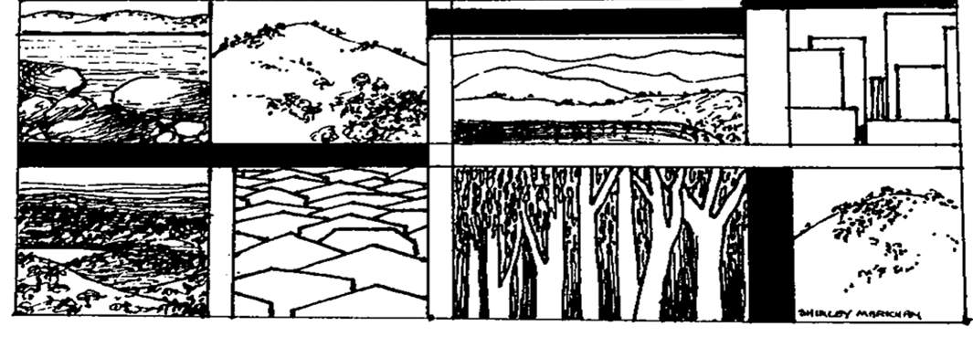

**The Yizraelite - No 2114 Date:7.7.2023**

**Kibbutz Yizrael**

Translated and edited by Eddie Solow

**Edi-torial**

**Parting is such sweet sorrow.**

**This week the newsletter is largely dedicated to Zimra Baran who is finally hanging up her gloves after 26 years as the Editor of B’Yizrael. Some fine and very moving letters from readers at home and abroad. Richly deserved words of praise. Zimra is an example for all of us to follow.**

**Last week, the kibbutz also said goodbye and thank you to Shaul Gur who served us well as chairman of the board of Yizrael Holdings. He too will be missed. He too received a fitting farewell.**

**Zimra’s Final Editorial**

I am feeling very emotional... Shalom to all my friends - those who receive a printed newsletter and those who receive an online newsletter. I'm writing these words, after I put all your good wishes into the newsletter... what can I say? – It is as if the compliments are about someone else ... are you sure? After all, I did my job with the newsletter, as I always used to do any job or task... It goes without saying, because that's how my father and mother raised me and my sisters, ... I thank all of you for the kind words – both written and spoken.

I also received warm and heartwarming condolences on the passing of Yossi Tzidkoni, the husband of Yochi, my (fourth) sister - who passed away in his sleep a few days ago. Yossi was a member of the Garin "Tzameret” and brought Yochi, my sister, to Yizrael after they fell in love on the "Jerusalem March". On all five days of the march, Yochi came to our camp (she commanded a group of soldiers, that won the competition). She came to drink coffee with us and prepare for the next day of the march... and so she also got to Yizrael. Yossi and Yochi lived on Yizrael as a family for about seven years. Orly was born here, Hezi Harpaz was her mitapelet, and she was five years old when they left. Yossi worked in the chickens and later with the youth. He was always building, erecting, and renovating wherever he was. Once we traveled to Sinai to Nueba, the three families - Davidson, Baran and Tzidkoni - within two hours we had a shower... In recent years, how appropriate, he founded "Saba Yossi's Carpentry Shop". Thank you to all those who sent condolences - everything was sent to Yochi and their four daughters. Thank you all. May his memory be blessed in our hearts always.

*On the day of my Hebrew birthday, the 19th of Tammuz,* my dear daughter – Tze’ela was born... Anton was so excited that he bought us a present, a shiny new baking oven, which "worked" for many years...

**Something about the special Pezaro family**. Years ago, I drove Inbal to her swimming training and I accompanied her to swimming competitions for several years. As a token of gratitude, they added me to their family and took me, at their expense, to the Paralympics in Athens - what an experience! Today, our Inbal is a young mother... Congratulations, appreciation, and thanks from the bottom of my heart to a charming, loving and devoted family.

Shabbat Shalom. Zimra.

**Now, what will be?**

**A New Editor for “B’Yizrael”**

And what's next?

After a long period, during which we were looking for someone who would be willing to step into Zimra’s large shoes, we are happy to announce that **Reut Shaliv-Levin** is taking on the task.

Reut meets all the demands of the job description and will combine editing the newsletter with her work at Maytronics and her role in the library.

At Reut's request, for the time being we are suspending the discussion of the alon format. Reut will continue with the existing and familiar format and will slowly adjust it as she sees fit. The new email address of B’Yizrael will be published next week.

**Instead of Flowers**

On the occasion of the end of the school year - **The Music School** would like to give special thanks to our volunteer drivers:

Yael Ben Shitrit

Yarden Naor

Nissim Avrahami

You helped us a lot! Bless you!

**General Assembly + Economic Council**

**On Monday, 10.7.23 at 19:30**

**19:30 General meeting**

**In the Moadon + Channel 900 + Zoom**

1. Answer to Amos Shemi's query on the subject: water charges

2. Food branch audit report

3. Audit report of the building branch

**20:30 Economic council - Moatza**

3 large investments in the community

Asefa Committee and Council Committee



**Disappointing Results from the Call to Donate Blood Last Wednesday**

28 people donated blood.

A big thank you to all the donors!

Too bad that more members did not come...

There is great importance in participating and making the effort to donate blood and save lives - each dose saves 3-4 people.So….

Next time we hope to double the number of donors.

See you in six months!

(If you were unavailable on the day, you can always drive to Afula and donate. – Ed)

**Personal Good Wishes to Zimra**

**on her Retirement as Editor of the B’Yizrael**

**Dear Zimra, newsletter editor - - Shlomo Cohen,**

Now, as you approach the end of your position as the editor of the newsletter, a few warm words in an attempt to express our gratitude and full appreciation for your energy and unique contribution. Over the years, your words of wisdom appeared in the editorial with fascinating intelligence and a unique social ability to create a deep connection to our community.

In each newsletter, you managed to unite the kibbutz's contemporary and nostalgic memories, creating a colourful picture of our shared experiences. You created a publication that unites us and emphasises our love for our beloved kibbutz. You repeated and emphasised that Yizrael is a home by using the nickname "Beit Yizrael".

The attention to every detail was impressive, remembering to congratulate, and participate in sorrow and remembrance when needed. In such a personal way, in small acts of love, you showed us the true nature of community, while reminding us that we are connected to each other both good and bad times.

As the editor of the Alon, your fingerprint was on every page, in its frame and in the selected quotes and in the placement of the wonderful illustrations. You provided the readers with memories and information while emphasising the wonderful connection between us. Your love for the kibbutz is reflected in every line you wrote, and you deserve many thanks for the many (and early) hours you spent on every page, every article and every message. For patience towards other writers and also those who needed a guiding hand and help in writing and drafting.

With this phase over, we wish you good health and all the very best. May you fill the coming days with joy, wisdom of life and the nostalgia that plays in your heart. The daily actions of the craft of writing could be combined into a short story, or a book. Take your time, while remembering that there are those who are expecting to read more. We are waiting and already miss you.

With regards and deep appreciation,

**Shlomo Cohen**, (member of the Alon board since 2018) on behalf of all board members over the years.

**Dear Zimra** - **Hedva and Irit**

We have always known that Zimra is the Alon, and the Alon is Zimra. In the office, we are your partners in bringing the bulletin to the public, talking to you every Thursday morning, about corrections and approvals, it's great fun.

Zimra, we will miss you every Thursday morning, we will miss you in the newsletter, but you will always be part of the newsletter, **because Zimra is the newsletter, and the** **newsletter is Zimra**. (I hope we will be forgiven if we address your replacement as Zimra from time to time).

May you continue doing interesting and wonderful things. May you have more time to enjoy life and family and please know, we will miss you very much.

**Hedva and Irit** - **Yizrael Secretaries**

**A bouquet of flowers - a bouquet to thank you dear Zimra - Ofra Shapira**

For years of dedicated work on B’Yizrael, your contribution in culture, in sports, but above all, in your praiseworthy work in publishing the kibbutz bulletin - "B’Yizrael", week after week, year after year.

It is not taken for granted that the bulletin will be published every week, in all its glory - meticulous, stylish and above all bringing to the general public, the news of the week. fresh, straight from the various committees, from the asefot, and also allowing members to express themselves and express their position on various issues.

My Fridays are not complete without sitting on the balcony, with a stack of newspapers, with the B’Yizrael on top of the stack. This is pure pleasure. This allows me to know what is going on in the kibbutz even in areas that I am not exposed to.

Bless you Zimra, and may you be blessed with good health and a long life to one hundred as twenty.

With great respect,

**Ofra Shapira**

**Dear Zimra - Ronen Nehushtan**

As usual, I eagerly read the Yizrael newsletter and this time I especially enjoyed the "CV" you attached. From the wonderful and exciting journey to the hospital (which sounded like “a tall tale”) up until now. Now, when we, the children of Yizrael, are busy with our parents' roots, it is especially interesting and exciting.

And again, as you approach the end of your job - I want to thank you for a lovely and interesting newsletter, week after week. Please see to it that your replacement continues to send a copy to the loyal readers in exile.

Love - Ronen Nehushtan

**Aliza Factor, Melbourne, Australia**

Zimra , I read in the newsletter that you have one more week left in your position as editor of the newsletter... On the one hand, I'm sad that I won't receive more emails from you every week, and not only because of the newsletter, but because I always waited to see your name in the incoming emails, but I know that you will have more free time.

There are not enough words to thank you for the weekly connection, ever since I left Israel nineteen and a half years ago...

You have helped me keep in touch with so many friends. It is true that my close friends keep in constant contact, but there were those I could congratulate or console and only thanks to the newsletter could I do so.

I still read every word - or almost everything... This week I enjoyed your words so much - "Those were days", and I laughed so hard, and I couldn't believe how your parents got to the hospital in Afula... It's lucky that you weren't born on the way... Those really were the days ....

Many years have passed, but I still miss the kibbutz life, friends, scenery, holidays and more. So, dear Zimra, I just want to wish you a happy birthday this weekend, and many days of continued activity and happiness.

Thank you from the bottom of my heart and with great respect,

Aliza Factor, in Melbourne, Australia

**Dear Zimra - Nitza Halevi**

As every Friday, this week too I will rush to my mailbox to find the weekly alon there, because there is no Friday / Saturday without the alon!

25 years of editing the B’Yizrael newsletter ended for you today.

The newsletter, which for half a jubilee year has contained the essence of our lives, the joy and the sadness, the holidays and weekdays, the work of the committees, the summaries of the hundreds of meetings and the fateful decisions that determined the course of our cooperative life.

The newsletter has also had sarcastic and entertaining pieces of humour, which brought with them a breath of fresh air, hundreds of poems that were carefully selected and adapted to the time, place, event - each week.

The newsletter was sometimes used as a platform for discussion and even debate on fundamental issues in our lives.

Personal interviews with new candidates or with 12th graders made it possible to get to know interesting people that we don't have the chance to meet on a daily basis.

For 25 years, you have produced the Yizrael alon every week with tireless diligence and without compromise, often overcoming impossible technical glitches and producing a glorious newsletter.

Dearest Zimra, for me you are the woman of the year!

I wish you the best for the coming years - health and love!

Nitza Halevi

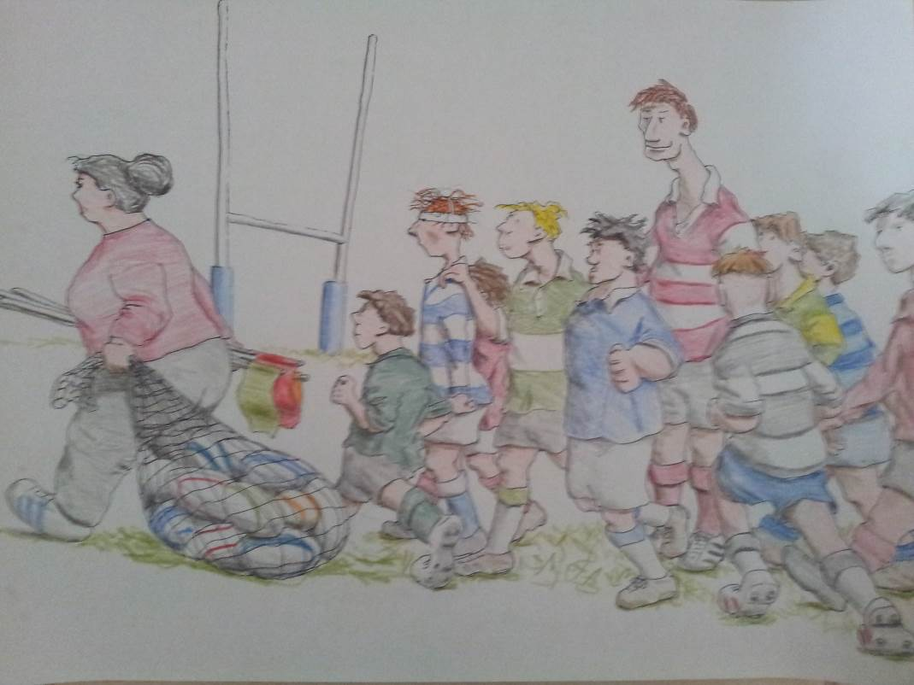

**Illustration by Chas Broadhurst**

**Going to practice/rugby game - Zimra, Milton and the kids...**

**The Song of the Alon - Yaniv Shapira**

In the opening of the latest newsletter, Zimra deviated from her custom, in which she usually expresses an opinion on current events in the world, on Israeli society or the events in and around the kibbutz. This time she chose to write about herself and listed her many workplaces over years (and without mentioning her areas of volunteering). How impressive it is to see the scope of her work in the fields of the economy, education, culture and sports. Now you can add to the same list and highlight that she edited a newsletter in the years 1996 - 2023.

Only those who have edited a bulletin or a daily publication, kibbutz or otherwise, know that the bundle of pages that is placed in the mailbox or sent on the computer every Friday, requires work around the clock. which involves chasing after officials and the collection of materials, proofreading, and editing; The job demands attention to detail, sensitivity, discretion and personal and public responsibility, attention to the design and construction of the order of things and finally also the bringing of it all to print. In the case of Zimra, the work of editing went far beyond the required and technical and was accompanied all these years by her initiative, her appeal and encouragement to writers from different fields.

And so, alongside the regular reports and familiar sections, including 'Wandering in our Small World', 'Not on Bread Alone', 'Those Were the Days', 'From the Mouths of Babes’ and 'I Care'; the thanks, the good wishes and the announcements; new columns were also added such as ' Our Photo Album', 'A Pile of Guys on the Lawn', 'Walking on the Hill’, and in particular personal articles such as 'A Donkey scooter', 'View from the Balcony', ‘Philo-sophia’, ‘The Search for Relatives (temporary name)', 'He Has Birds in his Head' (and I must have forgotten a few, with my apologies). I will always remember the column edited by Zimra, which also served me personally at the beginning of my journey, under the title: 'Between the Art of creation and the Creation of Art'.

Zimra started editing the alon alongside Nitzan Rivlin Feldman and at some point, replaced her. **A simple calculation shows she edited about 1300 newsletters over a period of 26 years**. In a conversation with her, she said that the two most important things to her were to publish a newsletter every week: 1. to maintain the sense of continuity of the community and 2. to give a platform for expression of the views of members, to get to know their heartfelt wishes, and in her words: "Not only reports, but also soul." Indeed, it is impossible to overestimate the importance of the B’Yizrael in these two aspects.

With the changes and upheavals that the kibbutz and its members went through over the course of the years, the alon was always a safe haven. The knowledge that it will be waiting in our mailbox, that it will have the relevant information, and that it will include supplements that are the roots of the existence and soul of our society, of the community.

In particular, I will mention Zimra’s special interest in poetry. Over the years, she has published songs by local poets, young and old, including Amen Becker, Gavrush Nehushtan, Mike Scheideman, Israel Mor Sarid, Nitzan Rivlin Feldman, Yossi Abadi, Matan Freiman, Shuli Mittelberg and one of Zimra’s own poems (appears at the beginning of this newsletter).

Hence, as one reads B’Yizrael edited by Zimra, not only is the image of the place evident in it, but also the image of Zimra herself.

Thank you Zimra for all of this, for your dedication, consistency, responsibility, will and production. Thank you for the spirit of the Alon and its music.

Yaniv Shapira

**Farewell to Zimra – Eddie Solow**

It seems that Zimra is really going to retire after her record tenure as the editor of the best newsletter in the kibbutz movement.

I can't imagine B’Yizrael without Zimra. I will miss our phone calls at three or four in the morning, and meetings at 5 in the morning - first in her office and more recently at her home. How many times has your office been moved over the years, Zimra? I would often get confused and arrive at the previous office in the dead of night and not understand why the lights were off.

Where will I find an editor who works my crazy hours?

Before I learned to type on a computer, Zimra was the only one who could read my illegible handwriting and understand my bad spelling (and that includes my wife, bless her). I can honestly say that without Zimra, I would not have dared to take on many of the public tasks that I have done.

Without Zimra there would be no "Yizrael March". Six or seven drafts until we got to the final version... all eight Marches! Who would have the patience for me, except for Zimra...?

Some of my letters to the Alon would never have seen the light of day, had it not been for Zimra (probably many members would have been happy about that..). I always knew that I could give Zimra the piece of paper in illegible handwriting with words crossed out and lines splattered with Tipex, and additions with arrows and lines in every direction - and Zimra would manage.

I owe Zimra a lot. I am so grateful to her.

Zimra, I wish you health and happiness. I'm sure you won't abandon the computer. Write a book with all the secrets and stories and facts that you have not been allowed to publish over the years. I'm looking forward to it.

With love, Eddie

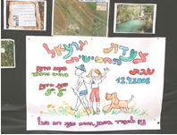

**Nitzan Rivlin Feldman**

To be the editor of this newsletter

Means always having a finger on the pulse.

Being alert so as not to miss any event.

It's an endless race against time.

and dealing with a deadline week after week

not stopping for a moment,

because as soon as you finish editing one Alon you are already chasing the next one.

To be the editor of this newsletter

means reading countless reports, not always the most interesting,

knowing how to separate the wheat from the chaff.

to illuminate dark corners,

to make room for different opinions

and give a platform and encouragement to local creators.

To be the editor of this newsletter is to know where you come from and where you are going

Remembering and respecting the past, looking towards the future

and living the present with open eyes,

It is to do your work with inner honesty and without bias.

To be the editor of this newsletter

must come from love,

of the place, of its people and of everything that is Yizrael.

You, Zimra, are all of these and you did the job consistently while breaking the record.

You did it professionally, with respect for writers and readers alike, honestly and with love

And for that and more - lots and lots of thanks, appreciation and respect.

Love you,

Nitzan Rivlin Feldman

**Google Translate is not so great – Zimra Special**

המון המון הצלחה והנאה לרעות ולכולנו!

Lots and lots of success and fun for the shepherds and for all of us!

מאז ומתמיד אנו יודעות שזמרה זה עלון, עלון זה זמרה.

We have always known that a singer is a flyer, a flyer is a singer.

זמרה יקרה מאד,

a very expensive singer

'פיל-וסופיה'

The Elephant and Sophia

**Farewell to Shaul Gur as Chairman of Yizrael Holdings**

This week a farewell meeting was held for Shaul Gur, at the end of his six-year term as chairman of the board of the kibbutz's holdings.

The meeting was held with the participation of members of the holdings board, the holdings managers who worked with Shaul and the managers in the community.

Speeches were made, words of thanks and appreciation were expressed and Shaul presented a summary of his years of work on Yizrael. Undoubtedly a very impressive period for the holdings!

Below are some of the warm words that were expressed:

**Dear Shaul - Yifat Assaf**

With the end of your tenure as Chairman of Holdings, I would like to express our deep and sincere gratitude on behalf of the Yizrael community.

You promoted the kibbutz business and elevated it to the league of the greats, professionally, quietly and pleasantly. You were the "responsible adult" and supported the team in various crises with your mediating, conciliatory and regulating leadership. The work environment you created was very pleasant, balanced and accepting, where cooperation and camaraderie flourished.

You were involved and caring and sincerely interested in the affairs of the kibbutz, in the community processes and in the members themselves, and you always knew how to ask, with real interest, what's going on and throw in a smile or a kind word at the right moment.

Thank you, Shaul, for everything you did for us. For your professionalism, the dedication, the wisdom, the support, your beautiful manner and the friendship. Thanks, and appreciation also for the dignified way in which you made the decision to say goodbye. It is so characteristic of you.

I wish you, on behalf of Kibbutz Yizrael, many more years of meaningful work, along with peace and happiness in the bosom of your family. We wish you an abundance of joy, health and beautiful days.

On Yizrael, and with me personally, there will always be a warm corner of respect and appreciation reserved for you.

Yours,

Yifat Assaf, on behalf of Kibbutz Yizrael

**Dear Shaul - Daniel Rosenfeld**

You were the first face I met on Yizrael, already in the interview which was indeed on Zoom... Corona period...

I met a radiant, shining, caring man who asks relevant questions. A man of many talents and extensive knowledge, who knows everything, and is connected to everyone.

Every question and problem I addressed to you, I always received a factual answer, with 4-5 examples where it is applied, or recommended. And if you didn't know, you came back to me, the next day, with a detailed answer, or referred me to people who could give me an answer.

Of course, each person you referred me to, I had to get to know and understand your shared history from the army, to what was the shared in the past in the kibbutz movement... I would like to thank you for allowing free discussion in the work environment, even when we argued or there was disagreement, there was always an atmosphere of discussion and debate and not the assumption of 'accept my opinion', and it is great to work under a chairman who allows the presentation of multiple opinions, in order to arrive at the correct business decision.

I always felt that agriculture had a big place in your heart, far beyond the economic and business issues being discussed at that moment. Thank you for the great tips - who to contact to get a good deal and a broader view, forming and using procedures and organisation, how to lead a discussion in management, etc. And there are the little tips: what to say and what not to say, how to say it, etc. And most importantly - a smile, a big heart and a lot of caring.

Thank you for what I received from you and what the holdings received from you, and I wish you the best of luck in the future.

Daniel Rosenfeld, on behalf of Kibbutz Yizrael Agriculture

Shalom to all the members of Yizrael,

As you know, this month I am ending a term of office and two full terms, as the chairman of 'Yizrael Holdings.'

**Thank You – Shaul Gur**

• For the great trust you placed in me, for the sense of belonging, for the cooperation I received from the various managers with whom I worked throughout the period - from the holdings board, from the economic council and from the entire kibbutz.

• For listening, having patience, the ability to change and adapt according to the situations that change every day.

• For the understanding that our job today is to take care of the members' well-being today and the members' well-being in the future. And for that, we must now lay the foundations for increasing activity and profit for the days to come.

• For the common responsibility we all share.

• For the friendship and the personal friendships and the good working relationships created between us.

• Everything described here is, of course, the result of joint teamwork!

• As far as I am concerned, I gave of my best, and I hope that my contribution to Yizrael will be significant, over time, for the benefit of Yizrael's business and for the benefit of all members and the kibbutz.

• And again, a big thank you for this privilege that fell to me, to be part of the journey of holdings, the initiative and the growth of the kibbutz.

• I wish Arik Shor, my replacement, good luck and I am sure that with his help the business will continue to grow and grow.

Yours,

Shaul Gur



**The Youth Contribute … to Society.**

Last week, a group of the youth went out to pick beetroot which we donated to the association "Ezer L’zulat" which distributes food to the needy

 Many thanks to the Field crop team for their cooperation.'

Shimrit Tsfadia

**More Google Translate beauties:**

* תודה רבה לעובדי הגד"ש על שיתוף הפעולה..'

**שמרית צפדיה**

 Many thanks to the GDS employees for their cooperation.'

**Scurvy yeast**

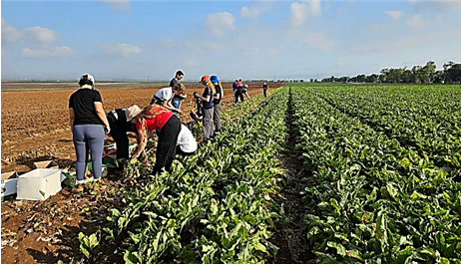

**A Meeting with the residents of ‘Sadot'**

**Subject: Closing Balconies**

**will take place: on Wednesday, 2/8/23.**

**At 20:00, in the Moadon**

**All residents of the neighbourhood are welcome.**

**Axel Levin, Shlomo Levy, Erez Peleg**

**Open meeting re the Northern Neighborhood**

**It will take place on Sunday, 23/7/23.**

**20:30, in the Moadon**

The meeting is intended for all potential tenants and all interested members of the public.

In the meeting, the project will be presented by Shlomo Levy and Axel Levin.

The purpose of the meeting is to provide all the information that is known at this time to allow the potential tenants to make an informed decision if they wish to move to the northern neighbourhood.

At the end of the meeting, the registration for the northern neighbourhood will open and the members who are eligible to move (in accordance with the housing procedure) will be asked to register on the registration form or sign a waiver of the right to move.

Regards, Housing Committee

**Help Wanted**

Payroll Accountant

Apply to Kinneret Govrin H.R.

Half Time Job



**Summary of the H.R. Management Meeting**

Participants: Eddie Solow, Irit Shemesh, Shlomo Cohen, Peter Pezaro, Nir Segal, Yifat Assaf, Erez Peleg, Rotem Agmon and Kinneret Govrin

**Date: 2.7.2023**

**(1) Survey of public opinion on the subject of toranut**

The survey was created with the help of an external company that specialises in surveys. The purpose of the survey is to identify the public's opinion regarding toranut as well as receiving information, such as: burdensome shifts and a price they are willing to pay or not, which will help shed light on the issue, enable HR to map the problems and address them.

In order to get as high a percentage of participation as possible, the survey is short, focused and will be accessible on Kehilanet.

In conclusion, the members of the H.R. administration approve the distribution of the survey to the public.

**(2) Adjustments in the organisational structure of the kibbutz and tenure procedure**

About a year ago, the organisational structure of the kibbutz was defined for the first time. The structure and all the formal bodies were approved by the asefa. In the last year, various adjustments were made, as part of the natural dynamics of processes and decisions, and they were brought to the public's attention.

Recently, the organisational structure was refined and presented to the H.R. management. Also, the document that contains all the information on the subject was updated.

This document is also accompanied by a tenure procedure that necessitated regulation. The document didn’t refer to all the selected jobs and positions, nor was there any reference to the number of tenures allowed.

The main points that came up in the discussion:

 The rationale was to group all the sub-activities under clusters and not directly under the social secretary; But there are activities that remain directly subordinate to her and are not associated with any cluster - social involvement, year of service and bereavement committee. It is suggested to associate these activities to clusters.

 The principle of rotation is very important, so it would be right to limit the number of terms.

 It is difficult to find people to fill positions in the kibbutz and then the principle of rotation can leave the system with no solution unanswered.

 The procedure refers to situations in which an incumbent will continue beyond his official term, such as not finding a replacement.

 4 years for one term sounds like a reasonable length of time, also in the context of filling two consecutive terms (8 years in total).

**In conclusion:** the organizational structure of the kibbutz and the procedure for terms of office will be presented to the members and submitted for the approval of the assembly.

Summarised by: Kinneret



**Goodnight – It is time to wake up and do something!**

**‘Give and Take’**

**Yizrael 75 - Grand Performance**

Do you want to act, sing, dance, appear?

This is your chance to join the team.

Come to the Moadon for a meeting with the producer.

Ido Dagani

N.B.This meeting is for those who are already on board too!

**Monday 10.7.23**

**18:00 – Exact Time!**

**English is Fun - with Rahel**

**Subject: WORDS OF JEWISH ORIGIN**

A fascinating list of words that you probably didn’t know have Jewish linguistic origins.

When you kibbitz with your friends, does your babble ever lead to a big brouhaha?

*Kibbitz, babble and brouhaha* are just some of the dozens of English words that come from Jewish languages such as Hebrew, Yiddish and Aramaic.

**Words about Talking**

Given Jews’ penchant for debate, it’s no wonder a number of Jewish words related to speech made it into English.

***Babble***likely comes from a famous story in the book of Genesis recounting how people tried to build a tower – called the Tower of *Bavel* (Babel in English) – that would reach the very heavens to wage war against God. God thwarted their plans and toppled the tower. Back on earth, people found that instead of speaking a common language as before, they all spoke different languages, which sounded like *babble* to others.

***Brouhaha***sounds a bit like the Hebrew phrase “welcome” in Hebrew (Baruch haba). Many linguists believe it was a dismissive word French people used to describe the sound of Jews speaking Hebrew. English speakers adopted this French word in the 1700s.

***Shmooze*** has Hebrew origins. *Shmu’ot* means ‘rumours’ in Hebrew. Yiddish speakers called idle chat *shmu’es*; from there, the word evolved into *shmuesn,* meaning to chat, and entered English as *shmoose,* meaning to have a nice, cozy, conversation.

***Being a mensch:*** words about kindness and doing the right thing.

*Mensch* literally means ‘man’ in Yiddish, just as it does in German, but the Jewish version of this word comes with a twist; reflecting the Jewish view that everyone is capable of being upright, honourable, and making a difference in the world. Calling someone a *mensch* means referring to them as a positive, good human being.

With Judaism’s emphasis on ethical behaviour, it is no wonder many English terms come from Jewish words.

***Cherub*** – a sweet little innocent child in English – comes from the Hebrew word for sword, *cherev*. In the Torah, a cherub (*cherev)* is a type of angel which guards the entrance to the Garden of Eden with a fiery sword, ensuring that people never return there.

………….more next week