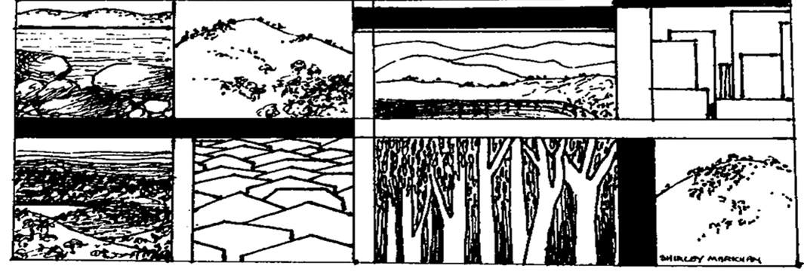

**The Yizraelite – No. 2138 Date: 22.12.2023**

**Kibbutz Yizrael**

**Edi-torial.** 19 Members and one Evacuee visitor went on an unusual adventure on the weekend (including yours truly) Instead of the usual trekking in the desert, we picked tomatoes on Moshav Amioz and helped prepare the strings that will support tomato plants in a hothouse on Moshav Ohad. The constant roar of canons and the distant sounds of explosions accompanied served as an ominous reminder of the war going on just beyond the tree line.

It is a very satisfying feeling, knowing that one has done a little something to help those who are paying such a heavy toll. Aching muscles are a small price to pay for such a good feeling. I recommend it and if necessary, you are all invited afterwards, to a few free Feldenkrais lessons to ease aching backs.

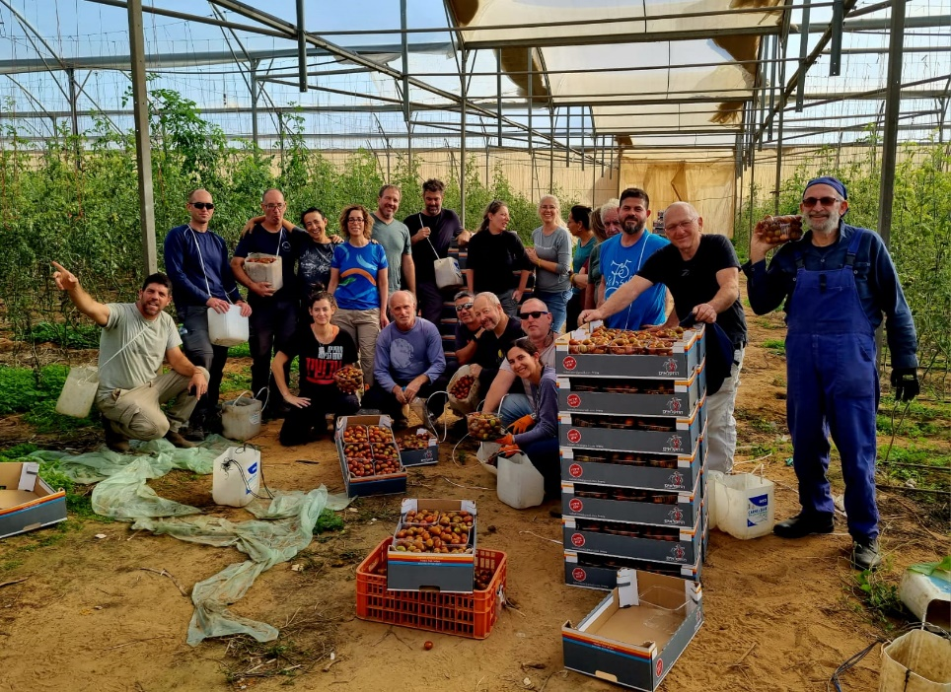

**"We share in the grief of Sigal Hadar**

**on the death of her nephew**

**Yarin Gehali of blessed memory**

**May sorrow never befall you again**

**Beit Yizrael"**

**Congratulations** to Ya’ara and Noam Greenshpon on the birth of a son, a brother for Amit and a grandson for Pnina Havshush.

Congratulations to the entire Havshush family and Noam's family.

May you have an abundance of joy, light and health and lots and lots of love!

**Best Wishes to our Soldiers – Yifat Assaf.**

To our regular and reserve soldiers, who have been away from home for such a long time. Some of you are inside Gaza, cut off from contact ... To all of you, I extend a warm greeting, with great thanks and appreciation, that you are there for us.

We are eagerly awaiting your return home, safe and sound, body and soul.

A big hug to your spouses, your children and your parents, who are worried and tense.

The thoughts of the Yizrael community are with you. We pray for better times when we will see each other on the paths and we pray for the return to our blessed routine.

If you need anything, just let us know!

Yifat Assaf, on behalf of all of us

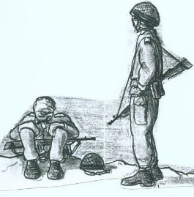



**Thanks to those Involved in the Hanukkah Events**

The holiday of light came this year at a complex time when we all need hope and encouragement.

We tried to combine the desire to preserve our beautiful traditions with the feeling that our spirit is not always free for celebrations.

We want to thank everyone who helped us expand the light during the holiday.

We hope that we were able to brighten your days and ignite hope in your hearts.

*(As is my custom, I have not transcribed the many names of those who participated in the events. My experience is that someone is always left out and most people only look for their names and skip the rest. If the readers think I should include the names, please let me know – Ed)*



**Home Security -** Lilach Harpaz Ron

A little about what's been going on in the last few weeks - we worked hard on the standby unit with regard to the personnel component. We thank the economic council for the financial support for the equipment for the armed standby unit and also for the peripheral equipment related to the emergency rule in the kibbutz - a portable generator, a lot of rescue equipment, advanced first aid kits, various training courses.

Last Monday, the team went out to practice warfare in a built-up area - we came back with new insights (and bruises...).

The mental health and support team and the home security team, “Tsachi”, were invited this week to a meeting under the auspices of the regional council - for the purpose of defining a “Tsachi” event, i.e. what are the important points to be made and especially the preparation for such an event. The meeting ended with homework and later another meeting will be scheduled with a concluding drill.

On Sundays and Mondays, we host the council's First Responders course on the kibbutz. The course emphasises rescue in the wake of destructive events (earthquakes, falling missiles). In the course we have 6 representatives!! Thus, our first response team has increased to 10 members!!

Spokesperson training will also take place on Sunday, so we will be able to deliver more accurate messages.

Soon, a practice will be held for our medical team on the subject of: “multiple casualty events”), but we are waiting confirmation from MDA (Magen David Adom) and the regional council.

In this way we will complete all the professional training for our teams. Our emergency room team received training on the sync software. They will get additional opportunities to practice in the future.

A lot is happening and not enough. The guarding of the gate is important as a deterrent! By keeping the gate closed, we are broadcasting to all those who would harm us, that Kibbutz Yizrael is protected, that it is not worth wasting energy on us. They may move on elsewhere. It's easier to say, "it won't help anyway" and therefore unnecessary, but this thinking is fallacious (Based on a mistaken belief – Ed). Guarding helps, it is a strong deterrent.

**We would be happy for more public participation.** - Lilach Harpaz Ron

**Community Management Report - 17.12.23**

**1. Entrepreneurship work plan + clusters**

• Shimon Zelas presented the summary of the 23rd year in entrepreneurship, as well as the plan for the 24th year, including an update on a number of expected changes, some of which are already being implemented.

• Yifat Segal presented the goals of the Culture Cluster, the summary of activities, as well as the plan for 2024 and the budget request derived from the plan.

• Limor Griman presented the summary of the year in the education cluster, the aims of the system, the plan for 2024 and the resulting budget request.

• We are in the process of merging the golden age group under the health cluster umbrella, and the budget request will be structured accordingly.

• The Demography cluster will be budgeted similarly to the previous year. Best wishes to Ishai. Take care of yourself and a big thank you from all of us.

At the next meeting we will discuss the requests and the plans for investments in the community for the year 2024,

**2. Construction in old neighbourhoods (invited Aviva Beutler)**

It was once decided that after the old neighbourhoods had been renovated and expanded, there would be no further renovations and expansions, which require the use of heavy equipment. This is to prevent the destruction of infrastructure and gardens, which took a long time to restore, and so that we don't constantly find ourselves living in construction sites. In the last two years, construction and adaptation works have been carried out on apartments that deviate from this decision (for various necessary reasons). There are currently a number of requests from various members to enlarge apartments in the old neighbourhoods, which are currently not 110 square metres. We must examine the validity of the existing decision, and whether, and under what conditions, it is possible to build.

**Discussion-**

- The Housing Committee wishes to change the decision that heavy equipment cannot be entered into old neighbourhoods. This is important if we do not want to find ourselves with empty housing areas. We want to change the decision and judge each case on its merits.

- There is talk of demolition and rebuilding in the old neighbourhoods, as a long-term solution, the most appropriate solution for the old neighbourhoods, which have also been developed / extended like patchwork over the years. Such a plan should be put on the table, in which rows are cleared, and rebuilt one at a time. Considering the condition of the apartments, and the understanding that there is no getting away from demolition and reconstruction in the future, it seems wrong to invest huge sums of public money.

- The planning committee's original decision is correct, and it is not right to carry out significant construction works, with heavy equipment, and destroying the surroundings.

- People made their choices when they renovated their houses.

- The issue of the lack of safety rooms (Mamadim) in the old neighbourhoods came up. It was said that alternatives are being considered, but this is a topic for another principled discussion, another day. This is a complex issue, which is related to different aspects and is a dilemma between the good of the individual and the good of the whole.

**It was decided:**

**A. Validation of the planning committee's decision, according to which no construction work should be carried out in the old neighbourhoods, requiring entry with heavy equipment, causing damage to the surroundings.**

**B. Exception… In special cases, and with the approval of the planning committee, it is possible to allow construction in apartments smaller than 110 square meters, where it is not necessary to enter with a drilling machine, and on the condition that the construction will be made of light materials, and only in buildings where there is a safe room, and without exceeding the building line.**

**C. There is room for exercising discretion, for example for rehabilitation purposes.**

**D. The community management directs the planning committee to start thinking and working on a future plan for the old neighbourhoods, based on demolition and construction.**

**(Editorial Comment –** in my humble opinion B,C,D, invalidate A).

**3. Approval of a budget for the construction of a fence**

At the request of the “Tsachi”, the construction of a new fence on the southern side of the reservoir was approved, at a cost of about NIS 50,000. This amount is within the investment budget approved by the Economic Council for the war period.

**4. Vacating the older children’s rooms by the end of the school year**

It was decided that we will allow the evacuees to use the rooms of the older children until the end of the school year, which will then enable our soldiers to get their rooms back.

Erez Peleg and Yifat Assaf



**Report from the Asefa - 18.12.2023**

Chairman of the Asefa- Shlomo Cohen

Secretary of the Asefa - Uri Gilad

Present at the beginning of the meeting - 46 members

On the agenda-

1. Advancement to candidacy - Hadar and Tamir Lavi, Sivan and Guy Dashevski

Advancement to membership - Tal Freiman-Levy

2. Residency procedure

**1. Absorption reports-**

Uri Gilad presented the absorption committee’s report for the candidacy of **Hadar and Tamir Lavi.**

**Nitzan R. Feldman** presented the absorption committee’s report for the candidacy of **Sivan and Guy Dashevski.**

**Shlomo Levy** presented the joint report to the admissions committees and members in preparation for the acceptance of **Tal Freiman-Levi** to membership.

Voting by ballot will take place on Wednesday and Thursday this week.

**2. Residency procedure-**

**Yifat:** Over the years, several types of residency statuses have been created on Yizrael- members, parents of members, spouses of members, caregivers and more.

Also, over the years, various decisions were made on the issue of residency. Considering the aging of the members, and the changing reality we found that the time had come to create a single procedure, which brings together all aspects of the field of residency, while updating decisions. A team was formed that collected, studied, and prepared a comprehensive proposal, that includes the various decisions, into one document. Thanks to a dedicated team, which will ensure that the procedure is followed, and will be an address for the residents to turn to.

The proposal refers to the different definitions of the residency tracks, the duties and rights of the residents, the residency fees that have not been updated for many years, and the most sensitive issue, what happens when the connection ends, due to the death of the member, for whom the resident came to the kibbutz. The proposal was presented and discussed in community management and at an open meeting.

The residents sign a contract which defines rights and obligations.

Yifat pointed out that the decisions that will be made here tonight are not valid regarding the cases that are already on the table, and the conduct regarding them regarding staying in the deceased member’s apartment will be in accordance with the old procedures. (One year grace – Ed)

The team included Uri Gilad, Elad Ilan, Tzach Sassi and Yifat Assaf. In addition, the team personally approached Peter Pezaro to join the team as a representative of the spouses of the residents. A big thank you to the team for dozens of hours of thorough and hard work!

**Elad Ilan** presented the main principles of the new residency procedure, as they appeared in the background material (the presentation can be seen on Kehilanet).

A discussion was held, which was largely concerned with the question of the way to determine the price using the method proposed by the team. According to the team's proposal, the starting point is the sum of the cost of maintaining a person in the kibbutz, excluding the items that concern members only. According to the calculation made, the cost is NIS 7,200 per month. From this, the team suggests, there will be different discounts, according to the interests of the kibbutz. The team presented a model, which does not include pricing each item or service consumed (based on an estimate – Ed).

During the discussion, a motion to order was proposed by Phil Adler: to stop the meeting, return the matter to the team and come back with a clearer number, against the background of the ambiguity that he said exists regarding the pricing of the discounts. The proposal to order was defeated by a majority of 33 against the proposal, 22 in favour of the proposal. The meeting continued.

Eddie pointed out that since the proposed procedure was published to the public a few hours before the meeting, it is not correct to vote tonight on the full version, and that it is possible to vote on the principles of the procedure as presented in the presentation that was sent. In response to Eddie, the team said that the presentation that was sent on time contains the main and important things in the procedure.

There was a discussion about the conditions and the length of time a resident is allowed to stay in the member’s apartment after the member’s death. 3 alternatives were presented to choose from. The main idea that characterises options A and B is that the older the resident is and the more years he has lived in the kibbutz, the longer he can stay in the apartment.

A proposal was made by Biff, to update option A so that a resident who is 75 at the time of the member's death, could stay in the apartment without limitation (instead of the team's proposal - 10 years). The proposal was accepted by the team.

**First round:** A vote was held to choose one alternative out of the three alternatives regarding the length of stay in the apartment as a resident after the death of the host member, according to the table presented.

Option C proposes to leave the existing situation - limiting the resident's stay in the apartment to one year, regardless of his age or the number of years he has lived in the kibbutz.

Since in the first round no alternative received more than 50% of the votes, another vote was held between the two alternatives that received the most votes.

**Second round:** staying in the apartment as a resident after the death of the host member, according to the table.

**In favour of the team's recommendation** - depending on the resident's age and length of stay - 30 votes.

**In favour of the existing situation** - you can stay in the apartment for one year - 26 votes.

**The alternative recommended by the team was chosen.**

**Final Vote,** there was a vote on the entire procedure. With a majority of 40 in favour, 19 against, and 1 abstention - the complete residency procedure was approved.

Erez Peleg and Yifat Assaf

**P.S. It has been brought to the attention of the Assembly Committee that a group of members are collecting signatures for a rediscussion, so the decision may not be final! – Never a dull moment…Ed**

Below is the complete procedure that was approved, after several minor adjustments made in the spirit of the meeting. The procedure will be entered into Kehilanet in about a week, under "files and procedures" and will become official on 1/1/2024. (Unless the decision is changed – ED)

**Procedure for Residency on Kibbutz Yizrael**

**Background**

The kibbutz strives for its permanent population to consist of members, candidates and Young Generation. This procedure aims at regulating the exceptions.

The purpose of this procedure is to regulate the rules that apply to residents and hosts, so that they will be used as an additional tool by the management committee and the kibbutz institutions to handle these cases.

A person will not be able to choose to stay in the kibbutz as a resident - this is subject to the sole discretion of the kibbutz to decide who is a resident who will be allowed to live in the kibbutz and his status, all as stipulated in this procedure. As a general rule, residency will not be allowed for those who have no connection or affinity to the kibbutz (on the other hand, the Kibbutz is not obligated to grant any person the right to residency).

This procedure will replace any previous decision on the subject, either by the general assembly or by the executive committee or any party appointed on its behalf.

**Residency Procedure Summary**

Part 1 defines the various types of residencies. (Not included here – Ed)

Anyone who lives in a kibbutz as a resident and does not belong to one of the above categories is not a permanent resident and this procedure does not apply to him.

Status

A resident will not be entitled to the rights that candidates for membership or members of the kibbutz are entitled to by virtue of their status, including voting rights, rights to “severance” pay, a share in the profits of the kibbutz, be a part in the realisation of assets, etc.

**Decision on granting permission for residency in the kibbutz.**

The kibbutz secretary and residents’ committee will discuss a member's request to allow someone to join him to live in the kibbutz as a resident. If it is decided by the secretary and the committee to accept the resident in the kibbutz, this will be submitted as a recommendation for the approval of the community management.

The resident will be required to present his financial ability to meet his obligations .

**Residency agreement**

Each resident will be required to sign a tripartite residency agreement, which will be drawn up in writing, between him and the kibbutz and between the member who is related to the resident, The Community Management will be entitled to make changes from time to time in the wording of the agreement, including individual adjustments as it deems appropriate.

The member who is related to the resident will provide a personal guarantee for the fulfillment of the resident's obligations, even if the aforementioned member or the resident himself refrained from signing the agreement. Without detracting from the aforementioned, it is clarified that the resident's failure to sign the agreement will be grounds for the termination of his residency and/or a charge to the account of a member of the kibbutz, and the kibbutz will be entitled to act to remove the resident from the kibbutz as it sees fit.

The kibbutz will be entitled to deduct from the host's personal budget, or from any amount that the host will be entitled to from the kibbutz, any amount that the kibbutz will be entitled to receive from the resident, provided that the host and the resident himself were given a 7-day notice to pay the debt to the kibbutz.

Without detracting from the generality of the foregoing, the General Assembly hereby authorises the residents' committee to impose fines on the member related to the resident if the resident does not meet his duties or obligations towards the kibbutz and as long as he continues to live in the kibbutz. The fines will be imposed subject to the following:

The resident's debt exceeds NIS 5,000.

The resident and the member were given a notice to pay the debt and they failed to pay the debt within 14 days from the date notice was given.

A residents committee will hold a discussion regarding the resident's debt. The member will be invited to speak before the committee. The discussion will take place even if the member chooses not to attend it.

In relation to debt up to the amount of NIS 20,000, the committee may impose a monthly fine of NIS 2,000.

In relation to a debt over an amount of NIS 20,000, the committee may impose a monthly fine of NIS 2,500 including offsetting bonuses and redemptions.

**Expenses:**

The resident will bear the real cost of his residency in the kibbutz, including the expenses of maintaining his children (up to the end of 12th grade) who live and/or are educated in the kibbutz, as well as any other expenses in connection with his residency in the kibbutz (hereinafter: "the expenses").

21. A resident who has children in common (up to the end of twelfth grade) with a kibbutz member will bear 50% of the real cost of raising a child, i.e. paying half of all budgets, expenses and payments that the kibbutz spends on the child. The amount of child support that appears in the appendix (table) is for a single resident, for all routes, except for "a resident of his choice", a discount will be given according to the existing person maintenance assumption for this route for child maintenance payments only, not including education and health.

The prices will be updated from time to time and at least once every two years, and in any case will be attached to the last known consumer price index, except if decided otherwise by the residents’ committee. The base index will be the known index on the day the expenditure amounts are updated. There will be no linkage to the consumer price index in the event of a decrease in the index.

The kibbutz services for which the resident is required to pay are services that are provided as part of a basket of services and cannot be divided into different components, therefore no claim will be heard on the part of the resident or on the part of the member related to the resident or on their behalf, according to which the resident does not need a particular service provided by the kibbutz. All residents are entitled to a discount on the total basket of services in accordance with the discount rate established by this procedure and that this discount reflects, among other things, any deviation that occurred, if any, in the calculation of the cost of the basket and the residents will not have any claim in the matter. The kibbutz will be entitled to change the amount of the discount or cancel it at any time, at its full discretion, with three months' advance notice.

Burial expenses and arrangement according to the decisions of the Kibbutz in this matter.

The expenses are as detailed in Appendix B to this decision.

**Work and duty shifts**

The kibbutz will not be obliged to employ the resident or provide him with work and there will be no employee-employer relationship between the resident and the kibbutz by virtue of his residence.

The resident will be required to do shifts in the kibbutz according to the decisions of H.R. or a shift committee in this regard. The kibbutz may call on the resident to guard at the gate according to state regulations.

**Medical and long-term care insurance**

The resident must be insured by a recognised health fund. Any expenses related to his health, including hospitalisation or long-term care expenses, will apply solely to the resident and the kibbutz will not bear any cost in connection with this. The health expenses for his children will also apply to him, as stated in this procedure.

**The residential apartment**

The apartment in which the resident will live is owned by the kibbutz.

A resident who is the spouse of a member will be allowed to participate in the financing of the expansion/design of the apartment in which the couple lives, subject to compliance with the building rules established by the kibbutz, including the approval of the planning authorities. Even if the aforementioned resident participated in the financing of the expansion/design of the apartment, this will not give him any ownership or financial right in the apartment and he and/or any of his heirs will not be entitled to any reimbursement on behalf of the kibbutz even if his residence in the apartment ends and it will return to the exclusive use of the kibbutz.

**The resident's rights after termination of affiliation with the kibbutz member**

In the event of the death of the member related to the resident, the rules will apply as follows:

A committee dealing with residents will examine the case and use the reference table as detailed in the appendix

According to the decision of the residents committee, the resident may be allowed or not be allowed, the option of living in the member's apartment and/or in another apartment that is deemed appropriate.

The reference table will not limit the residents committee, but will serve as a guiding tool only.

The kibbutz is in no way obligated to a certain housing standard.

3 months advance notice will be given, in the event that the resident is required to leave the apartment or kibbutz.

The contract is for one year and can be changed, at the discretion of the kibbutz.

The resident will bear the full cost of the rent as determined in addition to the cost of maintenance.

The resident must find a member who will take full responsibility for his care and be his guarantor.

In the event of separation and/or termination of relationship other than by death between a member and a resident who is a member's spouse - the resident will be required to leave the kibbutz and his residency will be terminated. The kibbutz will not provide the resident with an apartment. Either in the case of separation or in the case of the host member's expulsion and/or leaving the kibbutz.

If the host member takes a year off, this does not indicate the end of the relationship and the resident may live under the same conditions, as long as the member's leave period does not exceed two years.

A resident who lived in the same apartment with the member related to the resident will not be allowed to live in the same apartment together with another resident and will not be allowed to rent it and/or part of it and/or bring in another tenant without the kibbutz's permission.

In exceptional cases, discretion will be exercised and the team will make their recommendation to the community management before a decision is made.

**Accompanying the resident**

A residents committee will accompany the residents during their stay in the kibbutz and will be the address for the residents' inquiries and the enforcement of this procedure. If necessary, there will be a contact person on behalf of the committee.

This procedure replaces any other past decision on the subject.

Approved by the assembly on: December 2023

Resident procedure team: Kibbutz secretary, Yifat Assaf, Uri Gilad, Elad Ilan, Tzach Sassi, Peter Pezaro.

**Management of Votes in the Asefa using** **Kehilanet**

Hello members,

In light of the closed asefa that took place this week, I would like to clarify the advantages of using Kehilanet for asefa votes,

A. When the meeting is open, and there are no technical malfunctions, it takes place both on Zoom and on channel 900. In this situation, voting via Kehilanet also allows members to vote from home. Nevertheless, there are situations in which we would prefer to vote with a show of hands. For example, when the decision is about changing the wording in one section that will anyway end up as a multi-section proposal for a vote in Kehilanet.

B. When the meeting is closed to members only and is not broadcast on channel 900 or Zoom. Voting using Kehilanet allows secret voting for members sitting in the meeting. There is no intention that the people at home will vote blindly on proposals after a debate they have not heard at all. In some cases, a closed meeting for members only will be possible that combines zoom with open video (for example when we wanted to allow members in the army, to participate). But as a principle, a closed meeting is physical attendance in the moadon.

As a general rule, I call on all members to be involved in the decision-making processes, to send suggestions and reservations in advance after reading the background material, to physically come to the moadon, to look the other members in the eye and try to convince them one way or the other. The social gathering over coated waffles and ginger-flavoured tea is almost as important as the decisions that are made. Certainly, there are reasons to stay at home and sometimes they do not depend on the member's wishes. Therefore, we will often prefer and allow meetings that include Zoom and channel 900.

**Epilogue**

A kibbutz member from another kibbutz wrote a few weeks ago, regarding her kibbutz meetings as follows:

"We have become a body managed by lawyers and their advice is in terms of "so see and sanctify". Someone forgot to talk to us... someone forgot to hear us... someone forgot that we need to be answered even if our questions are disturbing.... Someone forgot that they also need to gain the public's trust, and this can only be achieved if they see us as partners and not just captive voters. It's still a kibbutz, it's still our home and there's no place for a dictatorship here."

I call on all members to come to the meetings! The teams, the committees, the clusters, the community management and the management committee work day and night and work many hours to bring issues concerning the essence of our lives to the asefa.

Shlomo Cohen

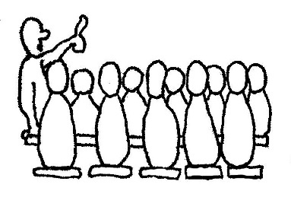

**Summary of the H.R Management Meeting - 17.12.2023**

**Kinneret Govrin**

Participants: Rotem Agmon, Peter Pezaro, Eddie Solow, Shlomo Cohen, Irit Shemesh, Yifat Assaf, Noa Armoza, Nir Segal and Kinneret Govrin.

**1. Failure to comply with the work obligation**

After the approval of the new work procedure in the asefa in June, a discussion was held in the management of the H.R. as to when the procedure would be applied since it was adopted in the middle of the year. It was agreed that the clause of failure to comply with the work obligation would apply as early as 2023. Other changes such as the number of days of vacation/sickness to be utilised, etc, cannot be applied in the middle of this year. Therefore, these parts will apply in 2024.

Now, towards the end of the year, another discussion was held on how to apply the non-compliance with the work obligation clause.

**In the discussion:**

• It is proposed to apply the new decisions of non-compliance with the work obligation this year to members who do not meet 80% of a job or less, the other members who are not full-time will receive an update regarding their situation.

• The threshold of 80% of a job is due to the fact that it is more logical and possible to complement job obligation by working one day a week in another job and despite this there are members who did not do this.

• Alerting the other members will allow them and the rest of the public to prepare accordingly, and to correct and change their conduct and functioning.

• The main goal is not punishment but harnessing the public to work and earn a living, so it is important that a clear message be sent out that one must work full-time.

**Decision:**

The clause of non-compliance with the work obligation will apply in 2023 only to members and candidates who worked 80% of a job or less. The rest who did not comply with the work obligation will receive a warning letter only. Starting in 2024, the full work procedure will be implemented.

About two weeks ago, letters went out to all those members who do not work shifts in the food industry or do not work at all. The members who received letters regarding an occupational doctor who will come to the kibbutz, can of course also contact an occupational doctor outside the kibbutz.

Members who do not bring a medical certificate for release from roster duty, will be assigned to duty as of February 1, 2024.

Kinneret Govrin

**The Outside Worker’s Branch Management Meeting Minutes**

**18.12.2023**

Present: Rafi Baum, Erez Peleg, Maor Parsai, Kinneret Govrin, Dima Tchernichovsky, Peter Pezaro

**Agenda:**

1) **Overtime of outside workers**: setting a policy regarding registration up to or beyond the standard. Data was presented in three categories:

**▪ Global overtime:** following a consultation with the kibbutz's lawyer for labour law, it was stated that global overtime is a means of distributing wages and should not be used to testify to actual additional hours of work beyond a full-time position. It was decided to give additional hours off only based on an actual attendance report. Members who want to receive credit for days off will be asked to bring the attendance sheet from the employer.

▪ Overtime that is paid in a pay slip: in this section it was decided to earn time off according to the registration in the pay slip, in accordance with the work procedure.

▪ Fixed job percentages: there are several members who work in jobs over 100% and they will be awarded days off according to the work procedure.

2) **Updating and reviewing the policy regarding the amount of the minimum gross salary required of each member going to work outside the kibbutz.**

A survey from August 2023, from 13 cooperative kibbutzim, was presented regarding the amount of salary required of kibbutz members working outside the kibbutz. There was a lengthy discussion on the subject. Below is the relevant data:

According to the existing procedure, national minimum salary + 30% which is 7,244 NIS

Yizrael data: (numbers normalized to 100% employment)

**Average gross salary:** 14,758 NIS

**Median gross salary:** NIS 12,302

In order to obtain an index that would be updated according to market conditions, it was proposed to attach the kibbutz requirement to the "average wage in the economy", with a 25% reduction.

The average gross salary for a salaried position of Israeli workers in 2022 according to the Central Bureau of Statistics, at current prices, is NIS 12,120.

After a 25% reduction, the amount is: NIS 9,090

Therefore, it was proposed to establish a new minimum according to this model.

The proposed new minimum is 25% less than the average wage for a salaried position according to the Central Bureau of Statistics. By the end of 2023, the amount will be 9,090 NIS.

4) Miscellaneous

A request was received to re-examine the credit of days off for an employee who ends his work and redeems his days off with the employer, and the kibbutz receives the redemption money.

Peter Pezaro

**From the Desk of the (New) Duty Shift Manageress**

As of January 2024, there is new software for shifts. The **Easyshift** software is no longer in use as of January and should be removed completely.

On Sunday 31/12 at 18:00 I will sit in the moadon - anyone who wants help with the new software or the app is welcome to come.

• Every month a new publication of the duty schedule will be sent. I published January and February (In the future, the schedule will be published 3 months ahead).

• Those who are on duty that month will receive an email with their duties that month.

• In any case, the application **'TimeTable**’ - software for arranging work, must be installed\downloaded (Note the capital **T**s In **T**ime**T**able– Ed) – in some phones the application is listed as 'Business Timetable':

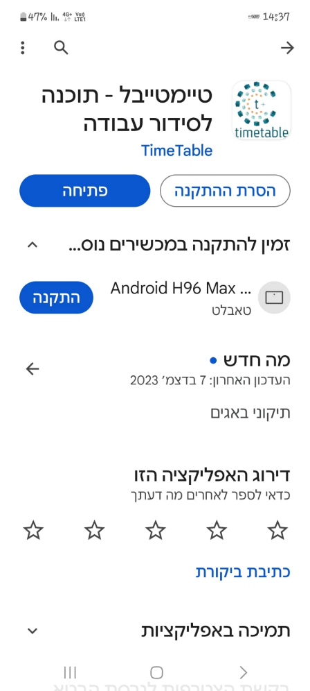

• The username and password are both your mobile number without spaces and without lines.

• In the application you can see all the shifts for that month in 'shifts'. It is recommended to view a list view and see all shifts for the month. Note that you are in the correct month.

• If you click on 'My shifts' the layout will appear empty except for your shifts.

• In 'My Shifts' you can click on 'Export to Google' and then the shift goes directly to the Google Calendar on the phone. It is highly recommended!

• A reminder for a specific shift will arrive 24 hours and also 3 hours before the shift both by email and in the application.

• Swapping out will only be done independently. I make substitutions only in the case of an army Order 8 or chronic illness. Therefore, it is important to inform me in advance about time off, work trips or any other absence that you know about in advance. If you have swapped out, please let me know about it on WhatsApp, or by email **toranut@yizrael.com**

• For any additional questions, you can send me a WhatsApp message, or come to the mazkirut and I will guide you on the matter.

This training file is permanently in Kehilanet and can be found on the home page - files - shifts - training on **timetable** software for shifts.

Ruth Mor will continue to update the members accordingly on WhatsApp.

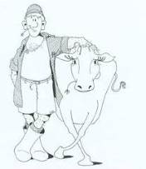



**Our Guests in this Time of War**

**Many thanks to Revital Amit for the help in preparing the section.**

**Idan and Hadas Celesta from Kibbutz Brur Chail**

**Who we are?** Mika, 4 years old, studies in the Rimon Kindergarten and Libby, 1.3 years old, studies in the "Arava" nursery school that was opened for the evacuees.

**What do we do on a regular basis?** Normally, Idan is involved in project management in the field of aluminum and Hadas is a behavior analyst, coordinator of a communication kindergarten in special education in Be'er Sheva.

**Where were we until we got to Yizrael?** The morning after the 7.10 we went to Hadas' parents in Kfar Yona and Idan was drafted into the reserves. After that, we stayed in Ma'agan Michael, with a good friend of Hadas’, from there we moved to a hotel in Haifa together with the Brur Chail community and then we arrived in Yizrael.

**What do we miss?** We miss our house the most, which we built and moved into a little over a year ago. We miss the space of the house, cooking in the kitchen and the girls' playroom.

Lucas, our dog, is also in Kfar Yona, with Hadas' parents and we miss him.

**What do you enjoy on Yizrael?** Kibbutz Yizrael welcomed us warmly. The cultural and community life is very noticeable here. We enjoyed the various Hanukkah activities and Kabbalat Shabbat. The kindergartens here are amazing and the girls are happy and excited to go to kindergarten every day. Thank you very much for bringing us into your home and giving us a home away from home during this time.

**From Zimra’s Column 22.12.2023**

From Bulletin No. 945, December 1, 2000. Things I wrote 14 years ago... "A few days ago, I received a message that at the end of 2001 I will be able to stop doing shifts due to my advanced age... see you next shift, Because I think that after all I will continue to do shifts as long as my health is fine – knock on wood.

As part of the community, the Baran, Shkolnik and Levy families are also hosting our family members: Giora, Reut, Daniel, Ayala and Alon Baran, who left their home in the far north and came to stay here.

Like many of our evacuees/guests, they are far from their homes, their occupations, their livelihoods and their social lives and I enjoy sweet and precious grandchildren... My grandchildren, like all evacuees' children, are organised in schools and enjoy our informal education, and activities.

The feeling of security we give them with a hug from the whole community, for many days - is priceless... We all thank you all!

**[](https://www.google.co.il/imgres?imgurl=http://lifeandletters.la.utexas.edu/wp-content/uploads/2009/09/homer.jpg?8a7882&imgrefurl=http://lifeandletters.la.utexas.edu/category/2008/fall-2008/&docid=IislXT0nf6tE-M&tbnid=W9lVBpHV3WJDaM:&w=200&h=187&ei=u8tYVKvmHoK_sQT9wIGwBg&ved=0CAIQxiAwAA&iact=c)Philosophia**

**Instructions** **Regarding** **Guarding**

Not the official version but then because we all know best it wouldn’t help anyway. In any case I hope this will help …. A little late I know but I was supposed to be in New Zealand but wasn’t – but the translator was and there are no Hebrew keyboards over there – a translation into Maori would have been of little use. We may need an Alon translated into Maori as well as English.

The most important thing about being out on the front line is to be there with someone who has a gun – the ultimate partner being one with a cool looking black T-shirt, M16 and Maytronics car. If not someone with all these then at least some sort of firearm, even one that used to belong to Wyatt Earp.

Assuming you are guarding and neither of you is armed then it is essential that your partner is smaller than you. Actually, not necessarily smaller – actually wider is also good. The point is we are talking about using your partner as a human shield when the shooting starts – the point is that your partner needs to be someone you can easily grab hold of and hide behind. This could be problematic if you are guarding with a friend – I suggest you put your name on the list and let fate take its course.

As luck would have it, we have two gates – just another thing we can be proud of – visitors I have guarded with, are overcome by our two-gate arrangement and on more than one occasion I told to them that we are thinking of adding a third gate, due to our proximity to Jenin. More than one told me they chose to be here with us because of our double gates and if we add a third one, they will find it very hard to leave.

The other advantage of having two gates is the nearly endless possibilities to confuse drivers entering and exiting. My favorite ploy is to let the buses in through the left gate and then while they are dropping off their passengers, I quickly swap the barricades around and then operate the right gate. This causes all sorts of havoc and certainly helps pass the time. If you really want to annoy the bus drivers, you can board the bus and ask to see the identity papers of all the passengers.

Then there are the parents who come to drop off a child or two at the Gan. If it’s a slow morning or you are just bored or feeling vindictive, insist that the parent lowers the back window so you can see the passengers. This is your opportunity to ask the kids if they packed their bags by themselves and has anyone asked you to bring anything to the Gan or if they are armed. Parents love this. Full body searches are not recommended.

Another thing you can do to spice up your stint at the gate is to pretend you don’t know what or where Maytronics is – this is really entertaining because there are so many who want to go there. When they flash their card ask to take a look at it more closely while holding it upside down. I admit I have a slight advantage because of my Anglo-Saxon accent – subconsciously your average Israeli assumes we are somewhat backward (my kids certainly do). Then apologise and ask them to park to one side while you make enquiries.

It's also fun to stop cars exiting and ask them where they are going.

As a general rule if you can’t see a kaffiya or a Kalashnikov it’s ok to just wave the car through into the kibbutz.

If you are wondering if there are any excuses for not volunteering for guard duty at the gate, then no there are none – this is not toranut!

**Little Tips for Big Feelings -** Gaya Sankar

"Everyone hears his voice,

The voice he didn't know, and here it is his

..

Everyone hears their voice.

Clear or hoarse, it resonates with him.

Everyone who listens may come, a voice that will calm them down

(Neufeld's glasses)

The last few days, or especially the last few nights, I have found myself singing to myself in bed.

Only then did it also dawn on me that I hadn't sung in two months. Not really. It seems that with the pain and shock the voice went. I didn't even succeed in listening to music, because how can you play what has no words?

But the truth is, it's just the opposite.

It is precisely music that gives us a voice to express what is inside us, what we do not always know how to collect or consolidate into words, and with its help a new life comes out.

In such moments, when we feel an incomprehensible "noise" inside us (and to be honest, it has already become so deeply embedded within us that we don't necessarily notice its existence), music is a wonderful tool to reflect it, unravel it.

Whether the noise contains anger, sadness, loss, pain, frustration, disappointment, or alternatively small and large joys. Even the confusion within us, we can express through music and thanks to it, everything becomes less confusing. Suddenly we have a voice. Suddenly we can process and understand and feel all these emotions that float inside us.

What to do?

An instrument can be played powerfully to help release the anger.

You can play soothing music that will help regulate the storm.

You can listen to the words which someone has already composed for us.

Or to the melody, which sometimes seems to describe exactly the melody of our soul and breath at a given moment.

You can dance to the music.

Or compose new sounds.

And the simplest…

You can sing, just sing!

No need to know how, no need to be beautiful and vice versa.

To sing and express everything inside us, even everything that is not beautiful. Singing activates our throat, releasing the tension from it, from the choked tears that accumulated in it, and from everything we wanted to say but didn't know how.

- For those who are interested, I also recommend occasionally recording ourselves singing. Like this quietly, on the cell phone, just for yourself. It is not easy, but there is also great value in hearing our voice from the outside, and observing what listening to it evokes in us.

- Music is a simple and wonderful tool to share even with children, who in their high sensitivity also experience the storm, but have not yet learned how to express outwardly everything that has been absorbed into them.

**Farewell to 2023**

**29.12.23**

**Noga D’Angeli**

**Stand up Comedy.**

**Hilarious – Good for the Soul**

**Clever, Witty, Biting**

**Tips Galore**

**Doors Open 21:30 - Show Begins 22:00**

**English is Fun - with Rahel**

“JEWS: Who Knew?” (byDebbie Jones Thornton)

Taken from the book “JEWS: Who Knew?”

In his 2015 book,”The Debate Over Jewish Achievement: Exploring the Nature and Nurture of Human Accomplishment”, Steven L. Please chronicles the disproportionate level of Jewish achievement in virtually every area of human endeavour, and offers a number of theories to explain this amazing phenomenon.

He says that in the end, the debate over factors behind Jewish exceptionalism boils down to nature (genetics) and nurture (culture).

The huge premium Jews have placed on literacy and education for more than 2,000 years. The Torah (the five books of the Jewish Bible) and the Talmud (recordings of rabbinic discussions) are intellectually complex and sophisticated. Throughout history, Jews have been expelled from many places and their belongings taken from them. Jews invested in knowledge for many reasons, among them because knowledge is portable and the only wealth that cannot be stolen.

Jews typically demonstrate high levels of self-discipline (deferred gratification). We see it in their commitment to formal education, their careers, and their drive to achieve. They encourage and develop their verbal skills and the inclination to speak up, make an argument, debate, and disagree if they feel strongly.

Ethical behaviour has been inculcated in Jews by the Torah and Talmud. God demands it. For most of 2,000 years, Jews had to exist as a small minority among other cultures with substantially different beliefs and native languages. Staying alive demanded rationality and adaptability.

I am not alone in being awe-struck by the stunning accomplishments of the Jewish peoples. John Adams (second President of the United States, (1735-1826) said, “I will insist that the Hebrews have done more to civilize men than any other nation. They are the most glorious nation that ever inhabited this earth. The Romans and their empire were but a bubble in comparison to the Jews.”

Winston Churchill said, “No thoughtful man can deny the fact that the Jews are, beyond any question, the most formidable and most remarkable people who have appeared in the world.”

I even found this quote from a rabbi who said, “I saw a remarkable study of the five most influential people of all time: MOSES, JESUS, MARX, FREUD and EINSTEIN. All Jewish!”

Many of the products and services we enjoy today are provided to us by companies with Jewish founders and executives, including Intel (Grove and Vadasz), Google (Brin and Page),Oracle (Ellison), Microsoft (Balmer), Dell (Dell), Qualcom (Jacobs) and Facebook (Zuckerman and Sandberg). In finance, the names are legion:

Rothschild, Warburg, Goldman Sachs, Lehman Brothers, Bear Stearns and many more.

And the incredible contributions of the tiny nation of Israel. Of course not all Israelis are Jews, but most are. So consider this: according to the book Start-up Nation, Israel, an embattled sliver of a country only 70 years old, home to eight million people, or 1\1000th of the world’s population, has in proportion to its population, the largest number of startup companies in the world, the highest production of scientific publications per capita in the world, the highest ratio of university degrees, the highest percentage of home computers , the most museums per capita, and I could go on and on.

I do conclude, unequivocally and with complete confidence is this: throughout history and continuing into modern times, the Jewish people have made unparalleled contributions to the betterment of mankind, far disproportionate to their numeric representation in the world’s population.

Note: DEBBIE JONES THORNTON is not Jewish. Her sister married a Jewish man and became a convert, and she states she is pretty sure you can’t be considered Jewish via sibling.

……………more next week

.



**Programme for 24/12/23 – 28/12/23**

**Daily 08:30 – 12:00 – coffee, cake, chats, board games**

**Sunday 24/12**

Opening the week with Monica.

09:15 Zoom Lecture – Around the World with Noam Segen-Cohen – Patagonia / Kenya

10:00 Ceramics room open with instruction from Ziv Ben Bassat

**Monday 25/12**

O8:00 Pedicure with Limor Mualem (by appointment only)

09:30 Preventing Falls in the Elderly – Galia Shemi

16:00 Open for coffee, cake, and chats

**Tuesday 26/12**

10:00 Trivia and board games with Galia

10:30 Ceramics room open with instruction from Ziv Ben Bassat

Tiyul to Ramot Menashe

**Wednesday 27/12**

09:30 Blooming nature with Hammutal

**Thursday 28/12**

07:00 Pedicure with Na’ama Baum (by appointment only)

10:00 Movie screening with Galia Shemi – “Maid in Manhattan”

17:15 Exercises on chairs with Michal Sha’anan

**Credits:**

Translated and edited by: Eddie Solow

Proofread by: Biff Markham Oren

Printed by: Zohar Asaf and Hedva Sharabani