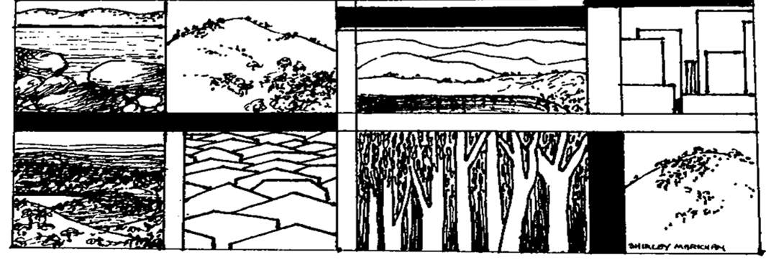

**The Yizraelite – No 2116 Date: 21.7.23**

**Kibbutz Yizrael**

**Edi-torial**

**Kibbutz Yizrael is in shock over the passing of our beloved Bernice Kaplan after her heroic battle against cancer. Our hearts go out to Milton and the entire Kaplan family. May you be comforted among the mourners of Zion.**

**From Reut Shaliv’s Editorial in “B’Yizrael”**

I wrote a few lines on Tuesday about the stormy days of demonstrations and the viewing of Channel 14 broadcasts compared to other channels. Then, when Wednesday morning came, everything faded into the background because of the grief over Bernice's passing. Bernice was our English teacher when we were children and to this day, I remember how she explained to us the difference between Play - to play and Play - to act, with the help of a story about her daughter, Cigal. On Saturday nights when we went out to protest, she came with Milton, and waved the flag, usually from the gravel strip next to the gas station. Next week we will publish the eulogies.

**Our home is in deep mourning with the passing**

**of our dear friend**

**the late Bernice Kaplan**

**Beit Yizrael**

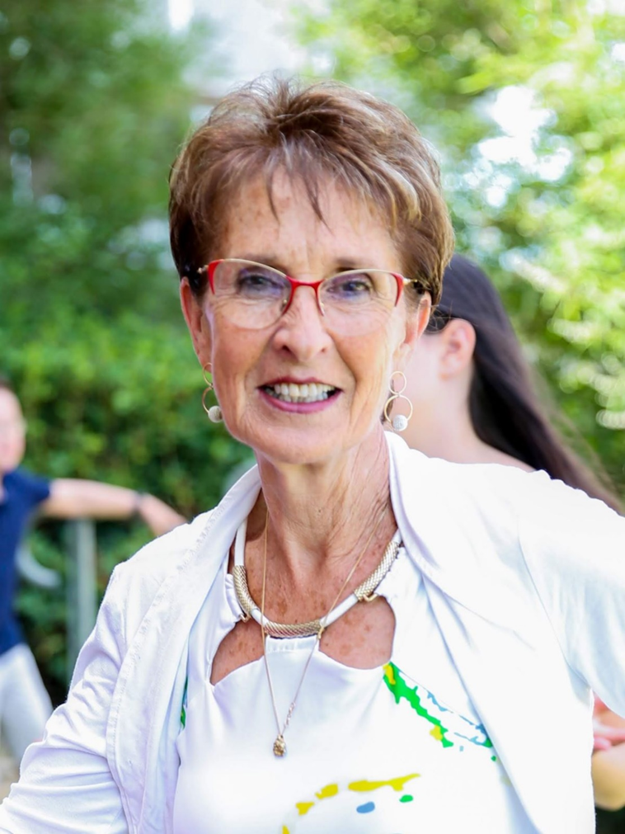

**We share in the grief of Yaniv Lifshitz and the family**

**on the tragic death of his nephew Rotem Zvi**

**May you know no more sorrow**

**Beit Yizrael**

We want to take this opportunity to thank everyone who visited, asked and helped us since word of the terrible disaster became known. We are blessed to have such friends and community.

May we only encounter happiness.

The Lifshitz family

**The Gym – The End - and Thank You.**

This week Eran Shkolnik cleared out the gym (with the help of several youngsters) for the purpose of renovating and expanding the zachat clubroom.

To Eran, at the conclusion of over 20 years of activity - a big thank you!!

It seems that almost all of us have worked out in your gym at some point, trying to improve our health and appearance...

Thank you for your persistence, for your desire to help, for investing effort in a place that was so dear to you and a part of the community for many years.

With thanks - from all of us

**Do You Need a Helping Hand?**

Do you need help with something small, not very urgent, that does not require a professional?

We can offer a helping hand...

We do non-professional jobs, such as:

* Help in loading/unloading objects from the attic

* Help in reaching objects that have fallen in an inaccessible place

* Help with the hanging of a picture

* Help with moving furniture

* Help with operating a smart TV

* Help with operating a mobile phone

*Help with various websites on the computer

**Please note** - the requests are not a call to a professional, but in cases where a little help is required, and you are embarrassed or reticent to ask ...

**What to do:**

You fill out the appropriate form on Kehilanet - and we will gladly come to help

For everyone, of any age in need of help with any issue.

If it seems that the request requires professionals – we will consider together with you, turning to the service branches.

Your call will go directly to Monica and Ruth Mor and we will update you as to who from the team, will arrive and when.

Thanks in advance,

“Lend a Hand” team

Ruth Mor: 052-3756077 / Monica Brustein: 052-3854938

**\* The team is recruiting volunteers. Please contact Ruth or Monica**

**(What a great service. Yizrael is a great kibbutz and getting better!**

Now my wife will only need me help her to fill out the request in Kehilanet – Ed)

**The Nominations Committee Recommends:**

• For the Head of the Young Generation Committee:

Ranit Levy

• Additional members for the Absorption Committee:

Eviatar Assaf, Joe Feldman, Nofar Brin Dolinko

**The nominations will be brought to the asefa on 24.7.23**

Staffing Committee - Nir Segal, Anat Friedman, Uri Brustein Ayalon, Albert Rosilio, Tzach Sassi, Liran Penn

**The Attention Revolution**

**The improvement of our relationship with the smartphone**

In his book "The Revolution of Attention" Dr. Micha Goodman wrote that in the last decade, our world has experienced two severe crises - the first is expressed as the increase in hatred and polarisation, the second is expressed as a leap in depression and anxiety data.

What do these two crises have in common - the political and the psychological?

Both are the result of a new and strange type of deficit that has been created in the world since the onset of the digital revolution, a deficit in the amount of people's attention. Our attention is stolen by the screens, controlled by giant corporations like Facebook, Google and Amazon, and sold for huge sums to advertisers. This is a new industry - an attention industry that employs thousands of programmers and engineers who develop algorithms, whose job it is to draw our attention and time from us. But there is hope, it can be dealt with!

How? Alone and together in an individual process and a community process. Through learning and understanding, through relating to the essential questions - should I limit myself, my children, my grandchildren’s screen time?

At what age is it appropriate to give a child a phone? When and where are you using screens?

To answer these questions, I propose to bring to the community a social process that includes a lecture and workshops, which will end with the formation of community agreements on this issue.

If you are also bothered by the increasing amount of your phone use, if you also feel that the phone controls you and not you, it. If you also worry about the consequences of phone use on your children - you will probably be interested in our "attention revolution" process.

On Sunday I will publish a survey in Kehilanet in order to test the degree of community interest and willingness to take part in this process. (Nonetheless, a survey on your smartphone screen? – Ed)

Limor Griman

**Changes to the Kibbutz Constitution**

At the end of three open discussions with attorney Omer Cohen, which were successful and interesting, the preparation of the draft stage for the updated statutes of Yizrael, was completed.

To the members who chose to come, took part, discussed, suggested and influenced - thank you!

The next step - bringing the regulations with the proposed adjustments to the asefa and after that - for approval by ballot.

Ballots to change the regulations require very broad participation, when the time comes, we will ask for the cooperation of the entire kibbutz, in order to complete the updated regulations for 2023.

All the best!

Jeremy and Yifat

**Management Committee Minutes 18/07/2023**

**Present:** Jeremy Perling, Ron Cohen, Avner Alterlevi, Sigal Hadar, Tzachi Tsfadiya, Adi Goldstein-Ilan, Natalie Zinenko, Yifat Assaf

**Agenda:** approval for the community management, audit committee and Yizrael Holdings to bring topics to the asefa.

We noticed a mistake in the approved organisational structure document, in which it was written that only the executive committee is authorised to bring issues to the asefa. Our practice is that the community management, audit and holdings committees also bring issues to the asefa. The committee was asked to formally confirm that the aforementioned bodies will also be able to bring issues to the asefa.

(Vote on WhatsApp – Ed).

**Decision:** Unanimously approved, to enable the community management, audit committee and holdings management to bring issues to the meeting (without going through the Management Committee – Ed).

Summarised by: Jeremy and Yifat

The amendment will be updated in the organisational structure.

**Economic Council - 10.7.2023**

Chairman of the Council: Uri Gilad

Secretary of the Council: Yifat Assaf

Present: 29 council members

On the agenda – investment budgets in the community

• Investment plan in the community according to 3 segments: consumer investments, infrastructure investments and investments in public buildings.

* Approval for 3 projects.

**Consumer Investments**

• Programme framework: NIS 394,000. The framework takes into account the deficit created last year as well as a conservative estimate of the income this year.

• Since there were investments beyond last year's budget, the opening balance of the fund was reduced accordingly. A discussion developed as to whether the investment framework in this area is annual or multi-year. But there was agreement that it is good to take a conservative approach this year.

**(NB. For detailed tables including the numbers see B’Yizrael – Ed)**

**• Decision:** to approve the consumer investment plan with a majority of 24 in favour and none against.

**Investments in Infrastructure**

Due to a burden of projects last year, the fund balance was reset and was over-extended. Since the infrastructure installation needs are always urgent, and projects cannot be stopped completely, the negative balance must be dealt with. The options are:

a. Taking an interest-bearing bank loan.

b. Taking a "cost" loan from another fund that has a positive balance.

c. Deficit management.

We chose the third option. A bank loan can be very expensive today, and the council advised to avoid it as much as possible. Internal loans between funds are a complicated practice prone to distortions and errors. That's why we prefer to manage the deficit: present it as it is, not charge interest on it, and try to close it over the course of several years. The expected deficit for the end of the year: NIS 1,460.000

• **Master plan for infrastructures** - we need to move forward with planning, even in stressful years. Execution without planning ends up costing us more.

**• Paths project in the center of the kibbutz** - the regional council approved a budget of NIS 300,000 for the project and will oversee it.

• Discussion on the financing methods. Members argued that interest should be imposed on the deficit, even if it is an internal loan between funds. On the other hand, it was argued that there is no point in punishing ourselves for carrying out actions above beyond the fund balance, for the benefit of the kibbutz members. By imposing internal interest, it then requires another fund to be credited, and this puts us in a conflict of interests, instead of caring for the benefit of the entire system. In any case, approval of a deficit in the fund is like imposing 0% interest on the fund.

• Members added that the maximum time for managing a deficit in the fund should be until the beginning of the next Fund key discussion, that is, by the end of 2024.

• In the past, the financial council approved taking loans for infrastructure projects, and we did the same in 2022 with the western road and road 1.

• In the coming year, we do not intend to take additional loans, but we must pay off existing loans.

• Added to the budget proposal:

• Repayment of an internal loan of NIS 400,000 to holdings for the construction of the northern industries road.

**• Purchase of a new generator to replace the damaged one**, costing NIS 210,000. We are currently renting a replacement generator at a cost of NIS 12,000 per week.

• **Proposed resolution:**

* Approval to carry out an investment plan from the infrastructure fund as presented, including NIS 400,000 repayment of a loan from holdings. The method of financing the deficit will be decided in consultation with the finance committee and the council will be updated by the end of July, including a project report. The aim is to close the deficit by the end of 2024.

Accepted by a majority of 28 in favour without opposition.

* **Approval of the purchase of a new generator in the amount of NIS 210,000.**

Accepted by a majority of 28 without opposition.

**Updates from the Absorption and Demographic and Youth Cluster**

**Absorption:**

• On July 24, the Vitelson family will arrive on Kibbutz - Jonathan, Gal, Michael (7), Abigail (3) and Libby (1). The family will begin an acclimatisation phase in preparation for the absorption process that will begin in the coming months.

“We are happy that you are joining Beit Yizrael and wish you a successful and pleasant acclimatisation. All the best”

• Later in the summer we will take in three more families – **Greenshpon**, Ya’ara (Havshush), Noam and their son Amit, **Broadhurst** Ben and Eden, and **Serano** Dekel and David and their 2 children.

• Yizrael families who are interested in becoming an "accompanying family" for the absorption period (two years) of the future families, are invited to contact Uri Gilad. We would be happy if you could help us in receiving the families in our home.

**Young generation:**

• Tomorrow, Saturday 22/7/23 at 8:00 p.m., there will be a meeting with the Dror group (12th graders) and their parents at the Brin-Dolinko family home. The meeting is the official acceptance of the group into the Younger Generation. The whole group has already received rooms in youth housing, some will live alone and some in pairs.

• On August 18, 2023, Friday afternoon, all members of the younger generation will go to the annual outing which will be held this time in Harduf. At the meeting we will welcome the Dror group, eat together, play a cool "Laser Tag" game and say goodbye to Noga, who is finishing her job as coordinator of the Young Generation Committee in October.

**Housing**

• We continue the renovations and the upgrading of the rooms. At this time, a general renovation is being carried out in two rooms in the youth housing in the eastern neighbourhood.

Much apartment moving is underway on all youth fronts.

**• N.B - On Sunday, 23/7/23 at 8:30 p.m.,** there will be an open meeting in the moadon about the new northern neighbourhood. In the meeting, the project will be presented by the director and the planning committee, and the registration phase for those who are eligible will begin. The public is welcome!

**Demographic growth:**

• We are in the process of building a new demographic plan for the coming years, we have already held several meetings on the subject. We went through the surveys done in the past in the kibbutz, surveyed the demographic situation as of today, talked about the goals of the programme, built and tested different models that take into account many aspects - housing, absorption, numbers of children, population distribution, etc.

We intend to continue deepening the construction of the models and at the end of the year, present to the asefa, the demographic plan for the kibbutz until the year 2030 at to receive approval to carry it out.

Summarised by: Ishai Levy

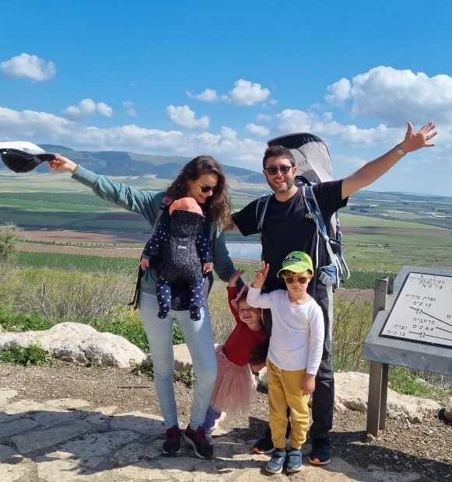

On July 24, the Vitelson family will arrive on the Kibbutz

**Summary of the Community Management Meeting - 9.7.2023**

**Present**: Erez Peleg, Maor Persai, Tamir Blas, Shlomo Levy, Kobi Levy, Limor Griman, Inbal Adler, Ilana Peleg, Ishai Levy, Yifat Assaf

Absent: Yifat Segal, Kinneret Govrin, Stas Gavrilov

1. **Consultation** (invited: Uri Gilad, Absorption Committee Coordinator)

Uri Gilad presented a request on behalf of the absorption committee, to return to the asefa with the section in the absorption procedure that was approved a week ago, which deals with the pre-absorption acclimatisation period (residency). In the approved procedure there is a section that allows the absorption committee to extend the acclimatisation period of candidates up to six months. This limit was added during the meeting with the consent of Uri Gilad and Ishai Levy, head of the Demographic Cluster. In a “think tank” that took place after the asefa, and in light of cases on hand, Ishai and Uri ask the community management to return this section to the asefa, with a recommendation to allow in special cases an acclimatisation period of over six months with the approval of the community management. Ishai and Uri's appeal was made within the time period in which the community management can stop an asefa decision, if new information is received. (There is no such time limit that I know of – Ed)

**It was decided unanimously: the clause will be brought back to the asefa.**

2. **Bringing members' parents to live on the kibbutz**

Background- Since the mid-sixties, bringing parents to live here has been carried out on Yizrael in a coordinated manner, according to an orderly procedure. The issue has been raised for discussion proactively, precisely during this period, when there are no vacant apartments, and bringing parents to the kibbutz has been at a standstill for several years. We find that it is time to examine the issue, and decide whether and how it is right for Yizrael to act today.

We want to stress that the discussion refers only the future. No decision will be applied retroactively.

In the past, when the kibbutz didn't have many elderly people, parents were allowed to come. It suited Yizrael at that time. Today the kibbutz is maturing, and there is a greater number of elderly members. Bringing more parents is a solution for their children, but in terms of the kibbutz as a whole, the question arises, is this right for us?

Various point were raised in the discussion:

- We allowed this in the past when the kibbutz was young and there was no senior age group...

- This is not a necessity, but a very great benefit, which applies to very few members.

- We must reserve the system for emergency situations only.

- Do not close the option. We should check demographically what our situation is, and accept parents, but for a realistic fee.

- The kibbutz can make excellent use of the apartments that will be shared with parents in the future.

- We are in the critical years when it comes to absorption. Except for the coming summer, several years without absorption are expected (because of the housing situation - Ed), so that any vacant apartment can provide a solution.

- This is about accepting adults. There are many veterans in the kibbutz, demographically it is more correct for us to add young people to the community.

- Maybe it is correct to reduce and limit the number of parents who can be here at any time, but it is important to keep the option open for emergency situations.

- Emergency apartments are not necessarily needed for parents.

It is wrong to give such a benefit to a limited number of members, and this is besides the fact that the large number of veterans will cause a burden on the system, interfering with absorption, etc.

- There are many aspects of parents living in a kibbutz. Bringing many additional parents could be a burden on the system. There is a difficulty with the size of the parents' apartments and suitability for housing a caregiver. The system provides a service to parents (even if for a fee). We treat a parent just like a member.

- Bringing parents to the kibbutz, gives a member peace of mind and that is worth a lot.

- There are 2 available two options: either clear criteria that will reduce the waiting list, or only an emergency feature.

- There are solutions in the kibbutz environment for those who want to be close to their children.

- There is no need for a public debate on this issue, it is not about the rights of kibbutz members. There is a procedure, it can be slightly updated if necessary.

- Until today, it was customary that the order of entry was according to first come first served, and you can enter the waiting list only after 10 years of membership in the kibbutz. In any case, if we continue to bring parents, it is necessary to change the method, and set criteria, for example - the distance required to travel to visit the parents, the health status of the parents, age, whether other parents from the same family are already here, etc.

- It is important that we determine the criteria today, and according to them we will update the existing list.

The community management invites the members to address the issue and respond to the things that came up in the discussion. A follow-up discussion will be held in mid-August, at the end of which a recommendation will be formulated for the asefa. The follow-up discussion will be open, and members will be able to come and voice their opinions.

Summarised by: Yifat Asaf

**From the Audit Committee**

**A number of points from the reports, the essence of which was presented at the asefa 10.7.23.**

Since the meeting devoted too little time to the subject of audit reports, several points from the summaries of the two reports are presented here. It is not possible to present all the points presented in the report summary.

**The auditor's note**: The data is taken by the auditor from the kibbutz accounts department, which is the source from which the auditor receives costing data. If a discrepancy is discovered, branch managers must take it up with the Accounts Department.

(In B’Yizrael, the report was reprinted together with the responses of the branch managers audited – Ed)

**The response of the asefa committee**

1. The time allocation for the discussion was done in advance with the auditor and with his consent. It is important to note that the reports were sent as background material and therefore only key points were presented at the meeting.

2. The auditor chose not to include the responses of the branch heads audited in the short report. We, the committee, should have noticed in advance and we will take this as an important lesson for next time.

3. Thanks to the audit committee that brought to the public the completion of the information that was missing.

**Conduct when Ordering Products and Booking Events from the Food Industry - 8.7.23.**

**The purpose of this document** is to regulate for members and residents of the kibbutz, committees and the various branches, the manner of ordering products/an event from the food branch,

**Ordering products**

Orders will be placed according to what is available at the time and in stock only.

In the case of a special order, at least two weeks’ notice is required in order to allow time for supplies to arrive.

Products can be ordered by paying the cost + 5% (handling fee) as practiced in the kibbutz (as of July 2023).

In case of additional work on the ordered products (for example - seasoning, cutting, etc.) an additional payment of 20% may be added.

The prices will be according to the last price as purchased by the food branch, plus VAT.

The ordered goods will be in their original complete packaging, except in cases where a proportional part of the ordered product is supplied, and in accordance with the discretion of the food branch.

The charge will be through the food branch and the kibbutz administration. A detailed account will be sent by internal mail in the kibbutz no later than one month after the actual delivery.

**Example:** A member ordered 30 chorizo sausages, and 2 kg of entrecote.

In this case the actual charge may be for 30 chorizo sausages and 3.7 kg of entrecote, depending on the size of the meat blocks available

**Order for an event**

The food branch caters committees and the various branches. small events, such as bar/bat mitzvahs, birthdays, commemorations, cultural events, etc., for the members of the kibbutz and its residents, committees and the various branches only, according to the availability and professional assessment of the branch.

Contact the food industry at least one month before the date of the requested event with initial details of the event:

Event date and time requested

Amount of people

Event location

After the initial contact, a meeting must be arranged with the operations manager/branch manager. The purpose of the meeting is to go over the details of the requested event, and to construct a menu according to the requirements of the client and the capabilities of the branch.

After the coordination meeting and building the menu, you will receive a quote from the food industry.

The pricing of the event will be calculated by considering the complexity of the event, the menu, additional manpower required to carrying out the work, energy (electricity), VAT, and the 5% operational fee as is customary in the kibbutz.

The quote and the complete order must be confirmed in writing no later than two weeks (14 calendar days) from the actual event date, and this in order to verify orders/supplies.

Changes to a confirmed order made less than two weeks before the event will be allowed according to the branch's discretion and according to the orders made.

The food branch will not use products that were not ordered through the branch, with the exception of products approved by the food branch and in accordance with the branch's discretion.

The food branch's responsibility is to deliver the food, in the branch's serving dishes/ or dishes from the kibbutz events storeroom, up to the door of the kitchen.

**Responsibility of the client:** coffee and tea station, dishes, table cloths, arranging the event area, transporting the food to the event area, actual serving, clearing up and cleaning, including washing the dishes and returning them to the appropriate place.

Use of food branch plates, cups, cutlery, etc will be allowed only with the approval of the managers of the branch.

It is the members’ responsibility to return to their rightful place, in the morning the day after the event, no later than 7:00 am, all the dishes and implements that were used, clean and intact.

Written by Adi Laviv, Director of Food Branch Operations, 18/07/2023

Confirmed by Itzik Shechter, Director of the Food Branch

The document was added by the food branch into the Kehilanet in the files folder

**Zimra’s Column**

A Barmitzvah party that wasn't...

When I read in the last bulletin (2115) with all the speeches I was moved. I tried to remember our Bar Mitzvah, at Beit Hashita, when we were in the 7th grade... I couldn't remember. I decided to call my classmate from Beit Hashita, Rachel Maroz, and I asked her if she remembered anything about the Bar Mitzvah, they did back then... She laughed and said to me: "Zimra, of course you don't remember, because we didn't have a celebration and we didn't have a party and we didn't have a Bar Mitzvah at all, because it was during the War of Liberation"! Although we both remember very well the Bar Mitzvah celebration of the senior class "Alon" group, above us - what a celebration they had! What fun everyone had... and we, the "Oren" group, knew that next year it would be our turn to celebrate. But they couldn't celebrate for us, because there were hardly any members in the kibbutz, everyone was drafted for all the missions and battles that were going on, our parents were also drafted... After all, there was a war, a war for the establishment of our state...

And here, on Yizrael, very close to my home, Beit Hashita, we are celebrating a bar mitzvah party for 19 boys and girls who have reached the mitzvah, happily, after completing all the tasks. Every year I am excited anew by the "Bar mitzvah year" events, always joyful, full of experiences, and at the end **- The Show!** which begins with the abundance of blessings from everyone - parents, leaders, teachers, members:

Warm greetings from me to all the Barmitzvah boys and girls,

Zimra

**New English books in the library**

Spare/Harry, Prince, Duke of Sussex

Old God's Time/Sebastian Barry

What We Owe/Golnaz Hashemzadeh Bonde

Miss Benson's Beetle/Rachel Joyce

The Yield/Tara June Winch

The Stationery Shop of Tehran/Marjan Kamali

The Seven Moons of Maali Almeida/Shehan Karunatilaka

I Have Some Questions for You/Rebecca Makkai

Hello Beautiful/Ann Napolitano

Revenge/Yoko Ogawa

Little Eyes/Samanta Schweblin

The Old Drift/Namwali Serpell

Reasons to be Cheerful/Nina Stibbe

My Name is Lucy Barton/Elizabeth Strout

Real Life/Brandon Taylor

Birnam Wood/Eleanor Catton

**Sportiyulim**

**Night swimming in Nahal HaKibbutzim**

**Friday, 4.8.23**

**Departure at 21:00**

**For ages 18+**

**(You can also go to the side of the stream)**

**Kibbutz Yizrael**

**75th Anniversary Weekend**

**Thursday 10.8.23**

**20:30**

**The play: “Negotiation”**

**Coffee and cake will be served after the performance**

**(No frills supper as usual in dining room)**

**Friday 11.8.23**

**19:00 – Festive dinner**

**20:30 Friday Night Moadon**

**Unveiling of the group historic photo**

**Plus, an exhibition of photos of our young people**

**A CAUTIONARY TALE.**

**Chas Broadhurst**

I have to start with a couple of truisms, you know, those things which are so self-evident that you don’t particularly think about them. Well, you should…

The first is that we are not as young as we used to be. Well, duh.

The second is that memory at our age can play sneaky little tricks.

Why are these things relevant? Well, a couple of months back, Neta my wife and I agreed to host a couple of travelers from England, friends of my brother. Their reputation preceded them – the previous year these two ladies, approaching seventy years of age, had effortlessly hiked the over 800 km of the Camino del Norte through the Basque country ending up in Santiago in just over 30 days.

Now they were coming to us on the kibbutz after wandering around the Galilee. What to offer them? Our own Za’adat Yizrael was about to take place, which is a nice gentle hike visiting archaeological ruins, Roman graves, ancient wine presses and down to Ma’ayan Yizrael, then back through the olive and almond groves to the kibbutz itself.

Around….eleven kilometers? Compared to 800 this appeared a bit silly, and, anyway, our official Za’ada would only take place a couple of days after they left. But the Gilboa walk…now that would be the kind of thing, they would be sure to appreciate….

At this point I refer you back to those two truisms. I’d done the Gilboa walk several times (yes, several times about twenty-odd years ago, my wife kindly reminded me) and I remembered it as starting at the top and walking vaguely horizontally and vaguely downwards until finally ending up, nicely tired, at Ma’ayan Harod. I mean, the paths are clearly marked anyway, so what could go wrong? As they write on current text messages – LOL.

So, we worked out a plan – Neta would drive us up to the highest point, drop us off, return to the kibbutz and then come and pick us up at the bottom a few hours later. Kaleh-kalut. (easy peasy)

And it was kaleh-kalut to begin with. There were small groups of people around, suitably attired in boots and backpacks, some singing those merry little hiking songs – and there were the trail marks, nicely set out in red and white. Off we set, a pleasant day not too hot, and the trail was the gentle downward slope I (thought I) remembered. We exchanged greetings with other hikers we came across. On the way down, occasionally other paths crossed ours, but I was confident, and we doggedly stuck to our red and white markers.

At some point, elements of disquiet began to make themselves known. The path was steeper than I remembered. And narrower. And there were far fewer people around. And then even steeper and there were no other people around. But there was one other animal. A huge bull with enormous horns stood defiantly in our path. I think he was as surprised to see us as we were to see him because after a few moments he turned round and thankfully strolled off, shaking his head – in retrospect I think he was shaking his head at my stupidity.

On we went, at some points having to climb down iron rungs fastened into the hillside. We seemed to be in some sort of crevice in the hillside.

My phone rang. “Where are you?” “On the mountain.” “Where exactly?” “I can’t see any street names, we’re on the mountain.” “Well which Yishuv can you see from there?” “Um, Tel Yosef.” “You’re not going very quickly, are you?” “We’re taking in the scenery. Call again in about 20 minutes.”

Twenty minutes later, ring ring. “Where are you?” “On the mountain” “Opposite which yishuv?” “Um, Tel Yosef.”

Twenty minutes after that, same thing. “You’re lost,” says my wife. “Maybe,” I reply.

But we can’t go back. I mean, back to where? In retrospect (yes, I’m still alive) we should have started off on the red and white trail, but then later turned off onto, I don’t know, a green and yellow track?

But the track we were on was clearly marked so onwards we descended – all descent, no lateral movement. It was by now over fifty percent iron rungs hammered into the rock-face.

Then I slipped.

Somehow, I reacted instinctively by throwing my hand out and grasping hold of a jutting rock. My feet found solid ground again and the ladies rushed to my aid. Anita and Pamela. Anita (henceforth to be known as ‘The Goddess Anita’) is a retired nurse and she surveyed the damage – a bloody hand and a scraped shin. We found a relatively stable place and she sat me down and tended to my hand. She poured clean drinking water over it, made a pad from the tissues we had and then innovatively took the plastic bag I’d had some sandwiches in, made a few holes in it and used it as a kind of glove with only my fingers exposed. Genius. I really needed that hand as most of our journey now involved descending metal ladders.

A thought flashed through my head – what if I was completely disabled at this point? No easy way up, no easy way down. A helicopter? Oh, the shame of it, I’d never live it down, going out for a morning stroll and needing a helicopter….

Ring-ring. ” Where are you….” etc…

Well, we made it to the bottom, one lady in front of me and one behind. Yes! But where, exactly? We’d come down at the edge of a field, no road, just a track. Where do we go from here? Just then, a young couple bounced by, energised by their stroll down the mountain (I hate them) and told us we would have to go around the field to the old Tel Yosef over there in the distance. So off we went again, me limping terribly but my two companions seemingly enjoying every moment. We eventually made it to the old Tel and I took a picture and sent it as a WhatsApp to Neta. Finally, a recognisable place. I sat down on a bench while the ladies sprinted (!) off to explore the Tel. About three-quarters of an hour later Neta came to pick us up. It turns out the only way she could get to us, involved driving via Keleh Shatta (the prison) and twisting back on her route around various reservoirs and fishponds. I still remember the quite unnecessary tutting and shaking of her head.

Anyway, at lunch in the dining room the next day, Eddie, the organiser of our kibbutz za’ada came up and asked if we’d enjoyed the kibbutz walk. He seemed disappointed when I told him we’d walked the Gilboa instead. I told him it was not as I remembered.

“Which route did you take?”

I told him the usual one with the red and white markers.

“What?!??!...”

**Dear readers. Please note that I (Eddie) translated this story from the original English to Hebrew. In order to maintain Chas’s special brand of humour, I was forced to make changes. I recommend you read the Hebrew version in B’Yizrael if you can – Ed**

**Thanks to Chas. I am so glad he lived to tell the tale**

**English is Fun - with Rahel**

**Subject: WORDS OF JEWISH ORIGIN**

A fascinating list of words that you probably didn’t know have Jewish linguistic origins;

**JUBILEE** comes from the Hebrew word *yovel*, an occurrence once every 50 years, when all debts were erased and indentured servants were freed.

**SHMOOZE** has Hebrew origins. *Shmu’ot* means ‘rumours’ in Hebrew. Yiddish speakers called idle chat *shmu’es;* from there, the word evolved into *shmuesn,* meaning to chat, and entered English as *schmooze,* meaning have a nice, cozy conversation.

**CIDER** comes from the Hebrew word for drink, *shaker.* It was translated into Greek as *sikera,* and migrated into Latin as *sicera.* In the Middle Ages, French adopted the word as *cidre,* and it began to refer exclusively to strong drinks made from fermented fruit, particularly apples.

**LOX** migrated into English from Yiddish; Germanic speakers throughout Central Europe referred to salmon as *lox, lachs,* or variations of the word and early Yiddish speakers adopted the term as well.

**BEELZEBUB** is a Christian term for a malevolent being and comes from the Hebrew *ba’al* (lord) *zevuvim* (flies), the implication being that a “Lord of the Flies” would somehow be drawn to death and decay, which also attracts flies.

**BEDLAM** was originally the nickname of England’s first mental asylum. It was formally called the Bethlem Royal Hospital. Like many old hospitals, Bethlem began as a religious order; it was founded in the 13th century as a priory, dedicated to St Mary of Bethlehem.

And Bethlem was corrupted to *bedlam.* Bethlehem, which literally means House (bet) of Bread (*lechem*) in Hebrew, is a town to Jerusalem’s south. It is first mentioned in the Torah, in Genesis, where Rachel is buried. Thousands upon thousands of people visit the Tomb of Rachel in Bethlehem today to pour out their hearts in prayer.

The Torah instructs us to be scrupulously honest when it comes to our weights and measures. Here are a few English terms that are derived from Jewish words.

**IOTA** comes from the Hebrew letter *yud,* which is the smallest of the Hebrew letters. Iota was the Ancient Greek form of the *yud*, and soon became synonymous with anything tiny.

**JOT** also derived from the Hebrew letter *yud,* and was the Medieval Latin form of translating the letter. As with iota, *jot* soon became a way to refer to anything very small.

**SABBATICAL** derived from the Hebrew word *Shabbat* (Sabbath in English), the seventh day each week when we recall God’s rest on the seventh day of the Creation by ceasing to perform ordinary, weekday labour.

………………..more next week

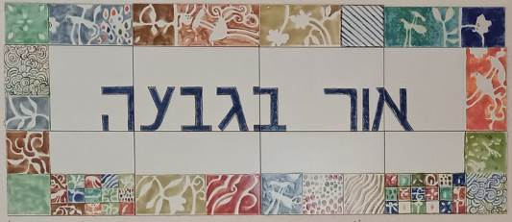

**Programme for 23.7.23 – 27.6.23**

**Daily 08:30 – 12:00 – coffee, cake, chats, board games**

**Sunday 23/7**

Opening the week - baking with Monica.

07:00 Feldenkrais with Ilana Lahav (BAO)

09:30 – Armchair discussion – The Sistine Chapel – Efi Ziv and The Cherry Garden by Chekhov – Dr Asher Yoshva

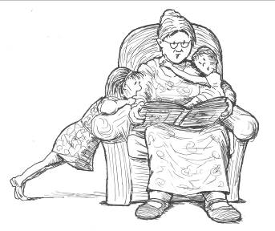**Monday 24/7**

08:30 Pedicure with Limor Mualem (BAO)

10:00 Trivia and thinking games with Rochele Matalon

16:00 Open for coffee, cake, chats

**Tuesday 25/7**

10:00 Movie – “Blaumilch Canal” – Galia Shemi

16:00 – 17:45 Ceramics room is open under instruction from Miki Touz

**Wednesday 26/7**

09:30 Handicrafts and games with Rachel Grossman

17:00 Tai-chi (advanced) with Einan Grosser

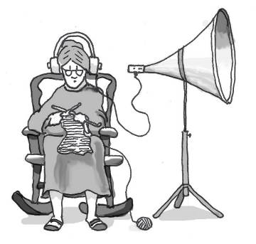**Thursday 27/7**

07:00 Pedicure with Na’ama Baum (BAO)

09:30 Dorit Fink – “Malapropisms”

17:15 Exercises on chairs with Michal Sha’anan

Translated and edited by Eddie Solow

Proof Read: Biff Markham Oren

Printed by Irit Cohen and Hedva Sharabani