**The Yizraelite - No 2079 Date: 4.12.2022**

**Kibbutz Yizrael**

**Translated and edited by Eddie Solow**

**Edi-torial.** This is an historical week, whatever your point of view. No one will forget this week for a long while. Zimra has called on a literary Nobel Prize winner to give us strength. I did my best to translate the text. If I erred in my interpretation of the text, please forgive me.

Fortunately, the Alon was short this week. I used the free space to print my memorial address in memory of Arnie and Peggy. In addition to all Arnie's other community activities, Arnie ensured that the English newsletter came out each week so I think it fitting that I should use these pages to remember them.

Have a good week and remember… everything is for the best!

P.S.

If you are on the list and do not receive your hard copy, please let me know, and I will get you one…Mistakes happen.

If you want a hard copy but are not on the list, let me know and I will add your name.

If you would like your name removed from the hard copy list, let me know too.

**Update from the Young Generation Committee**

As we always say - there are a lot of updates about the young generation!!!

So, this time...

Warm congratulations to Ofri Sharoni, who enlisted on 19/10/22. Ofri is in the final stages of her basic training. She will soon start a training course as an "Operations NCO " – קורס סמב"ציות

We wish Ofri an interesting and easy service!

Warm congratulations to Mai Savir who enlisted on 20/10/22. Mai is currently doing basic training and will later start a course as a radio operator or in the cyber field.

We wish Mai an easy and meaningful service!!!

Warm congratulations also go to Roi Mizrahi who enlisted on 4/9/22. Roi is doing a 'Soldier’s Teaching' course. Roi finishes the course on 09/10/22.

Kudos to Roy for his contribution as an instructor and teacher!!!

Mika Cohen started diploma studies last week

May everyone always be interested and enriched - take care of yourselves! We are awaiting your return to the kibbutz!

**דברי חכמים – שי אגנון**

"חכמים מושכים ידיהם מהנהגת העולם מפני שהם יודעים שיש חכמים מהם, ורוצים שיתהג העולם על-ידי חכמים גמורים. בתוך כך קופצים הטיפשים והרשעים ובאים ונוטלים את העולם לידיהם, ומנהגים את העולם כפי זדונם וטיפשותם.

מעתה, היאך נותנים החכמים לעולם שיאבד על ידי השוטים והרשעים? אלא מתוך שהחכמים חכמים, ומוסיפים חכמה. כל שנראה להם אתמול כחכמה שְׁלֵמָה, רואים אותו היום שאינו חכמה, ואינם עומדים על דעתם ואינם תובעים לעצמם שום דבר, מפני החכמה שמוליכה את החכמים מעלה מעלה.

לא כן הטיפשים, כל דבר שנתנו בו עיניהם, הרי הם מחזיקים בו ואינם מניחים ממנו, שאם יניחו ידיהם ממנו, אין להם מה שיעשו בעולם. לפיכך כל ימיהם תחבולות, ובלבד שיחזיקו את העולם בידיהם".

מתוך: "ספר המדינה", ש"י עגנון (1887 – 1970) זוכה פרס נובל לספרות 1966

**Wise words – Shai Agnon**

"Sages withdraw their hands from the leadership of the world because they know that there are wiser men than them and want the world to be ruled by complete sages. In the meantime, the foolish and the wicked jump in and come and take the world into their hands and rule the world according to their malice and stupidity.

From now on, how will the wise allow the world to be lost by the fools and the wicked? But since the wise are wise, they add to their wisdom. Everything that seemed to them yesterday to be complete wisdom, today they see as not being wisdom. They do not stand by their opinion and do not demand anything for themselves. Because of their wisdom the wise rise ever upwards to a higher standing.

Not so the fools, everything they set their eyes on, they hold on to and do not let go. For if they release their hold, they have nothing in this world. Therefore, all their days they scheme and deceive, in order to keep the world in their grip.”

From: "The Book of the State", Shai Agnon 1887 – 1970 - Nobel Prize Winner for Literature 1966

(Note. I have done my best to translate the text. Please forgive me if I erred in my interpretation – Ed)

**From the Education Council**

At the end of October, the first Education Council meeting for the year תשפ"ג (2022-2023) was held. The following issues were discussed:

(1) Introduction to the education system:

The director of the preschool system, Yael Oster, presented the preschool system to the council members.

About 80 children are currently being educated in the system in five age levels. About half of the children are from outside the kibbutz.

This year, the system underwent changes – there are two new leading mitaplot in Gan Alon and the Baby House. The main challenge facing us, is the stabilisation of manpower.

Yael presented the annual work plan, which includes training the teams to deal with difficulties and frustration in a congenial manner, a process that began immediately after the holidays and will continue into the year. (And forever more – Ed)

Adi Goldstein Ilan presented the informal education system: this year the system returned to the structure of two children’s houses ( Grades 1,2,3 Grades 4,5,6) and two youth centers - Zachat and Chevra Bogeret. There are 65 youths in the Chevra Bogeret and the Zachat has 70 youths.

This year the team is receiving guidance from an external professional. Main goals for this year are the building self-leadership and contribution to the society.

(2) Discussion of a new protocol (Nohal) - educational support for 1st-12th graders:

The purpose of the protocol is to regulate an area that has so far been neglected. In the past, anyone who needed extra help with lessons, brought a letter from the teacher and received a full refund for all lessons. Often the parents were not even involved.

The education system was in practice only a financing conduit. We would like to change this situation by introducing order, control and monitoring.

Avishag Sharoni is the "Child Care and Counseling Coordinator" It is appropriate that she will coordinate the “extra lessons” in order to provide more comprehensive, professional and accurate services for each child.

(3) "Brain storming" topics for discussion in the education council meetings this year:

A brainstorming session was held regarding topics that the council members are interested in dealing with this year. After weighing up all the aspects, the topics that will be discussed at the Education Council meetings were selected (in order of priority)

A) The location of the ZAHAT building + social education buildings in general

b) The human resources of the education systems on Yizrael

c) Rediscussing of the implementation of the camera law in the pre-school children's houses.

d) Rooms in the Chevra Bogeret

e) The continuum between parental responsibility and the education system's responsibility for the behaviour of children and youth.

f) The leadership of the Bar mitzvah year.

(4) The composition of the Education council:

As the result of a discussion, we found it appropriate that Avishag Sharoni, (childcare and counseling coordinator), who is a member of the Education Forum, should be a member of the Education Council.

However, this means increasing the number of officials in the council (to five in number), while the public representatives remain four. This mix is ​​not balanced, so we are asking to increase the number of public representatives to five.

In checking the definitions of the organisational structure, it was found that the decision requires the approval of the community management and will be submitted for approval at the next meeting.

Additional changes regarding public representatives:

Hamutal Ben-Amati Assaf – requested to terminate her term of office so that there will no longer be 3 members of the same family on the council.

Limor Griman, who was a public representative, was chosen as the head of the cluster

Amir Armoza - asked to stand down, and so too did Noga Harpaz.

Considering all this, we applied to the Positions Staffing Committee with a request to find five new public representatives for the council.

 We thank Hamutal, Amir and Noga for the last two years of membership in the Education Council, and for years of community work, and in the field of education in general. Thank you for the enriching insights and long-term perspectives, for diverse angles, for valuable observation and constructive thinking.

Limor Griman, Director of Education Cluster

**The Gates of Mercy**

Please note: I have no complaint about any of the members of Yizrael or those working in the field on our behalf. This is a call to action for all of us.

I realise that this headline may be seen as an exaggeration, but there is hardly a day that the issue of regulating the (dangers of) the entrance junction to the kibbutz near the Alon gas station does not come up in some conversation around the kibbutz.

We have heard much about the various promises that those concerned received from the regional council officials and others regarding the future improvement of the situation. We are also aware that in the (distant) future a large interchange will be built at the nearest traffic light, but...

There are situations where everyone understands that good-will is not enough and explanations regarding "order of priorities" or "soon we will improve the situation a little and, in the distant future, a comprehensive solution will come" is not acceptable. The disaster, unfortunately, is right at our doorstep, so all the residents of Yizrael and its many employees, as well as the customers of the gas station, must start to exert pressure to demand correction of the situation.

Hanan Shaliv (We have been warned – Ed)

**Asefa and Economic Council**

On Monday, 7.11.2022

at 20:30 / in the Moadon

Asefa (also on channel 900)

1. Elections: Staffing of positions - Security Committee (Brent: coordinator, elected) Lilach Ron, Ehud Cohen, Dotan Savir, Alon Reuven (Rabash)

(2) The establishment of Agshah - "Management of Agshahim" under Yizrael holdings

**Economic Council**:

Directly after the Assepha

Agriculture debt settlement

**Winter Rain Data 2022 - 2023 - Wednesday, 2/11/2022**

**In the last period (48 hours): 2 mm**

**Rainfall from the beginning of November 2022: 2 mm**

**Rainfall from the beginning of the season: 20 mm**

**Multi-year average, to date: 20 mm**

**Change compared to yearly average to date: +1%**

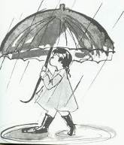

**Rainfall Table 2022-2023**

|  |  |  |  |  |  |  |  |  |  |
| --- | --- | --- | --- | --- | --- | --- | --- | --- | --- |
| Month | Sep | Oct | Nov | Dec | Jan | Feb | March | Apr | May |
| Total | 0 | 18 | 2 |  |  |  |  |  |  |
| Average | 0.38 | 16 | 51 | 99 | 111 | 80 | 52 | 19 | 5 |

Daniel Rosenfeld – Agriculture Manager

**"There's a Pile of Guys on the Grass"**

The beginning of the 2022-23 season - what's happening in rugby?...

The 2022-23 season started last month and rugby, after 2 stuttering seasons (corona for those who forgot... (because of memory loss induced by corona – Ed?) is back in full force - the senior league opened a week ago, our senior team (champions of the last 3 years), started the season with a home game against the " Hadarim" from Tel-Mond.

Due to a lack of players (injuries, overseas etc), a number of players under the age of 18 got to play in the league team for the first time - Eilam Mor, Ya’akov Emerick, Eitan Mizrahi and Yuri Olynik, as well as 5 soldiers who were released from the IDF and returned to play this summer.

The game was strong and tight in the first half, when Yizrael took the lead with a try by Aaron Emerick. "Hadar" returned with a try of their own and Yizrael returned to the lead with 2 more trys (Yuri and Aaron); Before the halftime whistle, "Hadar" made another try and the halftime score was 15-14 to Yizrael.

The second half was a completely different story, the champion players (Us! – Ed) took over the game and scored 7 more trys (Aaron with his third, Leo Holtz, Ma'ayan Levinson, Shai HaCohen, and 2 by Yiftah Engel). Together with 5 successful conversion kicks by Ma’ayan Levinson, the final score was 62-14.

A week later, the seniors went to an away-game in Ashkelon, against the Ashkelon-Jerusalem team. The young players continued to play and lead the team.

9 freshmen brought forth the victory 45-15 and gave us the first place in the table after 2 rounds. Gilad Vardi's 4 trys in the game placed him in first place in the try table, followed by Adrian Reinstein with 3. (Aaron Emerick also has 3 from last week, this week he did not play because of the IDF), another try by Yuri Olynik and one by Yahel Rosilio opened the game and gave Yizrael an easy victory on a hard field (synthetic, small, without lines...). (Good play on words **Amir Beutler**... "easy victory", "hard field"... Get it? – Ed)

The third round will bring together Yizrael and Ra'anana, currently in second place in the league table, for a match for first place in the table. The match will be held on Yizrael on 19.11.2022.

In the children's and youth section, all the teams (from kindergarten to 18) have started training and we see an awakening and return of players to the club. Much effort was invested in the schools (coaches in 10 permanent schools!). This is starting to show results and new players are joining the club, strengthening the teams and the rugby playing community is growing.

**Shabbat 5/11/22**

**The first youth tournament of the season, which will be held on our home field**

**from 10:00 to 14:00**

**This is an opportunity to see the future generation of the club and of Israeli rugby - everyone is welcome!**

In the international arena - the Israeli national team will start its’ games this coming Saturday in an away game against Bulgaria. Next Saturday the team will play against Cyprus in Cyprus.

We have about 10 players In the Israeli national team, including the captain Adrian Reinstein, Yahel Rosilio, Yotam Shulman, Omer Levinson, Yiftach Engel and Uri Abutbul. We wish success to our players and of course to the assistant coach - Nimrod Kaplan and the physio Alita Moore.

Also, at the international level - "Tel Aviv Heat" (or is it Hit – Ed), the first professional rugby team in Israel, which plays in the European Super Cup, played 3 games in Israel in the last month and won all three - two teams from Georgia and one from Romania. The victories ensured the team second place at home and a place in the semi-finals to be held in early December in Portugal.

8 players from our club train and play in the team and 5 of them even played and started in some of the games. We, at the club, are very proud of our players who came up from the youth teams and after hard work and many obstacles, were chosen for the squad and play at a very high level. Keep it up, you are leading the club and rugby in Israel, keep working hard and continue smashing glass ceilings!

That's it for now, have a successful season. See you at the most beautiful field in Israel!!! (In all the world - Ed)

Amir Beutler

**Education, Sports, Rugby – Idan Zelas**

In the final analysis, the rugby club is an educational enterprise. Physical education, sports education, team and competitive sports. 90% of the rugby club's activities are aimed at the younger ages and deal primarily with education.

So, with a hand on my heart, what excites me the most, is a rugby tournament for children and youth on Yizrael. More exciting than winning the championship or the state cup, more exciting than watching the Israeli national team.

In a youth tournament you can see the development of each player and team. Physical development, emotional development, personal and group development. Preparing for adulthood.

Children, who just a short while ago, arrived scared, for their first rugby practice - fall and get up, and find their place on the field. Little by little the fear is replaced by courage, trust in the team mates, strengthening each other, winning with respect, losing with honour, shaking hands. Sum up the game and get ready for the next time.

The parents, in the stands, are a mirror image of their children on the field. The parents, new to the field of rugby - worried, cringing at the sight of a tackle on their son, sharing their son's disappointment when he bows his head. Then their chests swell with pride as their son gains confidence, runs, passes, scores trys, encourages his teammates. At the end of the game, they cheer for the team, clap their hands (and breathe a sigh of relief).

And at the end, after the final whistle is blown, the whole group sits together, eats a hamburger, shares experiences, smiles and laughs. The children will have lifetime memories of these Saturdays and experiences.

20 children from the kibbutz are currently training at the rugby club. Come and cheer them on Saturday and get excited with us!

Idan Zelas

**From the Nominations Committee – Nir Segal**

Position staffing committee following its meeting from October 20, 2022

➢ Coordinator of the Education Committee (Merakez) - Peter Pezaro ends his term in office soon. We thank Peter Pizarro at the end of his term and appeal to the public to suggest names for the position.

➢ Coordinator of the Vehicle Committee - Dotan Savir has completed his term of office. We thank Dotan and are looking for another coordinator for the vehicle committee.

➢ Members of the audit committee - Dima Tchernikovsky and Milton Kaplan finish their duties in the audit committee. We thank them both. Reut Shaliv continues to lead the committee and we are looking for 2 more members.

Please Note! The members of the committee cannot be spouses of a member of the executive board, or of authorised signatories in the kibbutz.

➢ Public representatives for the education cluster - until now the public representatives have been: Limor Griman, Hammutal Assaf, Amir Armoza and Noga Harpaz. We thank them for their contribution. Although the term has not yet ended, most of them need or want to finish now. Limor was elected as the head of the cluster, Hammutal requests to terminate due to Avishag Sharoni joining the committee, Amir requests to finish, Noga continues until the end of the term.

Therefore, we are seeking to fill the ranks, as well as add a public representative - because the addition of Avishag as a position holder creates a majority of position holders in the Education Council, and the mix of position holders and public representatives should be balanced - therefore, we are looking for 5 public representatives for the Education Council.

You are invited to nominate yourself (or others - with their approval).

**➢ Chairman of the Economic Council** - following Anna Abramovich's announcement that she wishes to end her position as chairman of the Economic Council, we are looking for someone else for this position, alongside Sigal Hadar. Thanks to Anna for the time, she served in the position.

➢ Responsibility for driver's licenses - Tsofnat Mor requested to end her position as the coordinator of the driver's licenses field. We thank her and are looking for someone willing to take on this role.

Regarding all the positions offered - a member can nominate himself, or nominate another member, with his approval.

Job definitions for all positions can be obtained from Racheli Arava, Human Resources.

**Yitzhak Rabin will be Commemorated in the Fortification of Democracy - Salam Jubran**

The first lesson we learn - the real lesson, from the tragedy of Rabin's murder is that democracy does not live and survive on its own, but must be protected, fortified, and enriched all the time...

The second lesson - to return democracy to its roots, when the individual, the person, is at the centre of the state and the state must serve the individual and ensure his freedom and advancement. Fanaticism of every kind, creates fanatical self-emphasis and hatred for the other, for he who is different, and rejects the very fact that difference exists, is cancer!!

The third lesson - which we all must internalise, Jews and Arabs alike, is the right attitude towards religion. Religion, any religion, is heritage and culture in addition to being a standingn in relation to the creation of the world. All of us, religious and secular, must prevent the use of religion for racist extremist purposes.

The fourth lesson - which we must all internalise is the fact that democratic values ​​are one package, and it cannot be divided. It includes the sanctity of human life, and the right of the human being to freedom and progress, his right to freedom of belief, independent personality, national culture, language, and religious belief, all on the basis of human partnership in general.

Tolerance is the thread that must connect all our beliefs and be a bridge between us and others. Here, the true honour to Yitzhak Rabin and his memory will be in the defense of the democratic regime and its strengthening, in the continuation of making peace between Israel and the Palestinian people and all Arab peoples and in building a framework of thinking and a behaviour of respect and partnership among all sections of the population in Israeli society.

❖ Salam Jubran Peki'in, 1941 -18.12.2011, Nazareth) was an Arab-Israeli poet, writer, journalist and educator.

**A Cinderella story**

**Friday 4.11.2022 – 20:00**

**Sharon Davidowitz**

**A talk on "The love of sport".**

**Stories that will touch you and teach you**

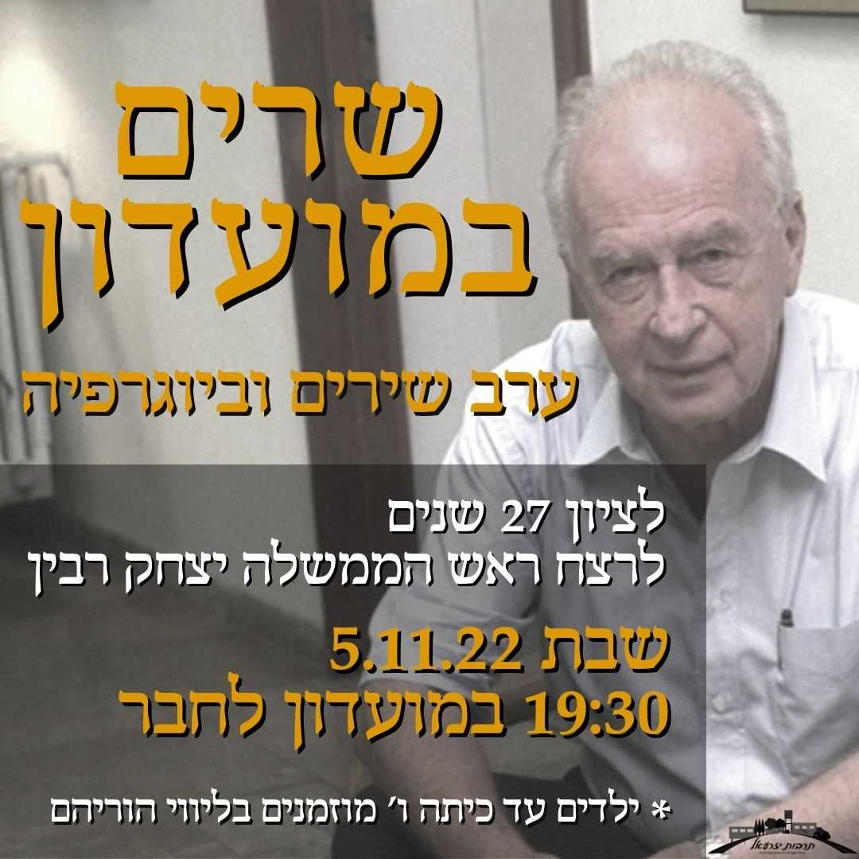

**Yizchak Rabin RIP**

**Stories & Songs in the Moadon**

**To mark 27 years since the assassination**

**Sat 5.11.22**

(Attendance of children under 5th grade with parents)

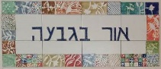

**BEACON ON THE HILL – 6.11.22 – 10.11.22**

|  |  |
| --- | --- |
| **SUN**  **6.11** | Baking with Monica  Feldenkrais with Ilana (BAO)  09:10 Zoom around the world – Galia |
| **Mon**  **7.11** | 9:00 Coffee, cake, chats, and games  9:30 Art Appreciation with Chas  8:30 Limor Mualem – pedicure (BAO)  16:00 – 18:00 Coffee, cakes, chats and games |
| **Tue**  **8.11** | 9:00 Board Games  10:00 Trivia with Galia  9:00 Helen Rosenberg – facial (BAO)  16:00 – 17:45 Ceramics with Miki Touz  17:00 Exercises with Irit Bahir |
| **Wed**  **9.11** | 9:00 Games  9:30 Blooming Nature with Hamutal  12:00 Pedicure with Na’ama Baum (BAO)  17:00 Tai Chi with Einan Grosser  16:00 – 17:45 Ceramics with Ziv Ben Bassat |
| **Thursday 10.11** | 9:00 Coffee, cake, chats, and games  9:00 – 12:00 Ceramics with Ziv Ben Bassat  Movie – "The Reader" with Galia **(Ed's recommendation**)  7:00 Pedicure with Naama Baum  17:15 Exercise on chairs with Michal Shaanan |

**English is Fun - with Rahel**

Only for my very smart friends and relatives:

Keep that brain working and see if you can figure out what these seven words all have in common.

1. Banana
2. Dresser
3. Grammar
4. Potato
5. Revive
6. Uneven
7. Assess

Look at each word carefully. You’ll kick yourself when you discover the answer.

Answer: NEXT WEEK’S EDITION

(If you discover the answer, let me know.)

Subject: English language

The European Commission has just announced an agreement whereby English will be the official language of the European Union rather than German, which was the other possibility.

As part of the negotiations, the British Government conceded that English spelling had some room for improvement and has accepted a 5-year phase-in plan that would become known as “Euro-English”.

In the first year, “s” will replace the soft “c”. Sertainly, this will make the sivil servants jump for joy. The hard “c” will be dropped in favour of “k”. This should klear up konfusion, and keyboards kan have one less letter.

There will be growing public enthusiasm in the sekond year when the troublesome “ph” will be replaced with “f”. This will make words like fotograph 20% shorter. In the third year, public akseptanse of the new spelling kan be expected to reach the stage where more komplikated changes are possible.

Governments will encourage the removal of double leters which have always been a deterent to akurate speling.

Also, al wil agre that the horibl mes of the silent “e” in the language is disgrasful and it should go away. By the fourth yer people wi be reseptiv to steps such as replasing “th” with “z” and “w” with “v”.

During ze fifz yer, ze unesesary “o” kan be droped from vords containing “ou” and after ze fifz yer, v vil hav a real sensib riten styl. Zer vil be no mor trubl or difikultis and evrivun vil find it ezi tu understand each oza. Ze drem of a United Europ vil finali kum tru.

UND EFTER ZE FIFZ YER, VE VIL AL BE SPEKING GERMAN LIKE ZEY VUNTED IN ZE FORST PLAS.

***GO GREEN: RECYCLE USELESS POLITICIANS!***

…………. more next week

**Forward. Last Friday was the annual Memorial Service for Dudi**

**and Neil. I was asked to say a few words in memory of Arnie and Peggy. Arnie was the driving force behind the event all these years and it was fitting that he and Peggy should be remembered at this year's ceremony – Eddie Solow (Eddie-tor)**

**FOR ARNIE -**   
(04/02/1934 - 20/02/2022)

**21.10.2022**

That fact that we are sitting in this place today is very much thanks to the tireless devotion of Arnie, who year after year ensured that we would come together to remember our dear friends Neil and Dudi. It is only fitting that we devote a few minutes to honour the memory of Arnie and his beloved wife Peggy who passed away so recently.

Arnie Friedman, the son of Esther and Jack Friedman was born in Johannesburg, South Africa on February 4, 1934, a younger brother to Rita, who was born eight years before him. It was the time of the Great Depression, and they lived very modestly. Before World War II, they joined their extended family in Capetown, where Arnie grew up and went to school.

In his youth Arnie played the piano and after several years he switched to playing the accordion. The love of music would accompany him all his life.

At the age of 11, Arnie joined the "Habonim", a love story that continued until the last few years when his health failed.

Arnie was the ultimate example of what a member of Habonim in those days, should be. Before signing the Chalutz Register he worked for three years, saving up till he could come on Machon Hachoref and see for himself. On his return, he signed the Chalutz Register, joined Garin Gimel, went on Hachshara and prepared for his aliya to kibbutz. Arnie even studied brick-laying, in preparation for nation building. (He testifies in his book that he had no idea that nobody builds with face bricks over here! (Where were the shlichim, I wonder?)

All Arnie's aliya plans changed when Shimon Peres, then head of the manpower dept in the Ministry of Defense called on the youth of the diaspora to drop everything, immediately come on Aliya and join the Israeli Army. Arnie did not hesitate... He dropped everything, came and joined the Israeli army.

After the army, Arnie's Garin were on kibbutz Ginnegar for (another!) Hachshara. (With all that Hachshara, no wonder Arnie lasted so long on the kibbutz)

At this time all the Anglo-Saxon kibbutzim fought to get the garin. The only kibbutz that couldn't give a damn, was Yizrael. So, the Garin decided to come here (Dafka?)

The Garin arrived on Yizrael right before the kibbutz's decade celebrations, and Arnie was immediately recruited into the organisation and performances. All through the years, Arnie was a cornerstone of kibbutz tarbut

In his haste to join the army, Arnie seemingly forgot Peggy at home. But not for long…

in 1956 Arnie returned to south Africa for Peggy. The couple married and set sail from Capetown to England, and after a honeymoon in Europe, arrived by ship to Haifa. There they were met by Benny and Miki Touz.

I know Arnie would not forgive me If I omitted to relate the story of their arrival on the Kibbutz in the dead of night in the middle of a storm. Mud everywhere. The guards were nowhere to be found. In the end they were forced to crawl through a hole under the fence. (Arnie would have told it better than me) I wonder what Peggy must have thought, lying in bed that night?

In 1960 their eldest son Doron was born. In 1962, The family went on a two-year shlichut to Capetown, South Africa during which their second son, Gil, was born. It was hard to manage on the sparse salary that the Jewish agency paid in those days. I suppose it is no different today. After their return from shlichut to the kibbutz, Yariv and Noa were born.

Arnie may have returned from shlichut after 2 years but he remained a shaliach all his life. He ran the ulpanim, and the volunteer programme on the kibbutz. He hosted Habonim groups all the time and made sure that all the ex-South Africans did their bit.

Arnie was throughout the years, very active in the kibbutz, with all his activities stemming from kibbutz and Zionist ideals. He worked in the noi, …More than that, the gardens were his life's work. Arnie took charge of the cemetery, including its maintenance and the ceremonies held there.

For many years he wrote a column for the kibbutz newsletter which he called "On flowers and garbage in the capital of Jezebel", in which he used to point out beautiful things that happen in the kibbutz, and also the ugly things. He wrote with a lot of grace and love. He was an educator and taught by personal example.

At the age of 80, Arnie decided to fulfill a long-standing dream, and went to study for a BA at the Jezreel Tertiary College. He was admired by his classmates and his teachers. At the graduation ceremony he was given a special honour and he was invited up to the stage to the applause of the audience.

Arnie loved the kibbutz and believed with all his heart in the humble, cooperative, communal way of life

In conclusion, Arnie left a real mark on our kibbutz, in the weekly column in the newsletter, in turning the kibbutz into a green and blooming garden, in the local culture, in its connection with the "Habonim" movement, with youth groups from all corners of the diaspora and with many volunteers around the world, all of whom returned to their countries as good ambassadors for Israel and Yizrael.

Arnie's character will accompany us for many years to come, in his many works, in his manner, in his smile, in his kindness.

Rest in peace, dear and beloved Arnie.

Eddie Solow

**For Peggy**   
(16/07/1936 - 19/09/2021)

I was shocked, as were we all, on entering the dining room, to read these words:

**A heavy burden fell on our home with the passing of our dear friend**

**Peggy Ann Friedman**

**The funeral will be held on Monday, 20/9/2021 at 10:00, in the Kibbutz Yizrael Cemetery**

**The family and Beit Yizrael**

**No one could put it better than Peggy's daughter, Noa when she spoke at the graveside:**

Beloved mother

You were an angel on earth

You are a giving and loving person

You are modest and humble.

Our house, your house was always immaculate

Adorned with flowers that you so loved to arrange.

You quietly embraced us in warmth and love.

We learned from you, mother, tolerance, giving and caring for others

You are a special person, and we are blessed with your loving, angelic caress every day

We grieve the fleeting moment in which you were taken from us

We will always be with you; we love you so much...

Noa (Armoza)

**Peggy** was born in Johannesburg, South Africa in 1936, older sister to Miki and to her twin siblings, Sunny and Bubbles. She met Arnie through “Habonim". They were married in 1956, and sailed from Cape Town to England, and after a honeymoon in Europe, arrived by ship to Israel and to Kibbutz Yizrael. Their eldest son Doron was born here. In 1962, the family went on a two-year shlichut to South Africa, during which their second son, Gil, was born. After their return to the kibbutz, Yariv and Noa were born.

On Yizrael, Peggy worked in the children's' house, then as a secretary at the "Elex" factory. She was in charge of looking after the Moadon and later went on to study as a medical secretary and worked in that capacity until the age of 75 when she retired. Those were the days on kibbutz when nobody made their own medical appointments. Nobody sat on the phone listening endlessly to a recorded message thanking you for your patience and then cutting you off or telling you that there is a system failure…try again later. You Just spoke to Peggy and as if by magic you had an appointment and all the necessary documents appeared in your post- box. (And we took it for granted?)

Peggy was a gentle, modest, and noble woman. She loved to help, loved to be with the family, caring for each and every one of them. She loved to arrange flowers and took great care of their warm and inviting home. She loved to bake, read and listen to music, she appreciated and accepted everyone as they were, without judgment. In recent years, Peggy cared for Arnie with great devotion and sensitivity, and did so with boundless love. The connection between them is a source of inspiration.

We, the members of Habonim owe Peggy a great debt. She, without a word of complaint, graciously hosted us in her home, each one in turn, individually and together, chanichim from the shlichut days, from the Machon and the Machon Hachoref, Ulpan, volunteers… Not to mention ex-Machon and ex Volunteers……. who kept coming back for more. In my opinion Peggy should have been awarded a medal by the Jewish Agency or the Foreign Office or both! I never understood how she could put up with it. But that was Peggy.

Peggy was and will remain part of the picture of the Yizrael landscape, riding the paths on a club-car, smiling pleasantly at passers-by.