

**The Yizraelite – No 2135 Date: 1.12.23**

**Kibbutz Yizrael**

**Edi-torial.** The hostages are slowly coming home but every day my stomach tells me this is the last day before the resumption of hostilities. Let us hope my stomach is wrong one again.

Those of you who read “The Yizraelite” on Kehilanet- Remember if you see any glaring mistakes, please let me know. Thank you, Steve... from now on I will spell “Blass” with two esses. ChatGPT stands corrected.

In the Hebrew Newsletter this week, there appears a summary of the activities of Yizrael Holdings. The translation is beyond my capabilities so I turned to our business correspondent, Peter Pezaro to translate. Thank you in anticipation, Peter. The article will appear next week. Peter doesn’t know yet that he is our business correspondent so keep it a secret, will you.

Have a good week (No promises) Edi-tor

**Extract from Reut Shaliv’s Editorial in the Alon.**

I watch them, getting out of the vehicles that brought them to the crossing point, walking towards the Red Cross vehicles. Some with the help of others, some on their own two legs, some taken hostage with their partners and returning without them, and some taken with their children and returning with them. Distant silhouettes of figures, they come closer and closer, and the heart still fears that something will go wrong... As they continue on their way, the heart beats faster with excitement, at the sight of the transition back home, to life.

**Asefa - General Assembly**

**Monday, 04/12/2023**

At 20:30 in the Moadon + Channel 900+Zoom

For kibbutz members only

**Agenda:**

1. Proposal for the suspension of membership due to the violation of assembly decisions - Section 5(a)(3) – Zivit Nanikshvili.

Legal phrasing: "The suspension of Zivit Nanikashvili’s membership in the kibbutz in accordance with Section 5(a)(3) in Part B of the kibbutz regulations, after violating the provisions of the regulations and assembly decisions and not ceasing the violations after being warned by the assembly that her membership is expected to be suspended."

Approval has been obtained from the court for this amendment process. This is a closed members' assembly for members only and for those invited by the assembly coordinator.

**2. Approval of the Kibbutz Regulations (Takanon Hakibbutz) – Amendments must be submitted by Saturday, December 2, 2023, to ensure legal consultation.**

**Update from the Young Generation Committee**

We are very proud of our girls!

**Yael Agmon** was released from regular military service a week ago and immediately joined reserve duty! Well done on your enlistment! We are very proud of you!

Congratulations to **Yonatan Asaf** on his enlistment to the IDF next Sunday. May your enlistment be smooth, meaningful, and come back home safely!Top of Form

And once again, to all soldiers in regular and reserve service, we trust you! We are extremely proud of all of you!

Young Generation Committee

Message - Monica Brustein



**Hanukkah!!!**

On Friday, January 8, 2023, the second candle of Hanukkah, there will be a festive meal with the Kabbalat Shabbat and the lighting of the Hanukkah candle in the dining room. In the same week, registration will open. Please make sure to register accurately. Additionally, if possible, we would appreciate it if you do not invite visitors on that evening since over 130 guests, are currently living with us (To avoid overcrowding – Ed)

Thank you for your understanding. The Holiday Team and the Food Branch

**Audit Committee Announcement – Vaadat Bikoret**

We are currently planning for the 2024. Anyone who wishes to propose a topic for review is invited to contact me.

Best regards, Reut Shaliv, Review Committee Coordinator

**Report from The Community Management Meeting**

November 26, 2023

Present: Maor Persai, Limor Griman, Ilana Peleg, Inbal Adler, Shlomo Levi, Stas Gavrilov, Yifat Asaf

The reasons for convening this meeting to discuss the issue of collecting payment from our evacuee guests:

* Understanding the importance of allowing evacuees to stay with us for an extended period.
* A request from the regional council that pointed out the importance of charging to ensure the we will continue to agree to host our guests for what could be a lengthy period of time.
* Direct feedback from some of the evacuees themselves, expressing a desire to pay for their upkeep.

An estimate of costs was presented, and a discussion ensued, addressing both practical and ethical aspects. Differing opinions were expressed, and ultimately, it was decided that the community management's tendency is to collect a symbolic amount for both living costs and the education. In addition, we decided to hold an open discussion to hear the public's feelings about the issues.

Summarized by - Yifat Asaf

**Economic Council Report**

**November 27, 2023**

Present: 27 council members

**Agenda:** Approval of a special budget for wartime expenses

Erez presented the topic:

A request for approval of a budget until the end of 2023 for expenses arising from the state of war (some occurred in October and November):

**Amount:**

Security investments - 320,000 ILS

Additional kibbutz expenses - 30,000 ILS

Additional hosting expenses -640,000 ILS

Total requested budget - 990,000 ILS

Discussion took place, expressing various opinions, mainly focusing on the issue of payment from evacuees. There was debate on whether it is right or wrong to collect fees, whether there is a difference between evacuees receiving state support and those who “chose” to evacuate or those who continue to work and those who can’t . It was emphasized that there is no intention to scrutinize bank accounts. At this stage, it was clarified that the ethical issue is not on the agenda of the economic council, and the council is required to deal with the requested budget and approve it. Possible funding sources were also presented, including funds from the social bonus, profit distribution key, and some nominal payment from the evacuees. Approval of the use of funds from the social project will be brought to the assembly soon.

**Decision: A vote was held, and with a majority of 25 in favour and no objections, the presented budget of 990000 ILS was approved.**



**Open Discussion - Hosting Evacuees in War**

**November 27, 2023**

The community was invited to an open discussion on the topic of hosting evacuees, aiming to provide a platform for feelings and thoughts. Moving and heart-warming words were expressed, focusing on the significance of the deed, a feeling of pride, and joy in our ability to assist people in need during these times. Members also mentioned the positive atmosphere of on the Kibbutz, vibrant with life. People expressed the opinion that they enjoyed the crowds in the dining room, library, House of Music, and on the paths. It is a pleasure to be part of the spirit of volunteering such as we see in duty shifts and guarding duties,

We discussed the practical-economic aspects and in ethical aspects of charging the evacuees a nominal sum. The correct approach to creating a sustainable financial plan for the coming months was discussed, emphasizing the importance of creating a comfortable feeling for the evacuees, some of whom explicitly express a desire to contribute to covering expenses. It was clarified that in any case, evacuees will be informed that if they face difficulties in payment, they can turn to us.

Erez Peleg and Yifat Asaf

**Asefa - General Assembly Report**

**November 27, 2023**

Chairman: Shlomo Cohen Secretary: Eddie Solow

Attendees: 36 members

**Agenda**: Audit Report - Organizational Structure (Guest: Internal Auditor, Uri Greenberg)

**Reut Shaliv**, head of the audit committee, opened and stated that as always, there is a gap between the completion of the audit and the submission of materials to the presentation of the audit, and it is possible that things have been corrected since then.

**Uri Greenberg,** the Internal Auditor, presented the essence of the audit on the organizational structure. The organizational structure is relatively new, and much time and thought have been invested in it.: Most of the issues raised in the audit have already been corrected since the discussions with the auditor during the audit process, contradictions mentioned have been corrected by the management and some improvements have already been presented to the assembly for approval as part of updates to the organizational structure. Uri thanked those under audit for passing on the materials and their full cooperation. The managers will use the audit report as a working tool for further refinement of the organizational structure and its implications.

Summary - Yifat Asaf



  
**Home Security Team Meeting**

**November 29, 2023**

We met to check “The state of the nation” and primarily to discuss the issue of manning the gate 24/7... It was decided to continue as is, for the following reasons:

* Our motto: We do the best we can for Yizrael, even if there are no security directives to maintain a guard at all hours.
* Purpose of guarding: Deterrence. That is, that if this kibbutz has surrounding fences and guards, the evildoers might choose to proceed to the next target rather than enter here. The goal is not to secure the kibbutz but to deter and alert. For this purpose, a distress button will be installed at the gate shortly.
* In addition, there is a powerful walky-talky for communication between the gate and the patrolling vehicle, which can be operated if needed. Instructions for patrollers will be placed in the patrol car.
* We appeal to everyone involved with workers/customers who regularly enter the kibbutz to ensure they have entry permits (distributed at the secretariat). Presentation of the permit is required at the entrance. (industrial, agricultural, community, early childhood workers, rugby players, the music students, etc.). **This will greatly assist the guards and those visitors alike**.

Most of us feel more secure in the knowledge that someone is guarding the entrance and patrolling the kibbutz. But the burden is not equally distributed. Some guard a number of times a week, and some never. This results in frustration. Please register. You can guard with someone you enjoy spending time with. Add your names to the list on the notice board.... (No hanky-panky allowed – Ed)

We will continue to meet from time to time and stay vigilant. Our team is undergoing specialized training under the auspices of the regional council.

Lilach Ron, Erez Peleg, and Yifat Asaf



**Summary of H.R. Management Meeting**

**(Human Resources)**

November 26, 2023

**Participants**: Rotem Agmon, Peter Pizzaro, Eddie Solow, Shlomo Cohen, Irit Shemesh, Yifat Asaf, and Kinneret Govrin. **Absent**: Noa Armoza, Nir Segal, and Erez Peleg.

1. **Open H.R. Meeting** After the approval of the rotation duty regulations at the assembly, an opportunity was given to the public to submit operational proposals regarding the new rotation system. The following proposals were raised, and management decisions were made:

* **Proposal: Recognition/Appreciation for members performing rotations**, not just imposing sanctions: It was suggested to find ways to reward those performing rotation duties to instill positive feelings and team cohesion. There is a question about the necessity of such an initiative (Does one need to reward people for doing their minimum duty? -Ed). It was proposed to define this task as part of the rotation coordinator's responsibilities and allocate additional budget for H.R. for this purpose. No decision has been made on this **yet**.
* **Proposal: Definition of an annual rotation quota**, and afterward members will continue to rotate beyond the quota on a voluntary basis only: The proposal was deemed impractical. A rotational system cannot be built on a voluntary basis over time unless a decision is made to include salaried employees and allocate funds for the topic. The result of the proposal could be that some meals may be compromised. The new regulations include aspirations for equality in rotation load. **The proposal was not accepted.**
* **Proposal: Rotation duties will only take place on weekends and be done mid-week by volunteers without a full-time job**: It was suggested that people without a full-time job or salaried employees perform rotations during the week. In other words, cancel the mid-week rotation shifts and define them as work. This involves additional cost. It was stated that this rotation duty occurs once every four months and is not a problem for most members. The proposal is not practical and does not align with the new regulations. **The proposal was not accepted.**
* **Proposal: Appeal on the decision to close laundry duty on Saturdays**: Transferring able bodied members from the laundry to the food branch can greatly contribute to easing the work load in the food sector. However, closing the laundry adversely affects some members despite the proposed alternative of opening laundry for personal use by members and providing washing machines and driers. It was suggested to operate the laundry by volunteers/in shifts among parents of soldiers as is done in the lift club transportation. Options will be examined, and the matter will be discussed again in the next meeting. No decision has been made on this yet.
* **Proposal: Freedom to choose when to perform rotations during the year**: It is possible to take into account personal preferences, provided that the request is submitted before the list is published.
* **Proposal: Rotations together with a spouse**: This is possible, provided that the request is submitted before the list is published.
* **Proposal: Reservists:** Sensitivity should be shown to the situation of reservists/Order 8, both for the rotation and for the spouse. This is already in effect today.

1. **H.R. Management Goals for 2024** The H.R. management continued to discuss and prioritize the goals for the coming year. A detailed work plan will be presented later, including the decided goals.

Kinneret Govrin

**Conclusion of the Rotation Coordinator Tender**

After discussing the suitability of the candidates, it was decided to appoint Zohar Asaf to the position of Rotation Coordinator. Zohar will start working immediately while continuing part time outside work in Beit Alpha and additional tasks in the secretary's office in place of Irit Cohen. A big thank you to Irit for all the years in the secretary's office.

Thanks to all the candidates, and good luck to Zohar!

Starting January 1, 2024, we will transition to the new rotation system according to the rotation regulations and with the support of new software. During December, members will receive explanations and training on using the new rotation application.

Kinneret Govrin

**Farewell Letter from Ortal Zaltzman -**

**The outgoing Rotation Coordinator**

Dear YIzrael Community,

A year and a half ago, I was privileged to assume the important and socially sensitive role of Rotation Coordinator in the community. Typically, this is a position held by kibbutz members, and I was the first non-member to take on this responsibility. In the near future, I will conclude my role as the coordinator of the rotation system, and the position will be filled by another member of the kibbutz. In my view, this is how it should be, and I happily conclude this role, continuing to fulfill my other responsibilities on Yizrael.

Responsibility for the rotation system is a significant social role. Continue to maintain and preserve mutual commitment.

I would like take the opportunity to express my deep appreciation to the Human Resources Manager, Kinneret Govrin, who took over less than a year and already the duty regulations are in place. Kinneret established order and organization that greatly assisted me in managing my work

Remember, there is nothing more empowering than serving."

Ortal Zaltzman



**H.R. – Help Wanted at Teldor**

We would be delighted to welcome members to Teldor. Applications can be submitted through Kinneret Govrin – H.R.

Teledor Cables and Systems Ltd. in Kibbutz Ein Dor is looking for an employee in the Quality Assurance Department.

**If you need Wisam Shibli**

**Inquiries from members and branches to the Cleaning Services Coordinator - Wisam Shibli.**

Wisam works as a caregiver between 8:00 AM to 2:00 PM.

Henceforth, inquiries and calls related to cleaning services will not be answered during these hours to avoid disrupting the dedicated care she provides.

This directive has been given by us, and we request your understanding and cooperation.

The scheduling of cleaning services is done a week in advance. However, it is clear that sometimes there are csituations that force the member to request to cancel or change the time.

When there are cancellations or special requests, please send a WhatsApp message to Wisam with the request. The message can be sent at any time, but Wisam will only handle requests in the afternoon during the hours dedicated to this subject according to our work agreement.

For example, inquiries made in the morning will only be addressed in the afternoon of the same day. So, if you send a cancellation request in the morning for scheduling on the same day, Wisam may not see the inquiry and we may have to charge you for the scheduled cleaning hours.

Please make an effort to update us at least 48 hours before cancellations and no less than 24 hours to avoid charges.

Best regards, Talia - Health and Wellness Cluster, Inbal - Senior Age Cluster

**Update from the Manager of Yizrael Holdings – Ron Cohen**

**This report will be printed next week - Ed**

**Update from the Social Involvement Team**

It is important for us to inform you about our community's efforts and contributions within the framework of a donation fund managed by the Social Involvement Team.

Following the tragic events of October 7th and the ongoing war, the Social Involvement Team has decided to allocate the majority of our donation fund for the benefit of people affected by the war and to support the well-being of soldiers and reservists in combat. Understanding that we are facing a prolonged emergency situation requiring widespread mobilization, we have decided to distribute the funds weekly until the end of 2023, allowing us to continuously contribute and assist.

So far, we have donated around 73,000 shekels, with approximately 23,000 shekels coming from financial donations collected during the initial days of the war and the rest from the donation fund. In addition, members have contributed thousands of clothing items, toys, dolls, and assorted pastries.

The donations are directed toward two main channels:

1. Soldiers – Sending packages to recruits from the kibbutz, organizing meals at bases in the region, participating in regional projects for food donations to soldiers, providing food and supplies through "Brothers to Arms," delivering groceries to needy families of reservists.
2. Evacuees and residents of the south – Dispatching food, hygiene products, clothing, and toys to distribution centres in the south and north, supporting the activities of "Dror Yisrael," which operates educational systems for evacuated children, purchasing electrical products for evacuees staying in Nir David, donating sports equipment to indoor facilities, providing sweets to new immigrant children, and offering targeted support to specific families.

Additionally, financial donations have been made to "Brothers to Arms," financial assistance in personal donation projects initiated by members, and the purchase of Hanukkah candles.

We would like to take the opportunity to express our gratitude to everyone participating in various tasks – drivers, cooks, buyers, and packers, as well as all those who contributed money, clothing, and supplies.

Special thanks to Itzik Shechter, Adi Leviv, and Tami Pen, who respond to every request at any time.

This is an interim summary; the emergency situation continues, and we will continue to try and help to the best of our ability within the framework of the donation fund.

It is worth mentioning that the activities and contributions within the framework of the donation fund at this time are in addition to the hospitality and mobilization efforts of our community in hosting residents displaced from their homes and supporting and serving military forces operating in the area.

Until the end of the current year, approximately 30,000 shekels remain in the fund, and we hope that additional funds will enter in the coming year, allowing us to continue supporting soldiers and assisting citizens in need due to the war.

Adi Goldstein Ilan and Yoni Brauman.

Top of Form

Top of Form

Top of Form

Top of Form

Top of Form

Top of Form

Top of Form



**Rugby National Tournament - Saturday, November 25, 2023**

On Saturday, we hosted the first national children and youth rugby tournament of the season, with teams participating from all over the country.

During the tournament, we held a memorial ceremony and a minute of silence in memory of those fallen in war and in solidarity with the hostages. Approximately two hundred rugby players filled the field, accompanied by hundreds of family members and rugby enthusiasts in the stands.

We are delighted to inaugurate the new facility that has been established, providing a significant upgrade to the rugby experience for players, the spectators, and the club's staff. All club teams displayed excellent rugby.

**Tournament Results:** Under 10 - YIzrael first place, Ramat Tzvi second place. Under 12 - YIzrael first and second place, Herzliya third place. Under 14 - Herzliya first place, Yizrael-Dovrat second place. Under 16 - YIzrael first place, Tel Aviv second place. Under 18 - YIzrael first place, Upper Galilee second place.

**Words spoken during the memorial ceremony**: "I am pleased to see so many teams and players who came today to the tournament, and many parents, and spectators. Thank you to everyone who came. Today's tournament is the first rugby tournament of this season and, of course, also the first rugby event in Israel since October 7th. As we stand here on this beautiful field, surrounded by the flags of Israel, we also remember today that over 230 people - children, women, and infants - were abducted from the State of Israel and are still held captive by Hamas. Members of the YIzrael Rugby Club contributed to and purchased the saplings planted today on the field for the sake of the families of the captives. These saplings will only be removed when all the captives return home safely. We will always remember those who fell on October 7th and in the war that broke out following those events. Among the fallen was Lieutenant Colonel Eli Ginsberg, a member of Kibbutz Dovrat, who fell in the operations of the Shayetet (Marines) fighting courageously in the Gaza border, saving hundreds of residents in settlements and communities. His son, Uri, plays today in the YIzrael Rugby Club in the under-14 team. The players of the team, along with their parents and families, wear a shirt in memory of Eli. I am pleased to see many members of Kibbutz Dovrat who are here with us today. Many rugby players, from the YIzrael Rugby Club and other clubs in the country, now wear IDF uniforms and participate in the war to restore security to the country's borders and bring back the captives. We hope for their safe return, along with all IDF soldiers and security forces, and, of course, to return to the rugby fields. Our enemies planned to destroy our lives here; they planned to break Israeli society. The very existence of this tournament is a victory for us, and in the future, through our sports activities, we declare to our enemies that we will not be broken.

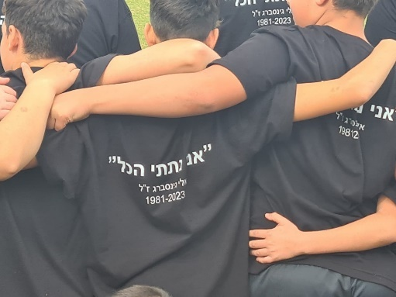**Idan Zelas**



**Talia Mor - Under-17 National Team in the European Championship**

Talia Mor scored a goal in the first match of the Israeli Under-17 national team against **Andorra** in the European Under-17 Championship. In the first game, Israel won 7-0 against Andorra.

Good luck to Talia! We are proud of you!

Ruth Mor (Congratulations to the proud Safta)

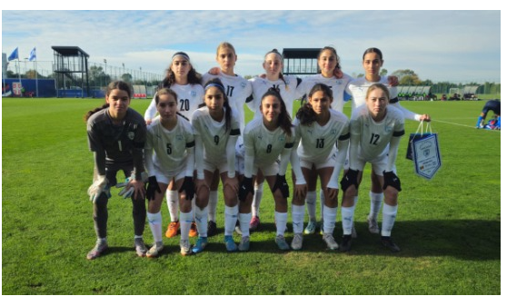

**I want to live in Andorra, Andorra, Andorra**

**I want to live in Andorra**

**It’s a place that I adore**

**They spend one dollar and ninety cents**

**On armaments for their defense**

**Have you ever seen such confidence?**

**Andorra Hip Hurrah!**

**(From deep in the hard disc of Ed)**



**Our Visitors in this Time of War  
Thank you very much to Revital Amit for helping with the column.**

**Chacham Family from Gesher Aziv**

**Who are we?** Sara and Avi, parents to three daughters and grandparents to ten grandchildren (who are not in YIzrael).

**What do we do in our routine?** We are retirees who enjoy volunteering in various organizations.

**Where were we before coming to YIzrael?** In the first week of the war, we stayed in our home in Geshar HaZiv. After a week, our son-in-law came to us and said that we needed to evacuate because the entire family was concerned. Someone from Geshar HaZiv connected us to Eyal Tirosh and Keren Kagan, and we are very grateful to them for their tremendous help and endless concern.

Sara and Avi are hosted by Sima and Musli Arieli, who help them a lot, warmly host them, and make sure they feel comfortable.

**Why do we miss?** The routine, quiet, and safe life.

**What do like about Yizrael?** The amazing people, the good atmosphere, the caring.

Top of Form

**“Behold I bring forth for the healing of the land, an Aruga of mint” For Josie**

**The Yaakobi family from Bror Chail**

**Who are we?** Noam and Oren Yaakobi, parents to Ariel, a 7-year-old studying in first grade at Ner HaGalil, Roni, a 3-year-old at Rimon Kindergarten in Yizrael, and Doron, a one-year-old at the Arava Day-care in YIzrael, which was opened for hosting families..

**What do we do in our routine?** Noam works as a social worker and serves as an emotional caregiver at the Communication Kindergarten in Ashkelon. Oren is the Investments Manager at "Amitim."

**Where were we before coming to YIzrael?** We were in four different places, including a hotel in Haifa, where several families gathered. We turned to the TAKAM (Kibbutz movement) and were directed to the Keren Kagan and Eyal Tirosh..

**Why do we miss?** Noam, a Baruch Chail native, misses her extended family and friends very much.

**What do like about Yizrael?** It's a charming kibbutz with people who opened their homes to us with warmth and love that deeply touches us.

Top of Form

**Zohar Assaf chatting with children from the visiting families**

Although a few weeks have passed, in November, I went on a walk with some of the children from the families staying with us during the war. We sat at Bernie and Omri's studio, with Omri sculpting a horse in the background.

**Almog Kofiyat Bar-Nur** from Kibbutz Shamir. Hi, Almog, tell me, why did you decide to come to YIzrael? Our friends live here, and we wanted a kibbutz. We live in a kibbutz, and we love the kibbutz. Now tell me something good here and something you miss in Shamir. I miss the dining room on Shamir (Wrong answer – Ed). In my opinion, there is very good food there. Here, I really love the culture.

**Yael Zohar from Bror Chayil**. Yael, how did you end up on YIzrael? We were in a hotel in Haifa with the entire kibbutz, but my mom felt that she couldn't stay in the hotel anymore. She wanted to move to a kibbutz. So, they organized us into groups so that we would move as a group and not just us alone. My mom doesn't like the city, and she wanted us to be educated in the kibbutz.

Why did she feel she couldn't stay in the hotel anymore? Because it was very tough for her there. She wanted to go outside, breathe some fresh air. What do you enjoy here, and what do you miss about Bror Hayil? In Bror Hayil, I miss our school. I don't know why. What grade are you in? I'm in third grade, the best third grade! What's nice about YIzrael? The dining room. The food here is very tasty. And it's really fun here. Do you live in the youth rooms? Yes, in a room that belongs to someone they call Yehel.

**Gefen Zohar (Yael's sister)** - I miss our home, the kibbutz itself, my dog Lizzie, who is now in kennels. At first, we were in Herzliya with our cousins, and then mom wanted to be with our entire community, so we moved to a hotel and then here.

**Shachar Meir from Kibbutz Elon.** How did you decide to come to YIzrael? Mom is a kindergarten teacher in Mitzpeh, and Mitzpeh was offered to come to YIzrael. Why do you miss the most about Eilon? Friends and the kibbutz itself.

Ayelet Baron from Kfar Sold, the daughter of Giora and the granddaughter of the Zimra, misses her cats and home. Are there people who stayed in Kfar Sold? Only a combat readiness team and a few elderly people. Recently, some have returned. Can you tell me how you got here? We heard there was a war, and we needed to move to a safe place, so we came here because we have family here. What about school? We study at the school at Gan Ner.

Where did you study when you were in Kfar Sold? At the "Alei Giva" school in Kfar Giladi. And what subject did you like best there? Gym and English. What do you like most about YIzrael? Being with Shlomo and Gazit, playing soccer, and eating with them...

I would like to mention that today in YIzrael, there is an activity for the visiting children that operates every afternoon at the Zachat Club, led with love by Idan Oruzko, Eli Axelrod, and Shira Israeli (Shinshin).

Thanks to the instructors and the adorable children.

Top of Form

**Small Tips for Big Emotions - By Gaiya Sankar**

**Meditation... oh, meditation.** Who hasn't heard about it in recent weeks? It seems that from all directions, voices invite us to breathe in and out, to connect, to release, to focus, to embrace, to see the whole picture, to see only the present moment, to receive, to relax, to remember. Oh, and don't forget to breathe. Not to mention that it might seem like meditation has become the undisputed consensus of the But what is meditation, really? How does it work, and why? And, most importantly, how do we overcome the feeling that it's absurd, nonsense for "spiritual" people?

For that, let's go back for a moment to basics (those less interested are welcome to skip directly to the last two paragraphs):

The human being that we are, is an integrated manifestation of energy, starting from its densest form (our body) to its most subtle form (the soul or life energy). These two forms, rooted in the same energy—much like water that can be both solid ice and gaseous air—have constant interrelations. Both influence each other all the time; the soul affects the body, and the body affects the soul.

In a brief and somewhat simplistic physical explanation, let's imagine that our body is like a fantastic radio device, and the soul is the specific wave that our radio knows how to tune in, let's call it 100fm. This wave moves in space and knows precisely how to reach our radio, not the neighbour’s radio, for example, because there is a match between them. The moment there are disturbances in this space, such as stress, fear, anger, lack of peace—all of these drains energies from us, changing the frequency so that the alignment between the different parts of us is no longer perfect.

We feel a lack of concentration, nervousness, fatigue, incessant thoughts, various pains start to appear, and overall, it seems like "we are not ourselves anymore." Meditation, in its simplest form, allows us a moment of absolute presence, a moment attentive to what I feel right now and what is passing through me at this moment; let's call it "re-alignment."

It enables us to cleanse—to clear the disturbances, the noises, the tension, to return to the source, which is us.

There is so much more to tell about this concept, meditation (I recommend reading, dozens, and perhaps hundreds of studies have endorsed its amazing effects), but due to lack of time and place, we will stop here for now. In conclusion, it does us good. And what do we have to lose?

How do we do it? There are many types and variations of meditations. This time I chose to share with you a project that is currently taking place, offering changing meditations every day at 21:00. All the meditations there are short and simple; you can find them on Facebook or YouTube.

The project is called "Light Accelerator" - search for it on Facebook or YouTube.

Much love and peace in your heart, Gaia



Top of Form

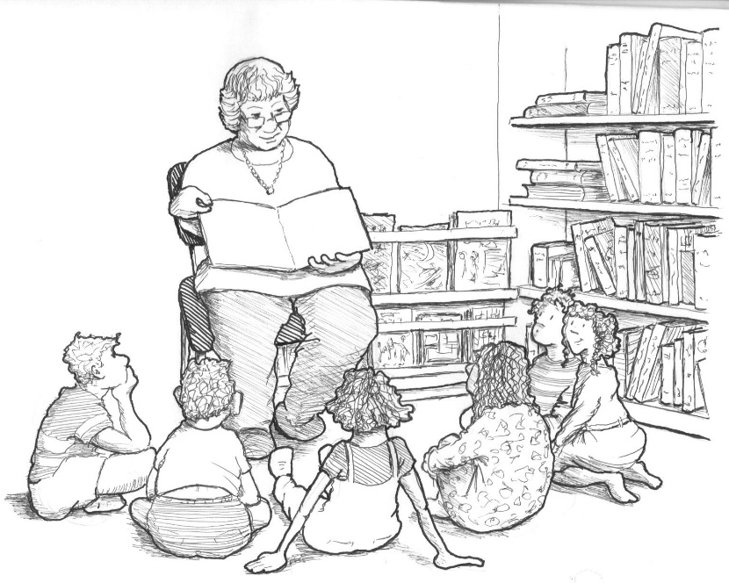

**New English Books in the Library:**

The Seasons/ BBC radio

The Tattoo Theif/ Alison Belsham

The Breached Wall/ Anita Burgh

Little Black Book of Stories/ A.S. Byatt

Live Wire/ Harlan Coben

Trust/ Hernan Diaz

The Break/ Martian Keyes

How to Kill Your Husband/ Kathy Lette

The Secret Hours/ Santa Montefiore

Thrush Green/ Miss Read

The Emperor of Lies/ Sterve Sem-Sandberg

The Dealer and the Dead/ Gerald Seymour

Asta's Book/ Barbara Vine

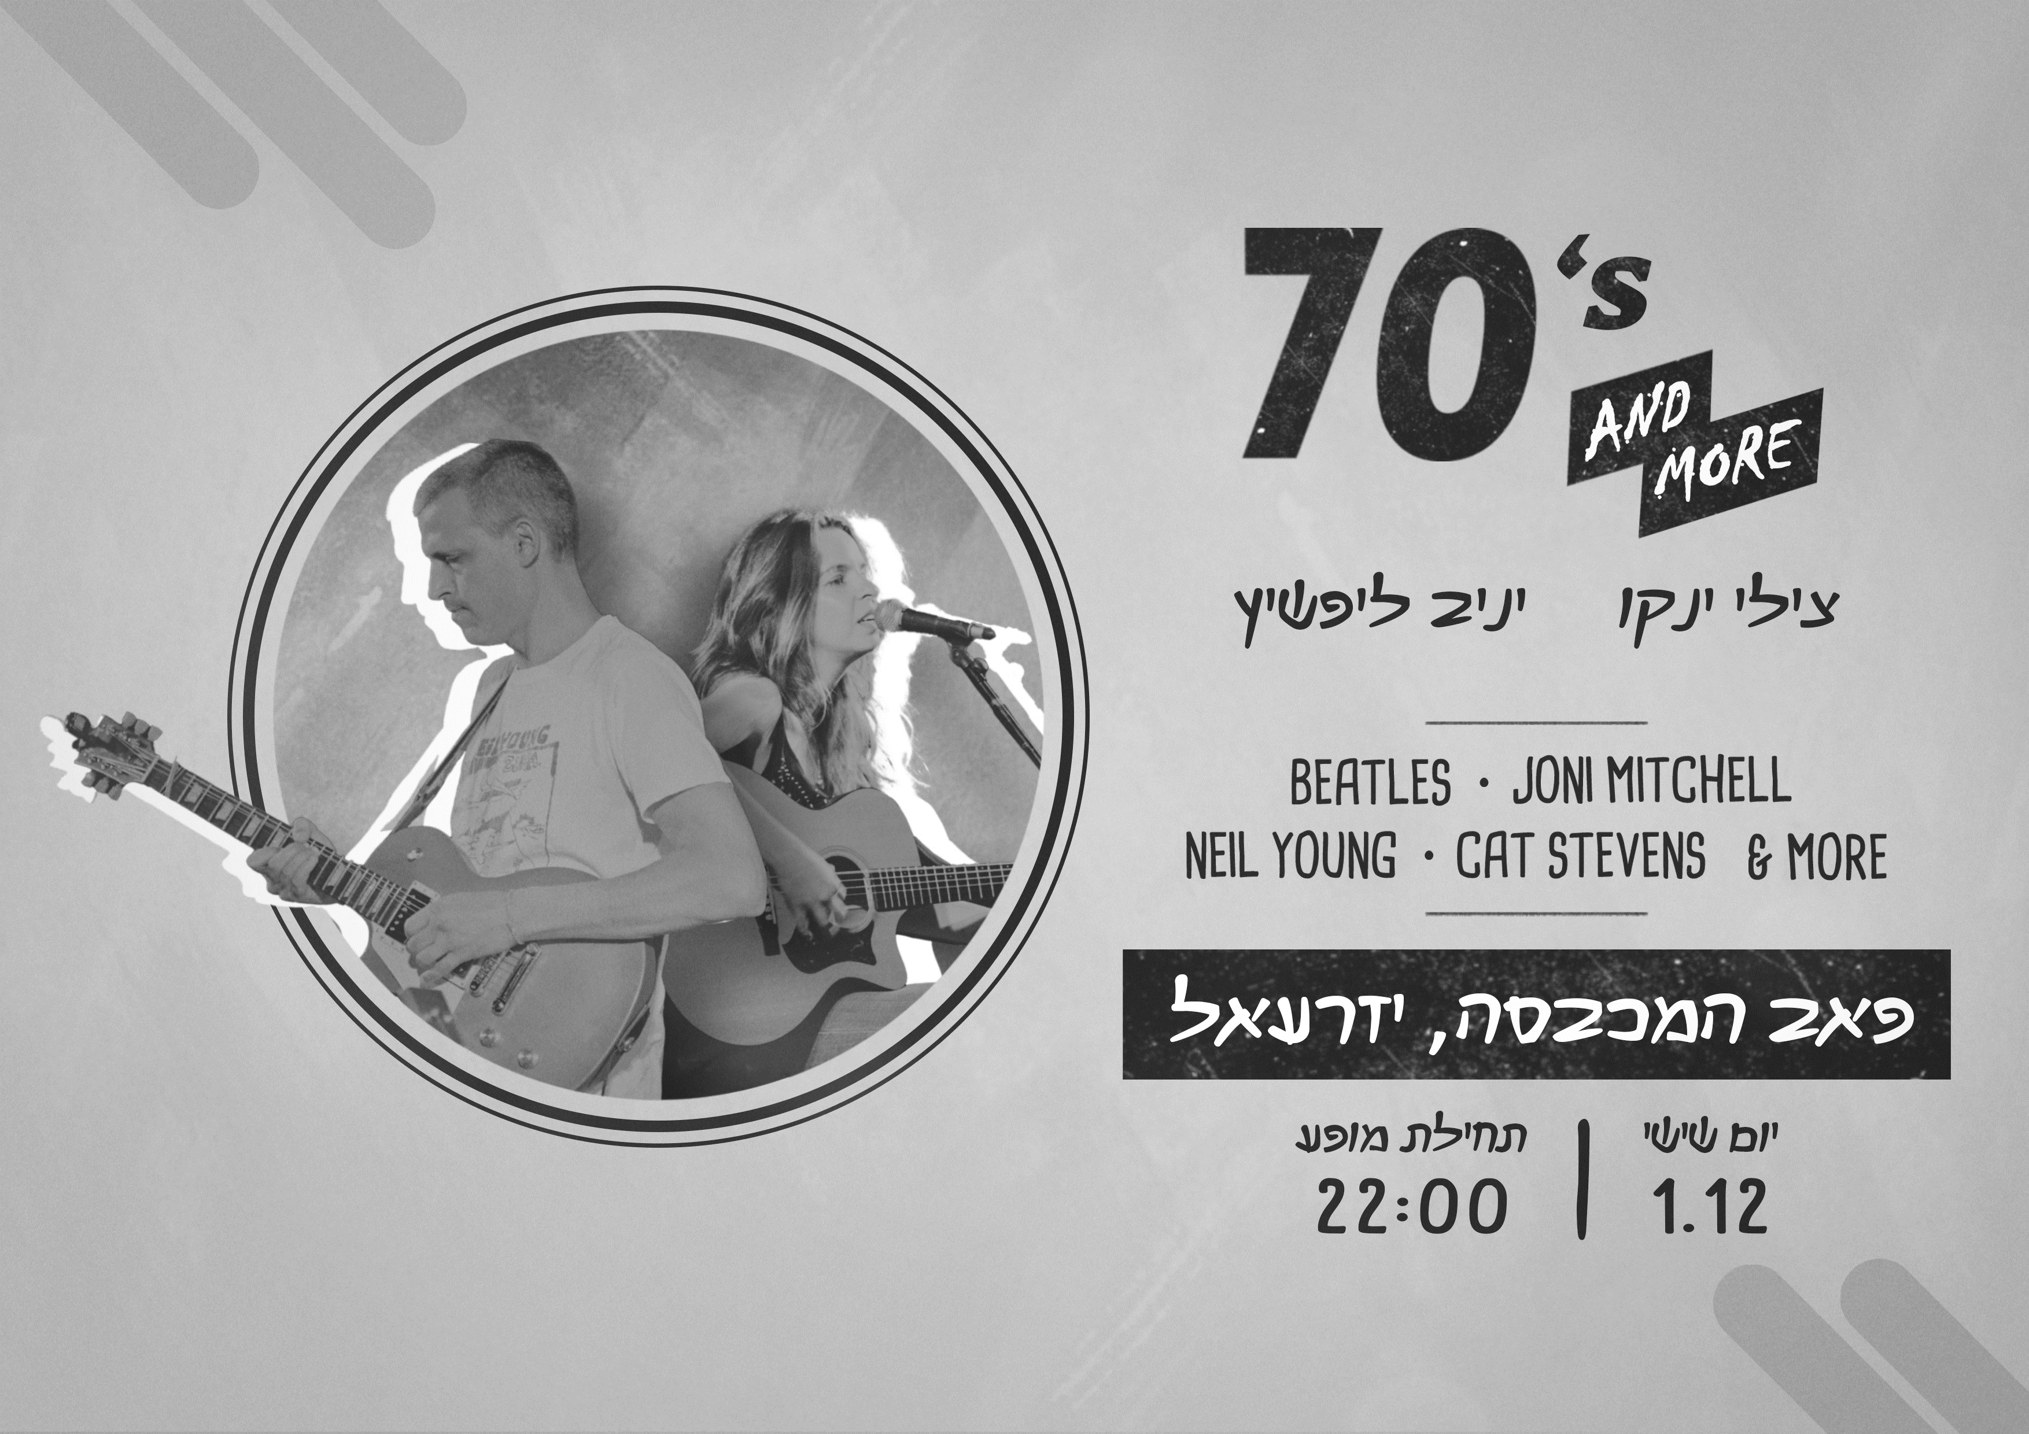

**70s and More**

**Chilly Yanko and Yaniv Lipshitz play:**

**Beatles* Joni Mitchel\***

**Neil Young * Cat Stevens* & More**

**The Laundry Pub - Fri 1.12.23 – 22:00**

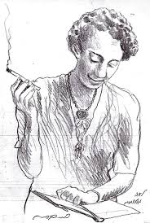

**The Seniors’ Cluster**

**invites you to a gathering for veterans**

**In the Moadon**

**"And You are Entitled to Love"**

**Songs, stories, and longing**

A performance of singer-songwriters:

Lea Goldberg, Nathan Alterman, and other beloved creators

We will talk about them, sing together, and reminisce a little

Guide: Lior Anbar

Singer: Efrat Feldman

**The performance will take place on 5/12/23**

18:00 - Dinner

18:45 - Start of the performance

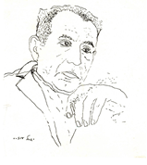

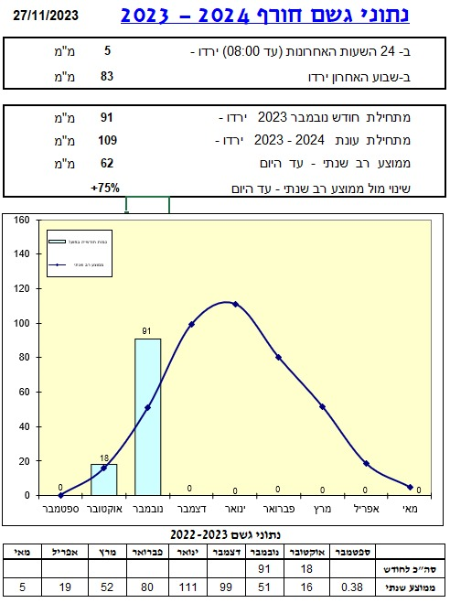

**Rainfall from the beginning of November 2023: 91 mm**

**Total rain to date: 109 mm**

**As compared to the multi-year average to date: 62 (75% above yearly average!)**

**Rainfall Table**

|  |  |  |  |  |  |  |  |  |  |
| --- | --- | --- | --- | --- | --- | --- | --- | --- | --- |
| Month | Sep | Oct | Nov | Dec | Jan | Feb | March | Apr | May |
| Total | 0 | 18 | 91 |  |  |  |  |  |  |
| Average | 0.38 | 16 | 51 | 99 | 111 | 80 | 52 | 19 | 5 |

Daniel Rosenfeld – Manager of Agriculture

**Energy - Winter Season -** Jeremy Peling, Energy Manager

The transition season has ended, and winter has arrived in full force, officially starting on the 22nd/23rd of December. Here are the winter schedule and electricity rates until the transition rates in March:

**Sunday to Thursday:**

* Peak (Pisga) – between 17:00 and 22:00
* Off-Peak (Geva) – none
* Low (Shefel) – all other hours

**Friday and holiday evenings:**

* Peak – between 17:00 and 22:00
* All other hours – Low

**Saturdays and holidays:**

* Peak – between 17:00 and 22:00
* All other hours – Low

**Low Voltage Consumption Cost (excluding VAT):**

* **Winter – Peak: 0.8604 ₪, No Intermediate, Low: 0.2802 ₪**
* Summer – Peak: 1.229 ₪, No Intermediate ₪, Low: 0.3258 ₪
* Transition Season – Peak: 0.3123 ₪, No Intermediate ₪, Low: 0.2726 ₪

**Reminder!** The most efficient heating is the air conditioner set to 22/23 degrees. Then an oil radiator with a thermostat set in the middle. For those with ceiling fans, change the rotation direction, pushing air upward. In this position, the warm air trapped near the ceiling will be pushed downward along the walls, saving energy costs.

Ensure doors and windows are properly sealed, close blinds for additional insulation. For Sabbath observants, adjust your clocks according to the winter schedule.

If you lack sufficient hot water, it could be due to accumulated sediment in the boiler or, in colder weather, needing more boiler hours. Please contact The Builders for assistance. Wishing you a warm and efficient winter indoors and a cold, rainy one outdoors.

Top of Form

**English is Fun - with Rahel**

“JEWS: Who Knew?” (by Debbie Jones Thornton)

Taken from the book “JEWS: Who Knew?”

2003: Andy Warhol’s series of silkscreen prints and paintings entitled “TEN PORTRAITS OF JEWS OF THE TWENTIETH CENTURY “ (1980)

The ten individuals depicted are George Gershwin (American Composer), Golda Meir (one of the founders of Israel and its fourth

Prime Minister), Albert Einstein (German theoretical physicist and father of the theory of relativity), Franz Kafka (Czech-born author best known for his story, “The Metamorphosis”), the Marx Brothers (American stars of vaudeville, stage, film and TV). Martin Buber (German-born religious philosopher), Gertrude Stein (American writer, poet and playwright), Sarah Bernhardt (English actress), Louis Brandeis (American litigator and Supreme Court Justice) and Sigmund Freud (Austrian neurologist and co-founder of the psychoanalytic branch of psychology.)

Seeing these images, I was struck by the immense impact these cultural and intellectual icons – all Jews from diverse fields – have made in the world.

**Considering the Jewish people constitute less than one-half of one percent of the world’s population, their contributions to religion, science, art, literature, music, medicine, finance, philosophy, entertainment etc., are simply staggering.**

Not only was I awestruck; I was intrigued. Why should this be so? I’ll begin by highlighting just a few of the many Jewish contributions to society.

Some examples:

Isaac Singer – invented the sewing machine

Levi Strauss – inventor and largest manufacturer of denim jeans

Gabriel Lipmann -discovered colour photography

Martin “Marty” Cooper – invented the cell phone

In the field of medicine alone, Jewish contributions have been phenomenal. It was a Jew who created the first polio vaccine, who discovered insulin, Novocain, penicillin and the measles vaccine, who found that aspirin dealt with pain, who introduced chlorination of drinking water, who discovered the origin and spread of infectious diseases, who invented the test for diagnosis of syphilis, who identified the first cancer virus, who invented the mammogram (I bet it was a male. R.) and introduced the birth control pill, who founded the Heinrich Maneuver and who added to our knowledge about yellow fever, typhoid, tetanus, diphtheria, meningitis and influenza. It is estimated that the lifesaving medical and scientific advances made by Jews throughout history account for an estimated 2.8 billion lives saved.

Consider also that Jews constitute:

51% of Pulitzer Prize winners for non-fiction

50% of Ivy League presidents

Nearly 50% of chess grandmasters

37% of Academy Award directors

33% of symphony conductors and

Three of our nine Supreme Court Justices (Ginsburg, Breyer and Kagan..all the rest are Catholic, by the way)

Clearly, Jews are the world’s most disproportionate high achievers. But the most astonishing statistics deal with the number and percentage of Jewish Nobel Prize winners.

……………more next week

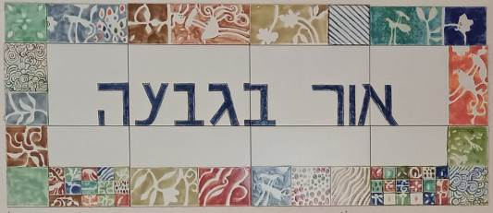

תכנית פעילות מה-3 עד ה-7 לחודש דצמבר 2023

כל יום:מ8:30 עד 12:00 קפה, עוגה, שיחה ומשחקי שולחן

|  |  |
| --- | --- |
| יום ותאריך | פעילות |
| ראשון 3.12.23 | פותחים את השבוע עם מוניקה  9:00 התכנסות עם קפה, עוגה, שיחה ומשחקי שולחן  9:15 זום מדורות: רואים עולם – רווית חבשוש: קובה / מחול השדים בסציליה  10:00 חדר קרמיקה פתוח בהדרכה של זיו בן בשט |
| שני 4.12.23 | 9:00 התכנסות עם קפה, עוגה, שיחה ומשחקי שולחן  8:00 פדיקור עם לימור מועלם *  9:00 יצירה עם רחל גרויסמן / משחקי שולחן  16:00 אור בגבעה פתוח לקפה, עוגה, משחקים ושיחות |
| שלישי 5.12.23 | 9:00 התכנסות עם קפה, עוגה, שיחה ומשחקי שולחן  10:00 טריוויה ושעשועי חשיבה עם גליה שמי  14:00 חדר קרמיקה פתוח בהדרכה של זיו בן בשט  18:00 מפגש ותיקים – תזמורת לוחמי הגטאות |
| רביעי 6.12.23 | 9:00 התכנסות עם קפה, עוגה, שיחה ומשחקי שולחן  9:30 טבע פורח עם חמוטל אסף |
| חמישי 7.12.23 | 9:00 התכנסות עם קפה, עוגה, שיחה ומשחקי שולחן  10:00 הקרנת סרט עם גליה שמי  7:00 פדיקור עם נעמה באום *  17:15 התעמלות על כסאות עם מיכל שאנן |

* יש להזמין תור

**Credits:** Translated and edited: Eddie Solow

Proof Read: Biff Markham Oren

Printed by Irit Cohen and Hedva Sharabani