**English Newsletter – No: 2068 Date: 19.8.22**

**Kibbutz Yizrael**

**Translated and edited by Eddie Solow**

**Edi-torial**

Not one more word about spelling YIZRAEL in my Edi-torial! What I have to say, I said in my reply to Hila. (See page 9) Yaniv summed it all up in his usual humorous biting way (Page 13)

Today I am calling for suggestions for a name for our Paper. We can't go on calling it "Newsletter" forever.

To get the ball rolling, I thought of The Jezreelight (Inspired by "Or B’givah" and " Light unto the Nations") and The Jezreelite (The King James English Bible version).

Suggestions will be gratefully received.

**Happy 74th Birthday to Kibbutz Yizrael**

Open your eyes and look around - Yizrael is already all grown up, almost old... and is undergoing a rejuvenation process in preparation for the future - our physical environment is under construction, the absorption faucet is opening again, and water from the fountain of renewal and diversity will soon, once again, spring forth.

Yes, Yizrael is already really big. We are excelling in varied fields, we already have a new and improved organisational structure, and social clusters, to facilitate better management of the many committees and activities. The circle of cooperation is wide, and democracy reigns supreme.

We have service branches that labour daily to improve the level of service.

We have businesses that are growing and developing. Our vehicle fleet has been upgraded. We have also established a "Ta’asukon", which is successful and breaking productivity records. We have a club for veterans - "Beacon on the Hill", which is charming, inviting and full of content. This is our statement that we respect and honour our veteran generation. We have a high-quality education system. Peals of our children's laughter ring out in the dining room (Perhaps a few decibels less would be good – Ed), over the lawns and along the paths of the kibbutz.

Business is booming, and we know how to strengthen our economic resilience through proactive and responsible actions, for our own future and the future of our children. We hold general meetings (asefot), where we democratically discuss the various aspects of our common life. We are constantly looking for the right balance between concern for the individual and concern for the society, the balance between maintaining the existing traditions and making necessary changes.

And tonight, begins our 75th year. All of us should stop for a moment, observe this wonder and hold up our heads in pride, for our beautiful, growing, developing kibbutz. Sometimes we disagree, but much more often we agree. There is some anger and resentment, but much more pride and joy, some preoccupation with the material, but much more preoccupation with the spirit. Yes, Yizrael is a wonder. A special and rare place. A piece of heaven on earth. And she is ours!

May we see the good, appreciate it, nurture it and even fight for it, if need be. May we know how to share some of our wealth with those who are less fortunate than us.

Mazel Tov Kibbutz Yizrael Yifat Asaf

**Congratulations on the Marriage of Galit Harpaz to Daniel**

Congratulations to the happy grandfather, Daniel Harpaz

Congratulations to the parents - Noga and Omer Harpaz and Daniel's parents and to all the members of both families.

With much happiness and love from us. - Young generation committee 😊

**Happy 94th to Great-grandmother Aviva Boitler!**

Wishing you a wealth of light and joy, nachas from the family, good health and much love.

**Congratulations Bernie**

Congratulations and best of luck to Bernie Fink on his **80th birthday**!

Wishing you a wealth of light and joy, success in whatever you turn to and may you have good health, much love and the best of luck.

**An Important Message from the "State of Emergency" Command**

During the next two weeks I will be updating the family register for the committee. I need and would appreciate your cooperation when I request the details to be updated.

I also request you send a WhatsApp message to Irit Cohen: 0523756032, or by email at [reception@yizrael.com](mailto:reception@yizrael.com) in response to the following:

(1) Let us know if you have a 4x4 vehicle

(2) If you can help in an emergency in any area - doctor, medic, nurse, plumber, psychologist, education, social worker, electrician, ambulance driver and anything you can think of that may be of help. (Now is a good time – Ed)

Thank you for your cooperation

Irit Cohen, on behalf of Lilach Ron-Harpaz.

**We mourn with Rachel Hadar and family on the death of Rachel's brother Tzion Udi**

May you know no more sorrow

**Thank-You**

Sarit Laviv, Tzachi Tsfadiya, Anat Friedman, Shani Beor, Nir Segal, Damian Chicorel, Nitzan Rivlin-Feldman, Nitzan Kamilian, Yaniv Lifshitz and Tal Wolfson-Darom

I want to thank each and every one of you for your hard work.

I know how much effort you all put in. You thought of every detail. We want you to know we enjoyed every moment!

Thank you, it was a wonderful holiday!

Keren Stamper-Kagan

**To the Building Team, the Electricity Team and the Housing Committee**

In a short time and in this busy period, you managed to prepare two high quality renovated apartments, bright and welcoming.

On behalf of the families beginning the intergration process: Dashevski and Edelstein and on behalf of the absorption committee - thank you very much.

With great respect, Uri Gilad.

**Economic Council**

**Diarize (Save the date - Ed)**

Monday, 22.8.2022, at 20:30 - in the Moadon

**Agenda:**

(1) Approval of a budget for the kibbutz’s part of the northern neighbourhood's infrastructure (in addition to the participation of the Ministry of Construction and Housing)

(2) Approval of a budget for correcting construction errors.

**Please note** - until the public representatives in the new Economic Council are elected, the council continues to function in its previous composition. (We took legal advice, and it is perfectly kosher – Ed).

From the Asefa and Council Committee

**Welcome to the New Families**

**We welcome the Edelstein family** - Shelley, Niv and their children: Kfir (6) and Maor (7), upon their arrival to the kibbutz.

The family will begin the absorption period on September 1 2022, and until that time the family has the status of “guests”.

The family will temporarily live in the home of the late Peggy and Arnie Friedman.

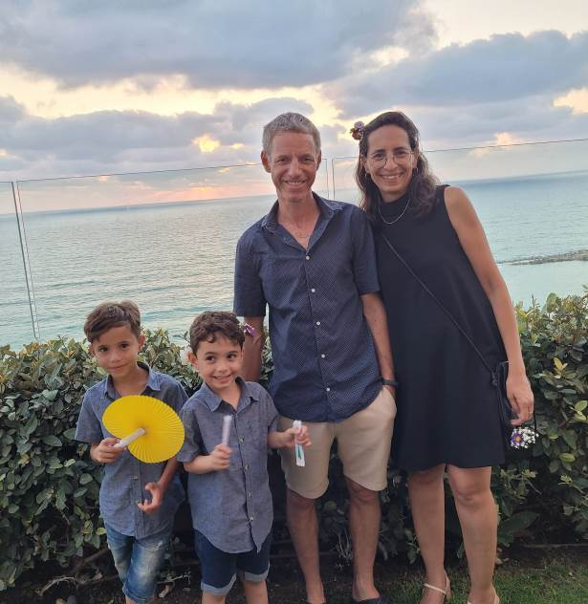

Niv Edelstein continues his work as a coordinator for educational projects in the “Dror Schools” network, as well as a director and consultant in the “Blokal Ravid” Company.

Shelly Edelstein - Human Resources and Payroll Manager in the “Blokal Ravid” Company, in addition to being a travel guide to Poland.

Kfir – will be starting first grade.

Maor – will be moving up to second grade.

Adopting family - Nofar and Ariel Brin-Dolinko

Coordinators on behalf of the committee - Liora Kamilian and Brent Abramowitz.

We wish the family a successful and meaningful klita (absorption)

**We welcome the Dashevski family -** Guy, Sivan and their children

Nevo (7), Geva (5) and Peleg (3) upon their arrival..

The family will begin the absorption period on 1/9/2022, until this date the family has guest status. The family will live in the Gilboa neighbourhood, in the former home of the Ziv family.

Guy continues his work at the Ministry of Defense

Sivan continues to work at “Or Shalom” as a foster care provider

The children will join the education system:

Nevo – will be moving to second grade

Geva - will be a “senior” in Gan Alon

Peleg – will be starting in Ganon Rimon

Coordinators on behalf of the absorption committee: Tzach Sassi and Nitzan Rivlin-Feldman

We wish the family a successful and meaningful klita.

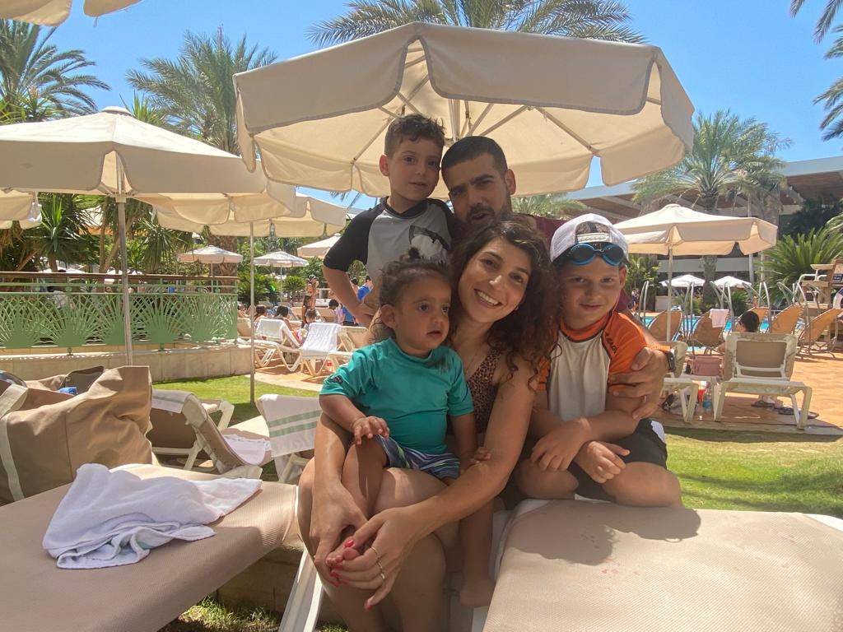

**Let's Dream - Social Action on Yizrael -Yifat Asaf**

At the end of my fourth year in the job, I observe the character and strength of our special community. Social action and contribution are cornerstones of our community. Looking back on the Corona years, it becomes even more apparent, how important it is to return to the basics, to create meaning, do things together and be there for one another.

In light of this, I would like to share with you a dream: to establish on Yizrael an ongoing project of contribution – “Beit Chaim” - a project of joint social action, of contribution within the kibbutz, which will give us a great deal as a community, and at the same time help those who need us.

“Beit Chaim” - is a home for people with special needs who live and are integrated into the community, that is, to bring a population with some special needs into the kibbutz environs, and make it their home. The intention is for 8 to 10 people, who will live in a kibbutz in an organised structure, who will integrate into the work and life of the community. “Beit Chaim” exists in a number of kibbutzim, and they receive support from the kibbutz movement, and from the Ministry of Welfare, both in the establishment and in support and funding.

Next year we will celebrate the 75th anniversary of Yizrael, and I believe that this is a way to give ourselves a significant gift, one that will enrich us and give a little of what we have to others, who are less fortunate.

In my understanding, creating a project of joint social action, is the true and most important kind of sharing. It produces a regeneration process, creates a true partnership and energises the community. It is a lever of growth, action, doing good, finding meaning and adding value to our lives. This is an important and wonderful example for our children.

Soon there will be an open meeting to get to know the subject, and to recruit volunteers from the kibbutz to develop the dream and bring the idea to fruition.

I invite anyone, who wants to be a part of the venture, to contact me.

(I will let you be in my dream, if you let me be in yours – Bob Dylan said that – Ed)

**The Third Age Cluster – Inbal Adler**

The Cluster Includes

(1) Beacon on the Hill: a community center for senior citizen members and residents. A social meeting place. It includes a day centre 5 days a week, various social activities, ceramics club, various treatments and more. Director: Monica Brustein. Team: Galia Shemi, Chamutal Assaf

(2) Professional Team: deals with discreet consultations on individual issues. Forum members: Liran Pen (representative of the clinic), Merav Navot (consultant social worker), Rinat Chicorel (field worker), Inbal Adler (manager).

(3) The Cluster Council: deals with issues related to the welfare of the general population of senior citizens.

(4) Senior Citizens Council (formerly the senior citizens committee): Philippa Segal, Zohar Assaf, Axel Levin, Danit Kirshberg; Beacon on the Hill director: Monica Brustein, Health and Welfare Manager: Kobi Levy; Field worker: Rinat Chicorel; Public representatives: Anat Freiman, Bernice Kaplan.

(5) Field worker: Rinat Chicorel

(6) Ta’asukon (temporary name): Ehud Cohen

Work Protocols - for personal aid to members

1) Initial contact: You can contact the clinic or the members of the professional team.

2) Information flow: the cluster works as a team. Personal information will only be passed on to other team members with your approval.

3) Initial meeting: At the beginning, a meeting will be held with the member and his family members to better understand what the needs are and to coordinate the treatment.

4) Follow-up: The field worker coordinates the treatment.

5) All members who receive help from the kibbutz must utilise their rights with the National Insurance, (Bituach Leumi)

Fieldworker duties

▪ Assists the family.

▪ Contact with the family members.

Mediation and assistance with relevant parties and institutions: Or B’givah, Health Coordinator, Rehabilitation Coordinator, Clalit, National Insurance and more

▪ Direct contact with members. Home visits according to the needs arising in the field.

▪ Liaising with the cluster manager on senior citizen issues, work organisation, priorities, personal matters and more.

▪ Contact with the health and welfare manager or nurses and help with issues such as: caregivers’ work, gardening and home maintenance and more.

▪ Liaising with the management of Or B’givah to be inclusive for senior citizens and to raise issues arising in the field.

**I want to thank Sigal Perling**, for her many years as a field worker. Sigal built the field work from scratch, studied the subject, and developed a field that did not exist on Yizrael until then. With great love and devotion, Sigal provided solutions for senior citizens’ needs. I thank Sigal very much on behalf of the Third Age Cluster and on behalf of all the senior citizens.

Sigal, good luck to you on your new path!

Inbal Adler - Director of the Third Age Cluster

**I Care Too - Believe Me – Eddie Solow**

**"Navot the Jezreelite owned a vineyard in Jezreel, near the hêḵal of King Ahab of Samaria". King James Bible**

When I took on the translation of the Hebrew Alon into English, I did not realize that I was facing such a big challenge. Neither did I think that so quickly we would feature in the Hebrew Alon. Believe me, friends, translating the newsletter is not an easy task. Only the encouragement of the English speakers keeps me going.

I was looking for a solution. Help came in the form of GOOGLE TRANSLATE - far from perfect, but a big help. I found, to my surprise, that every time the kibbutz is mentioned in the text (many times every week), Google spells the name of our kibbutz differently:

Jezreel, Yizre’el, Yizreel, Yizrael... (even Israel!)

The most annoying one for me, as the typist, is the version with the apostrophe, that's why I chose YIZRAEL. Comments came from the English-speaking public, some enthusiastic, some angry. I went to check with our English teachers. The first one explained to me that in the English language, the use of the apostrophe is reserved for association and in cases of a missing letter (it**’**s a boy! Eddie’s newsletter). According to her, the sign at the entrance to the kibbutz is a mistake. In French there is extensive use of the apostrophe, but I am translating into English not French.

She recommended me to choose YIZRAEL. It made sense to me but I talked to another teacher.

The other teacher chose the traditional version YIZRE’EL with an apostrophe. I researched the sources and the first teacher is correct. I could have chosen the version I preferred, but to generate interest, I thought I would hold a referendum. There is no doubt that I “achieved” my goal. A huge total of 15 members replied and the majority chose YIZRAEL. Most chose not to answer. It probably isn’t that important to most English speakers.

It is possible that the bureaucrat from Keren Hayesod who prepared the first sign for the entrance to the kibbutz immigrated to Israel, from France. Who knows? Maybe the Hebrew Language Academy will choose the incorrect use of the term (and I will respect that), but only after the proposed law passes the Knesset, after there is a new government.

(G-D willing - Ed)

I also checked the official letterhead paper. The new chairman of the executive committee found in his office, kibbutz letterhead paper and envelopes with both versions! Apparently, it depends on who gives the instructions (To the printer). It seems there is no right or wrong... If the executive committee or the asefa will decide on an official version for the name of the kibbutz, I will definitely obey them.

If you want to add interest and amusement to your road trips in Israel, read the names in English on the signs. Not exactly a reliable source, I must say. The main thing is that you recommend to your guests from abroad to ignore the signage and only rely on WAZE. (That is if you want them to get here – Ed)

By the way, I recommend not writing the word YIZREEL in the entry code to the new "EASYSHIFT" toranut application because only YIZRAEL will give you access. It seems to me that YIZRAEL will win in the long run.

By the way, as long as my packages arrive from my beloved “Ali Express” to the address: KIBBUTZ YIZRAEL, I am satisfied...

In the meantime, until I receive an instruction from above, I will respect the members who took the trouble to express their opinion and will continue to write YIZRAEL in the English bulletin.

Regards,

Eddie Solow

P.S. The following sentence was accidently omitted from the Hebrew version:

I would like to take the opportunity to thank “the English speaker” who chose YIZRAEL for our email Address. That is the way we all pronounce it, and that is how it should be written in an email. She avoided much confusion over the years.

Thank you, Aliza. You contributed much to the kibbutz, this too.

**Background Material for a future discussion on the topic: Life Fund 2 (Keren Haim B) – Nitzan Rivlin-Feldman**

1. **Reminder: On 7/21/21 the following notice was published in the Alon: For the information of members:**

**” Beginning of discussions on the issue of inheritance**

As you know, the issue of inheritance has been on our agenda for some time.

Understanding that the issue is important to many members… , we decided not to wait until November, as scheduled, and to establish a dedicated ad hoc committee to prepare the discussion for the Asefa.

The team will start work next week or the week after.

Nitzan Rivlin-Feldman, Yifat Assaf 7.12.21

The aforementioned team began work at the beginning of September 2021 and was joined by Yitzhak Peleg and Chanan Shaliv.

. In March 2022, the summary of the team's work, was submitted to the secretary, as background material, in preparation for bringing it up for discussion at the asefa. Since we were at the beginning of an organisational structure change, it was decided that this topic is more appropriate to be discussed in the executive committee and we were assured that this topic would be among the first to come up for discussion in the executive committee.

At the meeting of the Executive Committee, held on August 2, 2022, it was decided to task Natasha Tchernokovsky and Nitzan Rivlin-Feldman with preparing the issue of the "Life Fund 2" for discussion by the board of directors. Their task is to consider the proposal of the team that worked on the issue, as well as additional proposals that will come from the public.

**We are hereby announcing that proposals on the subject may be submitted to Nitzan or Natasha by Sunday, 4.9.22.**

Natasha Tchernokovsky, Nitzan Rivlin-Feldman

**Summary of the work of the team that dealt with the Hayim B Fund issue, dated 30.1.21.**

**(**Which was supposed to be discussed in the mazkirut)

Data: The number of years of seniority of all the members of the kibbutz is this year, cumulatively, 8700.

Below is a summary of our proposals for submission to the mazkirut and the asefa:

1. In principle, it is proposed that the new fund will work according to the same principles used in the Life Fund.

2. The fund will be based on seniority.

3. The accumulation mechanism will be like the life fund 1 - annual interest of 2% +linkage.

4. The value of each year of seniority will be NIS 6000, twice that of the life fund 1. This will result in a maximum accumulation (for 40 years of seniority) of NIS 431,350 per member (before linkage).

5. The accumulation of seniority in this fund will be from the age of 30 to the age of 70, that is - maximum accumulation - 40 years of seniority.

6. We propose that it will be possible to withdraw from the fund only from retirement age - from age 65 or 67.

7. Rate of replenishment of the fund - the amount available to the fund will be divided each year based on the years of seniority, that is - the amount will be divided by the number of years of seniority in that year to see how much you will receive for each year of seniority at that time. This amount will be multiplied by the number of years of seniority of each member and that is what will go into the fund that year.

8. In the event of death before the fund is filled - the fund will continue to be filled even after the member's death, until it has reached the target, according to the number of years of seniority the member has accumulated (there is room to discuss the question of whether it will be possible to withdraw from the fund what has already accumulated in it and continue to fill the balance of the fund

9. The rights of the deceased: we suggest bringing at least 2 proposals for members' decision:

a) The estate of a member who died after January 1, 1980 will receive the full amount, according to the number of years of seniority he/she accumulated until his/her death.

b). The estate of members who died before the appointed day will receive 50% of the amount, according to the years of seniority they have accumulated.

12. Fund sources

If we decide that the value of each year of seniority is 6000 NIS, then the relevant amount for today is about 130,000,000 NIS (it must be remembered that the number of years of seniority of the members who have not yet reached the age of 70 increases every year).

13 There is room to consider the opening of the “ key” before 2024 so as not to wait for the opening of the fund.

14 Realisation of some Maytronics shares should be considered. If so - we suggest that it be up to NIS 70,000,000 each time, in order for it to be designated exclusively for this purpose (reminder: according to our decisions, every time a return is received from the sale of shares that is NIS 70,000,000 or more, the purpose of the money must come before the asefa).

Nitzan Rivlin-Feldman

**Extracts from "Holech B’Tel" – Yaniv Lifshitz**

**What really matters?**

Put everything aside... what really matters: **Yizrael** or **Yizreel**. Wait, with an apostrophe or without? Well, let's turn to the Language Academy and see what they say... Hmmm... the diagnosis is not clearcut, maybe you should dig through the archives and find out. Ah! Here is a picture of the editor (!), in the 1960s (?) under an ancient entrance sign. Well, now everything is clear. Or not... Fighting in Gaza? War in Ukraine? Global warming? Everything is null in void compared to this life and death question. On the hill, as usual, we find the time to deal with the really pressing issues, never wasting time on nonsense. Or is it vice versa? Next on the kibbutz agenda: "Du-on" or "Children's House", "Archive" or "Ginzach", Bnei Meshek or Bnei Kibbutz , Sichat Kibbutz or Asefa, Dining room or Food Court, Executive Committee or Mazkirut, Merakez or Minahel and "Tralalu" or "Tralali".???? (couldn't resist adding a few myself – Ed)

**Only today!**

How do you know spring is coming? Look around... How do you know summer is coming? The mango returns to the hill! Not just coming back, but with a bang, knocking down any news item in its way (on the Kehilanet). In what parallel universe does it seem reasonable to clog the (online) bulletin board (and on Friday evening,) with mango orders "Bring a kilo", "give me two more boxes", "Fill my car boot". Remember the "it takes two to mango" commercial? Well, it turns out it takes thirty-two to 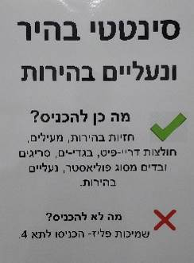mango on Kibbutz Yizrael.

**The Weekly Riddle**

(If you haven’t thrown in dirty laundry recently,

you won't understand this – but be sure to take

a tranquilizer before you do so – Ed)

What is in the picture on the right?

1. Introduction to Optalgin

2. 10 minutes that I won't get back.

3. The new laundry escape room.

4. All the above answers are correct, (unfortunately)

(I reckon, stick everything in Synthetic and RUN – Ed)

**English is Fun - with Rahel**

**Accidental bloopers: (concluding)**

To avoid hitting the bumper of the car in front, I struck a pedestrian.

I was sure the old fellow would never make it to the other side of the road when I struck him.

I saw a slow-moving, sad faced old gentleman, as he bounced off the hood of my car.

The pedestrian had no idea which direction to run, so I ran over him.

The pedestrian ran for the pavement, but I got him.

I was unable to stop in time, and my car crashed into the other vehicle. The driver and passengers then left immediately for a vacation with injuries.

When I saw I could not avoid a collision, I stepped on the gas and crashed into the other car.

My car was legally parked as I backed into the other vehicle.

I was thrown from my car as it left the road. I was later found in the ditch by some stray cows.

I told the police that I was not injured, but on removing my hat, found that I had fractured my skull.

The accident was entirely due to the road bending.

The accident was due to the other man's narrowly missing me.

The accident happened when the right front door of a car came around the corner without giving a signal.

The other car collided with mine without giving warning of its intentions.

No-one was to blame for the accident, but it never would have happened if the other driver had been alert.

She suddenly saw me, lost her head, and we met.

I misjudged a lady crossing the street.

I heard a horn blow and was struck violently in the back. Evidently a lady was trying to pass me.

One wheel went into the ditch. My foot jumped from brake to accelerator, leaped across the road to the other side, and jumped into the trunk of a tree.

The accident occurred when I was attempting to bring my car out of a skid by steering it into the other vehicle.

I had been driving for 40 years, when I fell asleep at the wheel and had an accident.

A cow wandered into my car. I was later informed that the unfortunate cow was half-witted.

The other man changed his mind, and I had to run into him

I was backing my car out of the driveway in the usual manner, when it was struck by the other car in the same place it had been struck several times before.

My car sustained no damage whatsoever, and the other car somewhat less.

I was on my way to the doctor with rear end trouble when my universal joint gave way, causing me to have an accident.

**BEACON ON THE HILL**

**Weekly Program for 21.8 2022 – 25.8.2022.**

**Every day** from 8:30 – 12:00 Coffee, cake chats and board games

9:00 – 11:30 Ceramics - to complete work.

|  |  |
| --- | --- |
| **Day & Date** | **Activities** |
| Sunday  21.8.22 | Opening the week - baking with Monica  9:00 Helen Rosenberg – facial (BAO) |
| Monday  22.8.22 | 9:00 Coffee, cake, chats and games  9:30 Art Appreciation with Chas  8:30 Limor Mualem – pedicure (BAO)  16:00 – 18:00 Coffee, cakes, chats and games |
| Tuesday  23.8.22 | 9:00 Games  9:00 Trivia with Galia  9:00 Helen Rosenberg – facial (BAO)  16:00 – 17:45 Ceramics with Miki Touz |
| Wednesday  24.8.22 | 9:00 Games  10:00 movie with Gala  12:00 Pedicure with Na’ama Baum (BAO)  16:00 – 17:45 Ceramics with Ziv Ben Bassat |
| Thursday  25.8.22 | 9:00 – 12:00 Ceramics with Ziv Ben Bassat  9:30 Summer trip to Norway with Maya and Hanan Shaliv  7:00 Pedicure with Na’ama Baum (BAO)  17:15 Exercises on chairs with Michal Sha’anan |

BAO - By Appointment Only Monica and the team