**The Yizraelite – No 2089 Date: 13.1.2022**

**Kibbutz Yizrael**

**Translated and edited by Eddie Solow**

**Proof reading Jo Feldman – With thanks**

**Edi-torial**

**Too much to take in. We all are asking, what will be?**

**All we can do is voice our opposition, protest the anti-Democratic path down which we are being led.**

**See David Grossman's article.**

**For Light relief, I advise you to read Daniel Shapira's letter… and obviously…. English is fun**





**Congratulations to Bar and Shahar Levy**

On the birth of a son Nimrod. Grandson to Yifat and Kobi Levy - great-grandson to Bini and Steve Blass. Congratulations to all the families: Levy, Blas and Katznelson (Bar) - 🌻🌺🍼with wishes of happiness, joy, laughter and play, good health to all - and lots and lots of love...

**From the desk of the Nominations Committee**

**Call for candidates:** The Staffing Committee thanks **Brent Abramowitz** for his work as the coordinator of the security committee and his contribution over the years to the security of the kibbutz and it’s members.

We appeal to members to suggest names for candidates for a new head of the committee.

Members of the staffing committee:

Racheli Araba, Albert Rosilio, Liran Penn, Anat Friedman, Uri Ayalon, Tzach Sassi and Nir Segal.

**Thank you from the bottom of my heart**

Last Friday we happily opened the 75th year celebrations of Yizrael

We wanted to thank all the participants in organizing the evening and making it happen: (see names in the Alon)

Did you know?... The poster with the photos on Friday evening on the bulletin board, was prepared by Shimrit Tzfadiya about 20 years ago, in honor of the receipt of the first cell... ("Retrieved" from the archive – (no small feat considering the current state of the archives - Ed))

In the coming weeks, the dates of this year's events will be finalized and announced to the public

A happy and unifying year for all of us

The 75th year team:

Dorit Fink, Hamutal Assaf, Tal Wolfson-Darom, Yifat Assaf, Tsofnat Mor, Shani Baor, Tamar Sanker.



**Message from Yifat Assaf**

Almost seventy-five years ago, Kibbutz Yizrael was established, in the nearby Tel Yizrael, where its spiritual values and community character was shaped. Here its members lived a life of modesty and sharing. Here they created cultural and social traditions, and bequeathed to their successors the seeds of the Kibbutz Yizrael that we know today.

Although there are older, larger and more developed kibbutzim... there are almost no other kibbutzim like Yizrael, that has managed for 75 years to maintain a real cooperative community, which is still growing and flourishing. A kibbutz which examines itself and adjusts its life style from time to time, but does not lose the cooperative values of the founding members.

Alterman has already written about this:

*"I swore, by my eyes, we will, again, see your beauty,*

*Your voice will amaze us forever.*

*There are, perhaps more beautiful than her*

*But there is no beauty like hers to be found.*

*Alterman*

Therefore, we, on Yizrael: members, residents, veterans, young people and children have gathered on this day, January 6, 2023, to hereby announce the opening of the 75th year celebrations for this cooperative group, which is Kibbutz Yizrael.

Chag Sameach, Happy New Year and to Life (L'chaim)!

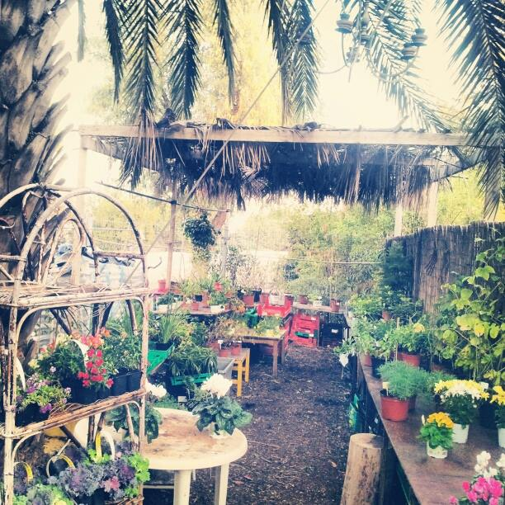

**Changing of the Guards at the nursery - "Rio Gardening Shop" From the Brustein family**

Dear Oded Fink,

We would like to thank you for continuing in the footsteps of our dear one, the late Claudio Brustein, in "Rio Ginun" - plant nursery.

Claudio invested a lot in establishing the nursery, both designing it and maintaining it. He would go up to water the plants during the day and at night, Saturdays and holidays included.

When Claudio became ill and weakened, he could no longer work as he had loved so much in the kibbutz and "Rio Gardening" every morning when he expressed a desire to come there, you made time for him and received him with a lot of respect. You listened to his professional advice, laughed with him and were one of the only ones who understood him.

Even after Claudio's passing, you continued to carry out many projects under the name "Rio Gardening" and kept the nursery well. Every time we came to buy something, we knew that you lovingly preserved something that our beloved Claudio established and that it was very important to us that it be preserved.

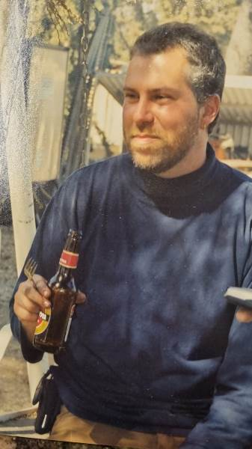With much appreciation and thanks,

From the Brustein family and Claudio's friends.

Dear Smadar Agmon, on this occasion, we wish you great

success in managing the nursery. We are sure that you will

continue to bring light and beauty to this wonderful

place, which was built with joy and love. We are

sure, that the good energies brought by Claudio and Oded

will remain in place under your management.



**A Preview of the 75th Chug Hameshek**

1. Esti Mittelberg - Laggard and Eddie Solow - Hyperactive.

Sign bearer: Milton Kaplan

- Hi. are you coming to go…

- Yes, sure. Where to tonight?

– Northbound, what do you think? To the rugby field?

- Gooood. Let's go!

***

– Ooooff! How far is it... I'm falling apart!

- Well, you agreed, didn't you?

- That's right, but I didn't remember how far it was...

- Hang on... a little longer, we are nearly there.

– My legs, my poor legs...!!!

- What is this?! There is a sign here... (turning it around**)**

* **"The Yizrael walk**... as part of the events of the 75th year **there will be a festive walk..."**

– (The laggard jumping for joy) WOW!! Great! I love Hiking...

***

Both together - **Wait... but won't there be a play?**

 (shouting of the Sign bearer): **And what about a Kibbutz Trip??!!**

1. The Fool and the Patient member: Damian Chicural, Daniel Assaf;

sign bearer: Yoni Brauman

- Hi. are you coming to go?

- Yes, sure. Where to tonight?

– Maybe towards the south? To the upper dam?

-Good. Let's go

***

– Look, what it is!

– what?

- New road... lamp posts...

- Well??

- And there is not one single tree in sight!

-Tree? What good is a tree?

- At least there'd be shade... I hope there's a bench to sit on

– Tree... right... I didn't think of that!!!

-What is?! Look, there is a sign here... (turning the sign around) "**Tree Planting**... as part of the events of the 75th year **- Planting an avenue of trees"**

- I told you?!

Both together - **Wait... and won't there be a play?**

 (shouting of the sign bearer): **What about benches and grass in the field crop’s park??!!**

(3) A couple of Seniors: Haim Nagar, Bernice Kaplan. Sign Bearer: Amir Darom

- Hi. are you coming to go?

- Sure, sure... it's been a long time since we walked... where to tonight?

– Maybe towards the west? Shall we check the new road?

- Excellent. forward. Let's go!

***

- Do you remember when we walked here last time...

- Sure, sure. Everything was mud...

- With all the kibbutz children... those were days...

- I wonder where they all are now...

- I heard that Tzvika's son is already a great engineer

– And what about Yusuke's? Scientist, right?

- and the actress of...

- and the singer of...

– All these children grew up so fast...

- I wonder what they look like today ...!!!

-What is?! There is a sign here... (turning around) "In the framework of the events of the 75th year - **a get-together of the kibbutz children from then till now..."**

-Walla! It will be crowded...

- Let them come... Let them come...!

Both - **Wait... and won't there be a play?**

 (shout of the Sign bearer): **Did you think about shirts??!!**

(3) The fancy lady and the farmer: Danit Kirshberg, Ohad Ziv. Sign bearer: Doron Kagan

- are you coming to go?

- Oh well, well... I'll just change my high heels... where to tonight?

- Towards the east. To the community farm of the youth service group?

-So far? I just had my hair straightened...

***

-What a beautiful evening! What fresh air!

– Yes, but the smell from the cows is killing me... just hope the smell doesn’t stick to me!

- It's natural...

– Natural? What's wrong with the make-up?

- Dhilak!

-Polish? What's wrong with my nail polish?

- Leave me alone, enough! Is it so important to you how you look?

- what do you mean? Maybe someone will see me?!!!

– Wait, what is this? There is a sign here... (turning around) "Within the events of the 75th year: **a group photo of all the residents of Yizrael"**

-Woe! When?! I need to grow a mustache!

**Both - Wait... and won't there be a play?**

 (shouting of the sign bearer): **And what about a mosaic wall??!!**

 (Summary of the producer**): Mosaic wall- another time... but everything else mentioned, and more – we have a full year ahead of us.** (And especially the play – Ed)

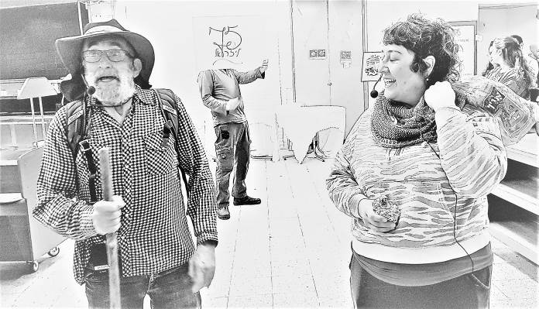Article: Dorit Fink (The Producer)

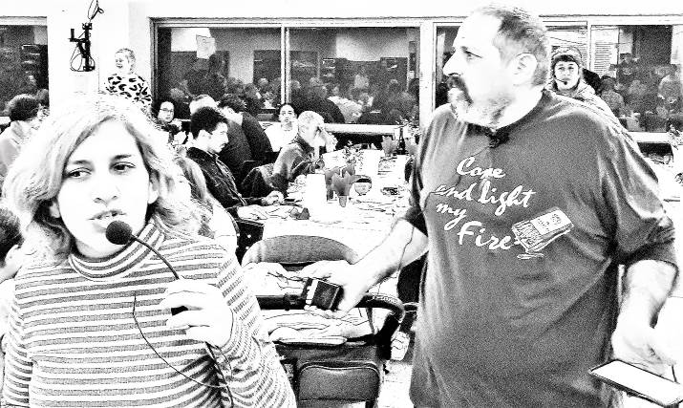

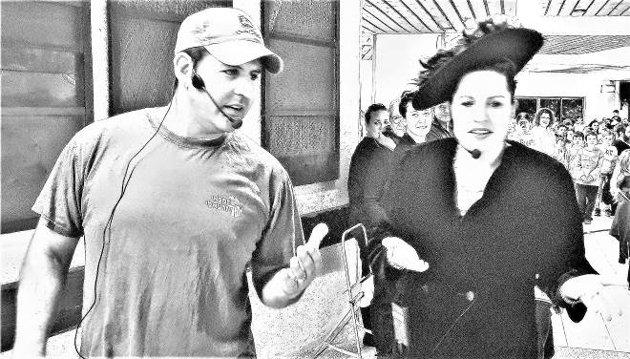

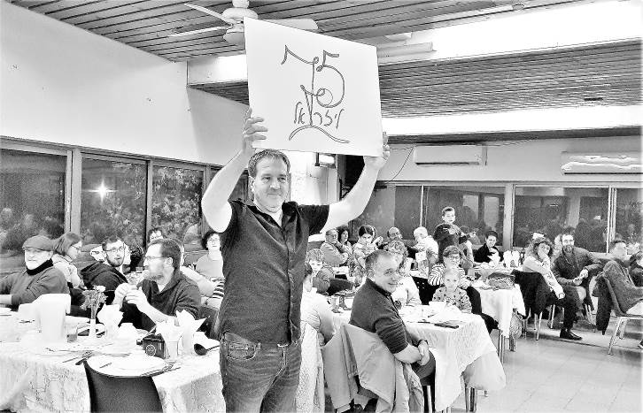

**Reserve fund general meeting (asefa) - 2.1.2023**

The Entire balance will be linked to the index + 2% interest, when a member reaches pension age.

Jeremy presented the dilemma of the amount of the deposit at the end of the year, following the freezing of the average wage index during the Corona years

It was decided in the executive committee to deposit the amount according to a target of 5,600 NIS instead of 5,214 NIS. This is according to the decision of the assembly, which is 50% of the average wage in the country.

Jeremy presented year-end deposits by age groups funds

Jeremy presented the 2023 budget and the 2022 performance.

Forecast of the fund; There are no unusual elements in the budget.

The budget was approved = 67 in favor, 5 against, 4 abstentions

Concluded: Jeremy Perling

**Executive committee protocol - 3/1/2023**

Present: Jeremy Perling, Ron Cohen, David Mittelberg, Yifat Assaf, Elad Ilan

Missing: Avner Alterlevi, Natasha Chernichovsky, Nitzan R-Feldman

**1) Community budget 2023** - Maor and Erez presented the community budget frameworks for 2023, both in the kibbutz budget and in community funds. A number of proposals were made for adjustments to the presentation of the budget. It was said that the process of building the budget was conducted for the first time by the community management and not by the Budget Committee. The process was correct, and the data came by what was reported from the managers of the branches/clusters. Goals and objectives were defined, which were translated into a budget.

There was a fruitful discussion between the managers of the branches, about efficiency and collaborations. It was noted that this is the right way to build the community budget and thus there are no surprises for anyone. The budget proposal will be submitted to the Economic Council for approval. The committee members requested some additions and changes so that the material presented would be clearer.

**It was decided**: to approve the principles for the discussion and approval of the Economic Council. The final presentation will be sent to the committee members for final approval before its distribution to the Economic Council members.

**2) Appeals procedure** - Elad Ilan presented the subject: today there are references on the subject of appeals in a number of procedures (E.g., Takanon Hakibbutz - Ed). With the help of Attorney Ezra Mizrachi, who guided the organizational structure process, all the references were collected, and everything was consolidated into one orderly appeals procedure. At the end of the process, there will be no contradictions between the appeals procedure and the Kibbutz Regulations (takanon)

**It was decided:** the procedure will be finalized after the conclusion of the work on the new regulations.

**3) The pension target** - Elad Ilan presented the team's work on the pension target: the decision on this issue will come simultaneously with the principal decision regarding the second life fund, since one of the proposals for the second life (Haim B) fund relies on the same financial resources.

The economic discussions on the subject will be in preparation for the 2024 key. The fundamental difference between changing the pension goal and committing to members in other ways, was discussed.

Jeremy explained that it is better to find an internal kibbutz way (such as: a trust account managed by a lawyer), to guarantee members higher amounts, but not by increasing the pension target, which harms the kibbutz capital and brings with it external obligations. Yes, the pension target is a complicated and rigid mechanism that is difficult to change, compared to an internal fund that is easy to change whenever we want.

**It was decided:** A team will be established consisting of members and external experts on financial and legal issues, which will recommend to the committee the best way to ensure higher pension savings for members. Names have been suggested for the team. Elad Ilan will establish the team

**4) Budget of the "local municipal committee"** (Vaada Mekomit)- the Gilboa Regional Council transfers a budget to the settlements for independent activity in the areas of such things as: removal and treatment of garden waste and garbage, cleaning and gardening in the community. The total amount is 148 thousand shekels. The budget was approved.

**6) The kibbutz's response to continued violations of the kibbutz regulations and its decisions** (invited: Zivit Nanikashvili) - Zivit did not come to the meeting, and the discussion, about her noncompliance, took place in her absence.

**Decision:** To call a general meeting (Asefa) to warn Zivit that her membership of the kibbutz will be terminated if she does not comply with the decisions made during the general meeting.

**Summarized by: Jeremy Perling / Written by: Yifat Assaf**

**The recommendation of the search team for the position of Human Resources Director:**

**Kinneret Govrin (from Mishmar Emek)**

**The nomination will be brought to the General meeting on Wednesday 18/1/2023**

**and later, for election by ballot (according to the new organizational structure regulations) - Best of luck - The search team**

**Alina Axelrod, Hila Alterlevi, Yifat Assaf, Irit Shemesh, Ofra Shelef**

Hello everyone,

My name is Kinneret Govrin. I am a mother of 3 daughters, a member of Kibbutz Mishmar HaEmek, a human resources manager and have a master's degree in clinical criminology and human resources studies

I managed the human resources of Mishmar HaEmek for 6 years and then I managed the company 'Mishmar HaEmek Chickens' - a business for the production of eggs and broiler chicks, for 4 years.

I bring with me, experience in collective and business management, which includes leading processes, building infrastructure and improving human resources processes, designing organizational culture, accompanying managers and more. I coordinated various committees and teams in my kibbutz, such as: human resources management, job search team, salary team. I also took part in the financial committee of the kibbutz, the absorption committee, the education committee and more.

As a member of a cooperative kibbutz (from the day I was born), I know intimately and deeply the vision and values, the way of life, the manner of conduct, the language and the mindset, as well as the challenges, dilemmas, conflicts and complexities of the cooperative lifestyle.

It is important for me to respect the way of life, the policies and decisions of Kibbutz Yizrael and to bring my experience and abilities for the benefit of promoting and improving the scope of work in the Kibbutz.

I believe in significant and proactive human resources as a full partner in achieving the social and economic goals of the kibbutz which operates in a systemic, transparent and participatory manner, and whose role is to find the balance between the values and needs of the kibbutz and the commitment to shared livelihood and the ambitions and desires of the members.

I believe that it is the responsibility of human resources to respond to the adequate functioning of the work system in the kibbutz, to direct members and young people to necessary and valuable jobs for the kibbutz, to realize the earning potential of the members, to professionalize and optimize the work system of the kibbutz, to develop and give tools and to accompany the managers.

In addition, I see the importance in finding suitable positions, in developing the kibbutz's human resources, and in sensitive and professional handling of work problems and retirement from work.

I would love to take an involved and meaningful part and be a professional, friendly and approachable address in the position of human resources manager in your kibbutz

January 2023.

**Summary of the meeting of the community management**

**8.1.2023**

Present: Ilana Peleg, Erez Peleg, Yifat Segal, Yishai Levy, Limor Greiman, Maor Parsai, Stas Gavrilov, Inbal Adler, Kobi Levy, Racheli Araba, Shlomo Levy, Tamir Blas, Yifat Assaf

**1) Community budget 2023 - final adjustments**

**Erez:** The budget frameworks were approved by the executive committee. A number of comments and requests for adjustments were made which are brought up for discussion here. A lot of work was done to exact the budgets, including reductions in certain budgets. We will update the personal allowances.

Last year we increased the budgets by 8%, this year there will be an increase of 1.3% compared to an increase of only 0.5% in the general budget. Erez presented the summaries of the past year and the annual budget plan. Maor presented the state of the funds and the outlook for the coming year. Exacting of the budget items was carried out throughout the year by the managers of the branches with Maor and Erez, as part of the budgetary control meetings that took place once a month. However, the community plan consists of hundreds of budget items, and every year, when preparing the annual plan, some of the issues are dealt with. A number of principle proposals are offered to improve the financial situation, to close gaps in the budget and to budget the services more accurately.

I**ncreasing the profit margin in the Kolbo from 5% to 7%.** This amount will reduce the community's subsidization of the Kolbo's operating expenses. (and bring prices up – Ed)

**The increase of the hourly rate in the Electricity branch from NIS 35 to NIS 40** (branches: NIS 55), will cover at least the salary cost of a kibbutz member.

**Discussion:**

Often seniors need more services because their abilities are impaired. Is this issue reflected in the pricing of the various services? I would like to have a discussion on the subject.

A question was asked about the ability of the third age cluster to activate, for example, the "A team", volunteers who help in the service for veterans. A question was asked, too, about the members' ability to use the services of the support community"".

Inbal will be invited to the service committee meeting to discuss the issue of service for veteran members

The issue of subsidizing the various services in the community was raised. This is a very broad topic. Yifat suggests that the topic of checking the subsidy of the community will be one of the topics we will deal with in the coming year.

In preparation for the next budget discussions, it is important that the community management become more familiar with the data and facts, such as: information about budgets in deficit, compliance with budgets, etc., which will allow for a more fruitful discussion.

There is monthly control over the budget in the major branches. The community management will study the issue throughout the year. We will know whether the deficit is due to a specific event, whether there is underutilization, whether there is improper management, etc. We will deal with the budget throughout the year.

There are about 300 items in the annual budget. Each year other sections are selected for discussion and change. There is difficulty in managing the budget because there are many elements that are difficult to anticipate

**An idea was raised to pay NIS 1 per kilo for laundry services**. This is not an "introduction to privatization", but an "introduction to savings"... So that laundry is not thrown in indiscriminately, especially at the change of seasons. It was agreed that such a proposal should first go through the service committee and reach the assembly as well, therefore it was dropped at this stage.

**2)** I**nvestment budget** - Erez presented the list of investments with reference to the various funds. The list of investments was long with a very high financial significance, and also that list was presented after filtering and converging on the ability of the funds to finance the investments. There are two funds whose ability to finance needs is very limited - the infrastructure fund and public buildings fund. The Northern Industrial Road project is very burdensome on the infrastructure fund and only the expenditure for the construction of sidewalks and street lighting was taken into account, since Maytronics and Holdings are supposed to finance the infrastructure and the restoration of the road

The money in the 'Public Buildings Fund' is not enough for the big projects in front of us, and it will be necessary to plan the financial sources for the projects beyond the accumulation of the fund.

**It was unanimously decided: to approve the community's 2023 budget plan as well as the investment plan, and forward it to the Economic Council for approval.**

**3) Attached vehicle procedure** - following the open meeting.

Yitzhak Peleg presented a proposal, according to which a mobility component will be added to the personal budget, which a member with a work attached car will not receive. The annual cost of the proposal - about 830 thousand shekels per month, which will be financed from a work bonus.

**Discussion**

The vehicle is not the story. The discussion at the moment is not about the car. The discussion is about needs versus status symbol.

To take from the general bonus for the vehicle, seems correct to me.

I am in favor of each workplace making a decision according to its needs and principles.

- I don't think there is equality in the kibbutz and it's a good thing. There are those who get more for their children and there are those who get divorced and the family gets another house and there are those who work until late hours and have a car. The word that should not be taken off the agenda is need. Most of our conduct is related to the needs of the members and finding answers to it. Every member could receive a car if he needs it. Necessity is a key word in the kibbutz, otherwise we will cease to be a kibbutz.

There are very large disparities in the kibbutz between the families with regard to the mobility expenses. Issues such as work vehicles and their use must be spoken out loud. At the same time, equality should not be expected.

Stop talking about Maytronics vehicles. This is a social problem beyond Maytronics. The discussion is broader. There are also outside workers who work from home and the car sits in the parking lot.

We need to stop talking about the word need. If necessary, Yizrael can provide a car for all outside workers. For everyone it is a benefit and not a need.

In the end, the goal is to have good employees in the company. If the car will bring better workers, then Maytronics should give a car. It is necessary to encourage people to work in Maytronics. More people should be recruited for Maytronics. This is a way to retain employees. A benefit is a tool to retain employees

In the open meeting, there was no input from "Human Resources". There is also savings for the kibbutz from a work a car. The money will give or not give or take from outside workers, does not answer the situation and makes the outside workers feel bad. It is a drop in the ocean

The subject is very touchy and it is difficult to reach decisions

- **Erez:** There are 3 points that are important for me to address

(a) The statement that the money collected from the owners of the attached vehicle does not change anything is not completely accurate. The money is transferred to the transport branch and accumulates to a total of 50 thousand shekels per year as of today. If the money does not get to the community, the community will have to subsidize more.

(b) In the open meeting, I noticed that people, who have no personal interest in getting a car, no longer care so much if people have an attached car, since there are many people with private cars and the issue no longer matters so much.

(c) Since the subject of the spouses is very difficult to calculate and very different from family to family, I suggest we drop this subject.

There was a big crisis on the kibbutz in the eighties. I am very afraid that once again this issue will lead to a crisis and damage our kibbutz.

We need to bring a clear opinion and decision. The fear of the social reactions in the kibbutz is clear, but, as I learned from local history, it should be remembered that the previous crisis was caused by a unilateral decision by Maytronics. This time we bring it to the assembly's decision, after public participation and transparency in the process, so that it will be different, and in the end the members will decide what will happen

The discussion has not yet ended and will continue at the next meeting

**General Assembly Report / 9.1.2023**

Chairman of the meeting: Eddie Solow

Assembly Secretary: Shlomo Cohen

Present: 42 members + many on channel 900

On the agenda: the routes of the food industry - a discussion before the ballot.

Yifat Assaf opened the general meeting and described what we have done so far and what the next steps are:

On 21.11.22 there was an open meeting, in which the alternatives team presented its work.

On 12.12.22 a general meeting was held to discuss the proposed routes, and to decide on the necessary majority in the final vote. It was decided that a majority of 60% would be required in the final vote.

Tonight, we are holding a meeting, followed by ballots to choose from the following options, the alternative in which we would prefer:

o **Collaborative track** with controls and financial solutions for extreme cases and Friday meals

o **Privatization**

o **Hybrid** (each family decides once a year, if they want to be on a cooperative or privatization option)

The next step is the meeting tonight, where we will finalize the wording for the ballot box on Tuesday-Wednesday next week.

A team, that will be selected, will take the route chosen from among the three, delve into it and define the various ramifications, so that, at the end of the process, we will publish and inform the public about the route.

Then we will conduct a vote that requires 60% majority = (for/against/abstain). A yes vote will move the track to execution. A vote against means - leaving the "status quo" as it is today.

**Said in discussion:**

**Neta Broadhurst** - In my opinion, there are only two routes here. If we choose a hybrid, we will need to divide the dining room and I don't understand how this is possible. We should choose cooperative or privatization. On the subject of privatization, no numbers were given to us and people do not understand. You can't vote for something without understanding what it means. What will happen to idea of people on the kibbutz working in the dining room and kitchen when the regular staff is not working (Toranut) if there is privatization. All these things were not discussed and it is important before voting to understand what you are voting for.

**Yifat Assaf** - that's why it was decided to vote in stages. First, we will choose which route we want to go check. We will prepare it in detail, and then the public will be able to decide when all the data is in front of them.

**Peter Pizarro** - I say in advance that I am in favor of a cooperative route. What I don't understand is how can we go back to what we have today? I am in favour of the cooperative alternative route with controls.

**Itta Penn** - How can you choose privatization without knowing the details?

**Eddie Solow** explained that in a situation of multiple alternatives there is an orderly procedure. The route that will be chosen in the end will come up against the existing situation. Yes, it is possible to offer another proposal "existing procedure" tonight. Keep in mind that this may split the votes

**Erez Peleg -** I want to touch on the content and understand that there are people who do not remember or were not there. There was an open meeting as well as an assembly and data was presented and a brochure was published. After members finish asking questions, tonight we will present the brochure and the data

**Sigal Hadar** - On the subject of the hybrid alternative, I would be happy if someone from the team would tell me what this hybrid is and what happened to the kibbutzim that tried the hybrid version. As far as I know, after a short time they went to privatization. If it's a cat in a bag then I'd love to know, so the members hear.

**Yifat Assaf** - in answer to Sigal's question - in the hybrid route, each family will decide whether they are on a privatized or cooperative route. Everyone goes through the checkout. The privatized person receives a monthly budget for food and is billed at the cash register and the cooperative member does not receive a budget and is not billed. That's basically what it's about. On Kibbutzim that tried this route - it did not survive. As soon as people from both tracks sit at the same table feasibility calculations are made. The members from the cooperative route who have once or twice missed a meal in one week, realize that they have lost money and opt for privatization. Maybe that's why it didn't survive in any kibbutz.

**Adi Ilan** - why offer a proposal that is doomed to failure?

**Yifat Assaf** - maybe it will work on Yizrael

**Jules Feldman** - I asked at the open meeting and did not get an answer. I ask again. Every privatization brochure we saw was based on an addition of 10-15% addition to the dining room budget. I want an explanation why. I personally think that the cooperative route is the most economical, yet I think that the members need an answer, why in privatization it is necessary to increase the budget of the food branch.

**Erez Peleg** replied to Jules - in the kibbutzim where privatization was decided, it was necessary to invest money because the dining room had to fight to attract people to come and eat. The dining hall does not know how many people will come and the community has to invest a lot of money in the food branch. In Kibbutz B'eeri they added another two million shekels a year after privatization in order to be able to maintain privatization and food levels. It may be that over time the amount decreases. Some kibbutzim have privatized and this has slowly suffocated the dining room to the point of external catering and closing. And there are kibbutzim where privatization took place and the dining room remained as a center of kibbutz life.

**Jeremy Perling** - If it is accepted that none of the tracks wins and we return to the status quo today, will we have to wait another year to vote on a cooperative track with controls?

**Eddie replied** - the majority we decided on, 60% of the voters, only concerns the final vote. And, members cannot demand a repeat hearing in a period of less than a year. The community management can, provided they have a reason. If the community management brings the issue back to the assembly, the assembly can also decide not to discuss it.

**Nitzan R. Feldman** - The food branch and the members who lead it, are improving the industry all the time. Even if controls are not decided on, I assume they will do their job naturally. Even now the branch makes necessary changes without going through the assembly

**Shimon Zelas** - I was not part of the committee and what I am saying is only my understanding. There are two methods of privatizing the food industry. One is the subscription method with an overall charge per meal, for example NIS 15 no matter what you take in the meal. Another method is the cafeteria method, which all kibbutzim eventually reached. Each dish has a price and it depends on what you take. Salmon 17 NIS, pizza 14 NIS, etc. It is my understanding that what was proposed here tonight is the subscription method. Accordingly, the branch cannot increase the prices, because he will not receive more and the members will not pay more. The subscription method is privatization. The branch has no reason to give better food. It is paid the same no matter how the food is. If you go for the cafeteria method, the branch can offer a variety, and everyone can buy and pay as much as they want. Right now, we are only talking about the cost of food. I did not check how much is budgeted per day. Once it was NIS 40. Only half of the amount is the cost of food, and the rest is maintenance, and work, etc.

About NIS 20-22 a day is the cost of food. Every family that does not eat dinner and breakfast in the dining room loses about NIS 10 today. A family of 5 can make an annual bill of about NIS 20,000 a year. Those who proposed a hybrid and tried it in other kibbutzim did move to privatization after a few months.

**Uri Gilad** - The team also discussed the considerations presented by Shimon and decided on a soft transition from a cooperative to a privatized side. In all the routes offered by the team at the beginning of the meal, you register in some way (app, badge, button, etc.) and then the meal is by subscription method. If you wanted another main dish, you will be charged for another meal

Uri asked to present his personal opinion. I want to support the hybrid route. The math presented by Yifat is correct. If this route is chosen, it may have to price the numbers in a slightly different way so as not to cause losses for those who chose the cooperative route as opposed to the privatized one.

The value considerations are the understanding that there are different people in the kibbutz and we are unable to find a route that will provide a solution for everyone. The people want to live together under different conditions. The hybrid track makes this possible. Even those in the minority will be able to get what they want. That's why I support this route and I will be happy if it is chosen.

**Neta Broadhurst** - we are going to vote on a route to concentrate on without knowing anything about the privatization route and that is not good. If Shimon's numbers are correct or not. And what if the children don't get money because they eat at the children's homes. How can you do the calculation and make a decision? With such an amount we cannot buy half a falafel dish. The amounts need to be stated so that people understand the cost of living. What happens outside when people go to prepare food for their family compared to what they get in the food branch. The same thing about the shifts. Maybe people will vote for privatization because they don't want to do shifts

**Adi Laviv** - Question for the team: The hybrid route failed in the kibbutzim. So how can this be supported? In which kibbutz does it work at all? The goal of the entire evening is to choose a route to delve into further. There are no answers. Cash register or badge or card. We do not know. The idea is to direct the team to what to examine. Want to vote on the question "What do you want to check?" That's why I suggest changing the wording. The wording should be an in-depth examination of a collaborative/privatized/hybrid route

**Adi's proposal** to change the wording of the vote is acceptable, because it is a semantic wording and that is what the team intended. The wording on the ballot will be as Adi suggested

**Peter Pizarro** - wants to "put a fox in a chicken coop". I am engaged in the branch of outside workers. 93 outside workers receive money for food. Once a family chooses privatization, it will not be able to receive food refunds for foreign workers. That means there will be no double payment.

**Tomer Chaiyun** - wants to address the issue of outside workers. The money they get is because of the price of food out there. Therefore, in a situation of privatization, this does not mean that we will suddenly receive the amount that will be determined for those who do not eat in the dining room. The outside worker will not receive both, but maybe you can choose.

**Yitzhak Peleg** - I, as a member of the team, want to say that the principle in my view is that no matter how much the amount is, the main thing is the principle of maintaining equality. The word hybrid is just a name. There are three tracks. One speaks only of an existing situation. The second is just privatization. And the third is a personal choice who wants to be privatized and who wants to be cooperative. If the cost will be, say, NIS 30 a day, this means that a member, who comes to eat three meals, pays NIS 30. If the food cost per day is 20 NIS, then one will be charged 20 NIS, because that is what he received

**Itta Penn** - The fact on the ground is that people are not satisfied. For years people have been talking about a change in the dining room and it's because the food doesn't taste good. Often the food is cold and not well cooked and that is why people want a change.

**Sigal Hadar** - In the three routes it was written in the committee's proposal to leave the vegetable market free for all. I would like to suggest that the vegetable market will not remain on the privatization and hybrid track. People have to decide, because there are no free gifts. It's populist on the team's part.

**Ron Cohen** - I will not get into a debate about taste and smell. In my opinion, what is done in the food branch is wonderful. There is a correct leadership of the process, and there are people in the assembly who are leading the discussion incorrectly. What is now being brought to the public is a decision on a principle level. Those who are now talking about money are wrong. I suggest talking about the principle and not the numbers. We have an opportunity to make a principle decision and investigate it.

**Sigal Hadar** - It is important to note that the proposed "status quo" route is not really the status quo, but something quite different.

**Shlomo Cohen** - In my personal opinion we should state that we should not change the food branch at all. The way we live is great in relation to what happens outside the kibbutz. What is important for me to say tonight is that we have been talking about the subject of the food branch for a long time. It is important that we remember that we have two kibbutz members who are at the head of the industry and work day and night for the members. It is very difficult to be "on the grill" all the time and we need to know how to do it gently, without offending, and also know how to say thank you.

**Segal's amendment- removing the vegetable market from the team's proposal from the privatization alternative and the hybrid alternative:**

There was no vote on the reservation, as it corresponds to the vote that will be held after the examination of the chosen route. Sigal will be able to present her amendment at the next stage.

The ballot to choose the track in which we would like to consider further, will be held on Tuesday and Wednesday of next week **(in this vote a simple majority of above 50% is required**).

Explanation regarding the multiple-choice voting procedure

Step 1: Everyone votes for their preferred proposal. If a certain proposal received **more than 50%** of the voters' votes - it will be accepted. If there is no such majority for any proposal, then the proposal that received the minority of votes – drops out. If there are several proposals, which together received less votes than the number of votes received by the proposal "above" them, these proposals will drop out together.

Step 2: Another vote will be held between the remaining proposals. If there is an offer that received more than 50% it will be accepted. If not - the above process is repeated: the proposal that received the lowest number of votes is taken down and a vote is held again. Continue: this continues until a decision of more than 50% is reached for one of the proposals.

Concluded: Shlomo Cohen



**From the Energy Branch**

**Electricity - price update for January 2023**

On January 1, 2023, electricity prices changed

Below are the prices of the members' houses and also the new price regime (season and time rate)

**Note: There is no more intermediate stage! The day is divided into low and high**

The old price: winter - peak: 0.91 NIS / intermediate: 0.54 NIS / low: 0.30 NIS - before VAT

**The new price: winter - peak: 0.89 NIS / low: 0.285 NIS - before VAT**

The old price: summer - peak: 0.99 NIS, \ intermediate 0.41 NIS, \ low: 0.27 NIS - prices before VAT

**The new price: summer - peak: 1.34 NIS, low: 0.345 NIS - prices before VAT**

The old price: transition period - peak: 0.410 NIS \ intermediate: 0.33 NIS \ low: 0.27 NIS - before VAT

**The new price: transition period - peak: 0.33 NIS \ low: 0.29 NIS - before VAT**

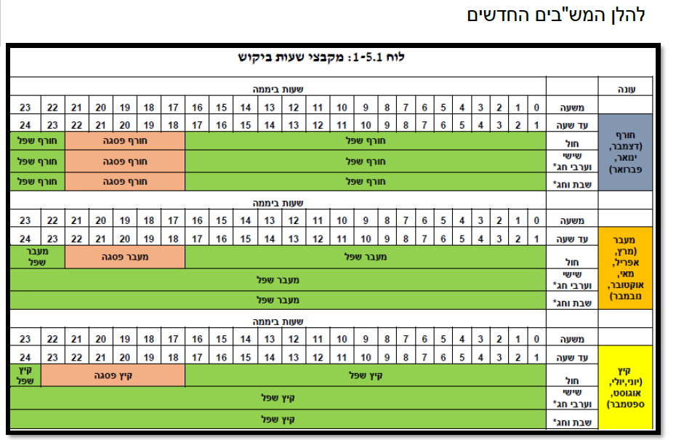**Below is the time-Table for electricity prices**

**(With apologies for not translating – Ed)**



**The entrance to Y**izrael

**Summary of a meeting with the Gilboa Regional Council**

**The meeting was held on Tuesday, 3/1/2023**

Attended the meeting: The Head of the Council - Oved Nur, the general director of the council - Anat Mor and the engineer of the council - Kobi Tzuri

From Kibbutz Yizrael participated: Amos and Galia Shemi, Peter Pizarro, Kobi Levy, Neta Broadhurst, Shmulik Hollander, Hanan Shaliv and Yossi Ba'avor. Erez Peleg also participated, as the director of the community.

The meeting was conducted in a respectable manner. With the help of a presentation prepared by Elad Ilan (thank you), we presented all sides of the issue. We raised all the relevant arguments, as presented on the page published in the Alon and we demanded reference and help from the council managers in speeding up the processes and a request for an approximate time schedule. We expressed the hope that the solution to the dangerous intersection will arrive soon.

The proposed solution, at this stage and according to the plans submitted to "Nitivei Yisrael road authority" is that of integration lanes at the intersection (since there is no practical possibility to make a circle)

The plans were approved by "Nitivei Yisrael road authority" and forwarded to the Ministry of Transportation for budgetary approval.

Based on similar precedents, the rough estimate is (God willing) that the budget will be approved in about a month. This is the optimistic assessment with which we left the meeting

Success to all of us Yossi and Chanan

**I care**

**Food Branch Process – Shimon Zelas**

Why is it right to vote "Hybrid" - this offer allows everyone to be satisfied. Members who want to eat for free can continue to do so. Members who eat some of the meals (mainly breakfast and dinner) at home - will receive a budget that will cover part of their additional expenses (today they do not receive anything)

In my opinion, there is nothing principled or collective here. I really respect families that eat family dinner at home, without noise and without dining room games

How much money will we get? We don't know but on the assumption that the budget will be based on the cost of food only for the food industry today, it will be about NIS 25 per person per day (this does not include labor, energy, maintenance and general costs)

It is usual to calculate that lunch as 50% of the daily food cost, so those who eat breakfast and dinner at home will have NIS 12.50 left to cover part of the cost of meals at home. It doesn't sound like much, but for a family of 5 it comes to NIS 16,000 a year

Vote "hybrid"

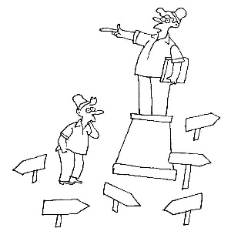



**General Assembly + Economic Council**

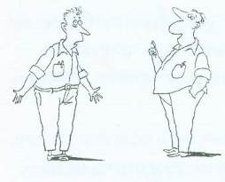**On Wednesday, 1/18/2023**

**at 20:30**

**In Da Club**

**Asafa: recommendation of the search team for the position of director of Human Resources - Kinneret Govrin**

**Economic Council: Community budget for 2023**

**Assembly and Council Committee**

**Shibolim group's Donation Evening**



**Thursday 19.1.23 at !8:00**

**In the Dining Room**

**Letter from Argentina / Daniel Shapira**

**18.2.2022, Mendoza, Argentina!**

The alarm clock is set to 9:30 – I start the morning with the song: "Sha'ar 6" to get into the mood.

10:00 – I go down to grab a croissant & espresso; The streets are already starting to take on a cautious holiday atmosphere.

10:45 - meet Sharon at "Birra House",a local Israeli woman reserved ringside seats for us in front of the screen and behind us sat, Argentina fans, in droves.

11:00 - Announcement of the lineups: on paper, an easy victory for France. Although it is important to remember that many French players are returning from illness and lack ideal preparation for the game.

11:30 - The Argentina fans filled the entire street with flags, cheerleaders, beers, silly-foam and above all, with the feeling of "here it is happening".

12:00 - The game begins! Madness in the stands, oops in Mendoza.

First half - Argentina goes up to 1:0, of course, Messi - penalty 1:0... very quickly Argentina goes up to 2:0 and the Argentines feel that the game theirs! Euphoria in the streets, a sense of oneness, here it comes. Where are the French?

By and large, until the 79th minute, France simply did not play football. The atmosphere in the street is buzzing; As the minutes of the game pass, so do the decibels of the Argentinians grow... and then Mbappe arrived on the scene - shrinking the score to 2:1 and I say to myself: "Please, just don't let France do a Holland on us,"... and here they did ... before I can say "Jack Robinson", Mbappe scores once again. 2:2 - a genius goal scorer, or in other words - Argentina against Mbappe / 11 vs Mbappe. I had the feeling that the French have the character of us Israelis, who don't know how to hold on to a result... The Argentinians don't know how to digest what happened and I'm like them. Shocked, shocked, totally. Where did it come from? There is an atmosphere of 3:2 to France after 90 minutes...

Extra time - wow, luck, we survived it; Messi, today, became the greatest player of all time, he just knew he wouldn't have another chance - all or nothing! Managed everything, moved the ball from side to side and also made sure to enter the statistic books once again. At this point I say to Shalio (my travel partner): "Remember, Mbappe will finish as top scorer, but the trophy goes to Messi" 😏 Not long after that… a goal! 3:2 to Argentina - Messi just wants the trophy! The Argentinians go crazy, just crazy and I'm the only one holding my head in my hands with the feeling that it's not over yet.

14:30 - Half time in extra time. 3:2, and I have a ratio of 3 liters of beer in my body to one single cup of espresso 🥴 and then, of course, Mbappe scores - 3:3. Momentum of France - chaos, such as I have never seen or experienced. Final, World Cup, to return to the game from deep in the grave, to score a hat trick (and potentially another one)... wow 😱🐢 I'm just hoping they get to penalties. I Trust Martinez (he brought Arsenal 2 FA Cups, as a goalkeeper).

123rd minute - Kolo Mani 1 on 1 against Dibo and then…. Dibo's heroic stop (!) - he sends the game to overtime; After this save and with his momentum, I know where the cup will go, but hey, what a thriller.

Penalties, and I'll cut the story short for you - the cup went to Argentina!!!!

After 36 years, Messi becomes the best player in the history of the game, in the greatest football game in the history of the game! The Argentinians are the clouds, all jumping, hugging, kissing those next to them and singing "Muchachos", which in my opinion should become their national anthem... They waited so long for this victory!

And if you've made it this far, then first of all, much appreciation❤️ and secondly - that for this die-hard football fan, these were the craziest 120 minutes of my life, the number of ups & downs I experienced, was not normal; (Or healthy – Ed) I was privileged to see this game and what is more, in Argentina!

Messi becomes the greatest of all (And this is an ardent a Ronaldo fan talking). I watched with a huge screen in front of me, and a whole army of fans behind. Crazy, crazy, crazy, crazy! 🎉

P.S... - Of course, the celebrations after the game were something else - 8 hours straight of "Carnival in Argentina", I couldn't ask for more!

Thanks to the Gods of football 😲🐑⚽️ Daniel Shapira

**Invitation to Eran Skolnik's Concert**

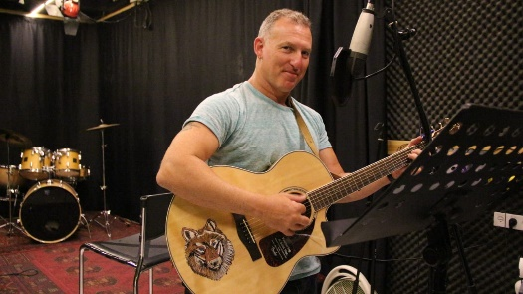 Beit Ha'yotzer, Tel Aviv

Wednesday 18.1.23

20:30

"גוף הפעולה המשותף" ייגש

**Next week we will publish Grossman's article – This addition is too long!**

**English is Fun - with Rahel**

English is a crazy language

English is the most widely spoken language in the history of our planet, used in some way at least one out of every seven beings around the globe.

Half of the world’s books are written in English, and the majority of international telephone calls are made in English. English is the language of over sixty percent of the world’s radio programmes, many of them beamed, ironically by the Russians, who know that to win friends and influence nations, they’re best off using English.

More than seventy per cent of international mail is written and addressed in English, and eighty percent of all computer text is stored in English. English has acquired the largest vocabulary of all the world’s languages, perhaps as many as two million words, and has generated one the noblest bodies of literature in the annals of the human race.

In the crazy English language, the blackbird hen is brown, blackboards can be blue, green or white, and blackberries are green and red before they are ripe. Even if blackberries were really black and blueberries really blue, what are strawberries, cranberries, elderberries, raspberries and gooseberries supposed to look like.

To add to the insanity, there is no butter in buttermilk, no egg in eggplant, neither worms nor wood in wormwood, neither pine or apple in pineapple, and no ham in hamburger. (In fact, if somebody invented a sandwich consisting of a ham patty in a bun, we would have a hard time finding a name for it.)

To make matters worse, English muffins weren’t invented in England, French fries in France or Danish pastries in Denmark. And we discover even more culinary madness in the revelations that sweetmeat is made from fruit, while sweetbread, which isn’t sweet, is made from meat.

In this unreliable English tongue, greyhounds aren’t always grey, ladybirds and fireflies are beetles, a panda bear is a racoon, a koala bear is a marsupial, a guinea pig is neither a pig or from Guinea and a titmouse is neither mammal nor mammaried.

Language is like the air we breathe. It’s invisible, inescapable, indispensable and we take it for granted. But when we take the time to explore the paradoxes and vagaries of English, we find that hot dogs can be cold, darkrooms can be lit, homework can be done at school, nightmares can take place in broad daylight while morning sickness and daydreaming can take place at night, midwives can be men, hours – especially happy hours and rush hours – can last longer than sixty minutes, quicksand works *very* slowly, boxing rings are square, silverware can be made of plastic and tablecloths of paper.

Why is it that a woman can man a station but man can’t woman one, that a man can father a movement but a woman can’t mother one, and that a king can rule a kingdom but a queen doesn’t rule a queendom? How did all those Renaissance men reproduce when there don’t seem to have been any Renaissance women?

If *pro* and *con* are opposites, is congress the opposite of progress.

…………..more next week

**Next week we will publish Grossman's article – This addition is too long!**