

**The Yizraelite – No 2131 Date: 3.11.23**

**Kibbutz Yizrael**

**Edi-torial** This edition includes the translation of an article which appeared last weekend in the supplement of the newspaper “Yediot Acharonot” called “Hadashot HaEmek”. They got to me through my friend and kibbutz spokesman, Yitzchak Peleg. They were looking for someone who has close family in the Aza area. My family survived and I hope they find the strength to overcome the trauma. I hope all the survivors do!

I can’t take credit for the excellent translation of the series “the Magic of Music. (Page 13). It seems “ChatGPT found the original and gave it back to me. Chat also cheats, it seems. (Page 13)

**Congratulations to Nitzan and Jules Feldman** on the birth of their granddaughter, a daughter for Meitar and Omer.

Congratulations to the entire Feldman family and the Shavit family.

**Football Tournament - Saturday, November 4, 2023, 11:00 AM**

**You are ALL invited to play, cheer, and have a great time!**

**Rules**: • 5 players per team. • A game ends after 10 minutes or when one team scores 3 goals (whichever comes first). • If after 10 minutes the score is tied, a penalty shootout will determine the winner. • Registration can be made on the community's WhatsApp group "Cultural Updates."

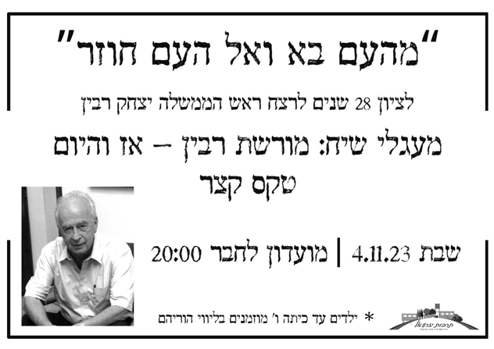

**He Came from the people and returns to the people.**

**In commemoration of the assassination of Prime Minister Yitzchak Rabin**

**Discussion groups on the subject:**

**Rabin’s Legacy - Then and Now**

**Shabbat 4.11.23**

**General Meeting + Reserve Fund (Keren Miluim) Meeting**

**Monday, November 6, 2023**

**Agenda: General Meeting:**

1. Proposal to terminate Zivit Nanikshvili’s membership due to violations of asefa decisions – closed meeting for members only and by invitation by the Asefa Committee.
2. Proposals from the Management Committee for managing the state of emergency (if necessary, an economic council will be convened for this matter).

**Agenda: Reserve Duty Fund Meeting:** Summary of the year 2022

**The following is the update from Kehilanet on the postponement of the asefa, which has been re-scheduled for this coming Monday, November 6, 2023**

**October 22, 2023:** As part of the proceedings initiated by the kibbutz regarding the cessation of Zivit Nanikashvili’s membership in the kibbutz, a general asefa was supposed to take place according to a predetermined agenda, which was communicated in advance to Zivit and all members. Zivit turned to the Nazareth District Court with a request for a temporary restraining order to prevent the asefa from convening, claiming that there were flaws in the process.

This morning, a hearing was held on the request, and the court rejected it while ordering Zivit to cover the legal expenses of the kibbutz. We will continue with the process following the timelines determined by the Asefa Committee in coordination with the Management Committee. Members who wish to review the decision are invited to contact us.

Asefa Committee

**October 23, 2023:**

The asefa committee met this morning in preparation for the asefa planned for this evening. Due to the tense security situation, the absence of many members from the kibbutz, and others who cannot participate in the asefa due to issues related to the security situation, it was decided to postpone for 2 weeks, the asefa scheduled for today. **The asefa will now be held on Monday, November 6, 2023.**

Eddie Solow, Uri Gilad, Shlomo Cohen - Asefa Committee

**Thank You**

From the Staff Sergeant of the IDF Soldiers who stayed on Yizrael:

Hello Lilach,

I wanted to say thank you. Thanks to you personally, thanks to the members of the kibbutz, and to the other guests staying in the kibbutz. Thank you for welcoming us in the first days of the war, for providing us with a warm home, for your wholehearted assistance with all our needs.

Thank you for the welcome that went beyond all expectations, chance meetings with kibbutz members with whom I had conversations and got to know, people who are the salt of the earth. Good-hearted people, ready with good conversation, and giving people.

Thanks for the material things, and most importantly, thank you for the spirit you brought and infused in us.

We will continue with our mission, with the hope that one day, after the war, in a different circumstance, we will have the privilege to return and know better days.

Best regards.

**Report from the Community Management Meeting - 29.10.23**

Present: Erez Peleg, Maor Parsai, Talia Arad, Inbal Adler, Ilana Peleg, Shlomo Levi, Limor Griman, Yifat Segal, Stas Gavrielov, Tamir Blass, Kinneret Govrin, Yifat Assaf Absent: Ishai Levi (drafted)

1. Reports from office bearers on the situation (Invited Guests: Keren Kagan, Eyal Tirosh, Adi Goldshtein-Ilan, Lilach Ron) Keren and Eyal, who are coordinating the needs of evacuees during the war, reported that there are currently 115 evacuees in Yizrael. In the coming days, families from Bruchyal will arrive. The evacuees come from various settlements in the south and north. Three teams work in different areas to assist the evacuees: an events and activities team, an emotional support team, and a school team. The evacuees are integrated into the kibbutz's tasks and various projects.

Adi Goldshtein-Ilan, who is coordinating donations from Yizrael during the war, reported that so far, Yizrael has donated 43,000 NIS: 23,000 NIS from members' donations and 20,000 NIS from the Donation Fund. The objective is to donate equipment and activities, not direct money. Examples of donations include clothing and games for distribution centres, equipment and food for southern evacuees through "Achim L'Neshek," barbecue meals cooked for soldiers at the Amos Camp and the Nahal Brigade at Ramon Airbase, care packages for our reservist units, clothing and additional requested equipment, and treats for children of new immigrant families staying at Ulpan Oliv, financial support for the families of missing soldiers, clothing and equipment for specific families, gluten-free food for soldiers in Na'ura, supplies for barbecue meals for the Tank Brigade in the Jordan Valley, electrical adapters, a washing machine, and a dryer for southern evacuees in Nir David, and special treats for children staying at Hotel Olive, and more. The response and involvement of the Yizrael community are truly amazing and moving.

**Lilach Ron, Head of the Emergency Response Committee** in Yizrael, reported on the situation in Yizrael, the readiness of the various teams under the committee in different areas, improvements to shelters and protected spaces, preparation for the first responders’ team and their equipment, and more.

**Kinneret Govrin, Human Resources manager,** reported on the work area. Kibbutz Yizrael is not defined as a combat zone, and we operate according to the Home Front Command's guidelines. A total of 28 members of the kibbutz were called up, including new recruits and from the young generation. Currently, 25 are serving. There are three foreign workers from the G’dash and two foreign workers (note: labour migrants) from the dairy, who returned to Thailand. Almost no worker shortages were reported in any sector.

The work tasks are carried out primarily by kibbutz members and evacuees from the south and north, including the pre army group, especially in the food and agriculture sectors. The main effort of the kibbutz members is directed towards security and patrols throughout the kibbutz. Efforts are made to involve evacuees in different areas, shift duties, and projects. It was decided that full payment would be made to all salaried workers who were absent from work during October. Work hours allocated for the benefit of the situation are monitored. Efforts are made to utilise the help of members in volunteer work rather than regular work hours, as much as possible. Within the kibbutz, including in Maytronics, we know who is working, but it is more difficult to ascertain the status of external workers. We expect them to update H.R. and they will be integrated into the kibbutz system as needed. Starting from October 29, when educational systems (formal, informal, and early childhood) will be fully resumed, we expect all members and salaried workers to work full time as usual.

**Erez Peleg, reported** that we are advancing in our preparations for emergencies. We have renovated the old bomb shelter in the perimeter area between the community garden and the reservoir. Maintenance work on the shelters is being carried out by the regional council, and all shelters are now adapted for at least a 10-minute stay. The results of the contributions to the emergency fund and how to handle the funds, considering the war situation are still being reviewed. The actual implications will be presented to the management and the asefa.

Summarised by Erez and Yifat.



**Reminder Regarding Allowance Overdrafts**

**Maor Persai**

We would like to remind our members who have an overdraft in their personal budgets, that the kibbutz regulations do not allow for an overdraft exceeding two consecutive monthly personal allowances. Members with a substantial overdraft are kindly requested to take action to rectify this situation. This may include:

1. Transferring money from other sources to cover your personal budget.
2. Adjusting your expenses to align with your income.
3. Converting your outstanding debt into a separate loan.

You may schedule a meeting with me for guidance and consultation regarding the desired solution. It is essential to address this issue promptly to avoid any penalties according to the regulations.

Maor Persai, Financial Manager.

**Agricultural Branches on Yizrael at the end of October**

**Jeremy Perling**

Pipe Dream or Pipe Nightmare? – Ed

New “Migunit” bomb protection unit at the G’dash (Field Crops Branch)

**Field Crop Branch:**

**Actual work:** We are about to finish the processing and preparing of fields for the coming year, we have planted carrots and are preparing for the planting of wheat and onions.

**In the almonds,** we will continue irrigating until the rains come; in the olive groves, harvesting is in action. The situation is under control and fully functional. We have 3 workers who have been called up: Ben Kirshberg, Ben Brustein, Daniel Rosenfeld (Agriculture Manager).

Before the war, there were 11 foreign workers, 5 left, (migrant workers). We are in the process of bringing back 2 foreign workers to Israel (they worked in Yizrael for 5 years and want to return, visas are given for two years).



**Dairy Branch:**

The dairy produces 16,200 liters a day. We milk 440 cows, 40 dry cows, 350 calves, and 120 heifers. Everything is running smoothly. Navot volunteered to work in the Aza area, and Milton went to England (To guard the King – Ed).

Jeremy Perling.



**The Story of the Jar**

**In memory of the late Dani Harpaz, may he rest in peace.**

On March 17, 1948, during the height of the War of Independence, a historic event occurred in Haifa that had a significant impact on the fate of the war. Arab forces in Lebanon organised and supplied arms, ammunition, and explosives to assist the Arab fighters in Haifa.

This convoy set out from Beirut and passed through Rosh Hanikra and Acre on its way to Haifa. The presence of this convoy became known to the Palmach's intelligence service (Shai), which decided to set up an ambush and eliminate the convoy before it reached Haifa. Dani Harpaz, who was only 18 years old at the time, was one of the Palmach fighters who carried out this heroic operation.

My family lived in Savionah (now Kiryat Motzkin), very close to where the ambush was set up. I was only 4 years old at the time, but I still remember vividly the enormous explosion when one of the ammunitions trucks in the convoy was hit.

A few months ago, I visited a museum in Kiryat Motzkin and saw a metal jar with a large hole in the centre (see picture). This hole was the result of a splinter from the explosion that entered a nearby house. Behind the mortar shell is an article that describes the events of that day.

I took a picture of the jar and sent it to Dani. He was very moved and shared with me the detailed story of the bravery of the ambush that took place on March 17, 1948.

Micha Ami

Note: I have provided a condensed account of the operation to destroy the arms convoy from Lebanon. For those interested, there is a detailed description of the event available on the internet.

Top of Form

**The Family of Eddie Solow from Kibbutz Yizrael Survived the Massacre in Kfar Aza:**

**"I feel inside that I went through a Holocaust."**

By Daniela Dadon

Published in Yediot HaEmek on October 27, 2023

Three weeks after the terrible massacre carried out by Hamas terrorists in the Aza border communities, stories of the disaster continue to emerge. Kibbutz Kfar Aza was one of the most severely affected communities. According to estimates, 84 out of its small population of about 700 were murdered by the terrorists, while some are still missing, and others are held captive by Hamas in Gaza. Amid the horrifying stories that are unfolding, many members of the kibbutz managed to escape the attackers, such as the family of Eddie Solow from Kibbutz Yizrael, his sister, Barbara Levinson, and her husband, Ralph, his nephew, Alon, with his wife and three children; and Michal, Eddie's niece, who was alone without electricity or a phone for 20 hours. They all miraculously survived the brutal attack.

"All the members of the Levinson family are heroes. Somehow, the terrorists did not enter their homes, and in a stroke of luck, they all came out alive," says Eddie Solow. "They each ponder their feelings of guilt, wondering why they were the ones who survived and how it happened. For some reason, the terrorists did not attempt to enter homes in that area. Even their car remained intact. It was a miracle."

"An Attack by Terrorists" Solow now retraces the events of that fateful Saturday morning on October 7. "At 6:30 in the morning, a friend from Ashkelon called us to ask how we were. I didn't understand why he was calling so early until they told us to turn on the television, and that's when we learned the horrific news," Eddie Solow said. "I called my sister, and she whispered that she couldn't talk. She said there was a terrorist attack, and she and her husband needed to take refuge in a secure room, but they had no phone reception when the door was closed. From that moment on, we were overwhelmed by intense fear. My sister had to open the safe room door to get cellular reception and maintain contact with the kibbutz members and their emergency headquarters during those hours."

Did she hear the terrorists? "Of course. There were gunshots at first, and they were sure it was IDF gunfire entering the scene. My sister thought it was just a single skirmish with a few lone terrorists that would pass soon. But little by little, every time she opened the door and received messages of cries for help from her friends and the headquarters, she eventually understood what was going on."

Alon Levinson, Solow's nephew, his wife, and their three children were also locked in their home on the kibbutz for hours. "My niece, Michal, had rented a small apartment in the kibbutz. She had a “safe” room, but after a while, the power went out, and she couldn't charge her phone. At noon, the connection was lost with her, and she was in darkness for many hours."

Only on Sunday morning did the IDF manage to enter the kibbutz, eliminate the terrorists, and take the survivors to a secure location. "The army arrived at my sister's house around 4 a.m. She interrogated them to ensure they were indeed IDF soldiers, and only then did she open the door. Two hours later, the soldiers managed to rescue my niece, Michal, and they moved her to another secure location along with other young people, leaving some soldiers to guard them. Michal was sent to Shfa’im, while the rest of the family went to a hotel in Eilat. Since then, the family has been moving between Eilat and Shfa’im and the vicinity, where many of their friends are staying.

The reality is beginning to sink in. According to Solow, the survivors of Kfar Aza are only now beginning to digest the magnitude of the disaster. "Now they are all starting to fall apart," Solow painfully admits. Everyone in the kibbutz is like one big family. Everyone is going through the same thing, each with their personal trauma, and it's only getting worse. As long as Hamas is on their doorstep, there is no reason to return. I ask myself, if I were in my nephew’s shoes, would I go back?"

Do they feel anger toward the army and the country that abandoned them? "They feel a great deal of anger over the fact that the first responders’ weapons were taken, by order of the IDF. I didn't ask them about their thoughts on the prolonged duration of the army's response. It is only now becoming clear why it took so long, as many soldiers were killed on their bases. Their perception of the entire security apparatus was that, in the worst-case scenario, only a few isolated terrorists would infiltrate, and they could handle them. This is not what happened. Now it is just the beginning of the war, and we do not know what will happen in Judea and Samaria and in Lebanon. This is just the opening chapter At least now everyone is prepared."

Eddie Solow concludes, "They all say the same thing: as long as Hamas is on their doorstep, they have no reason to return. We are not at that stage. They are all coping with their personal traumas, and it's only getting worse.

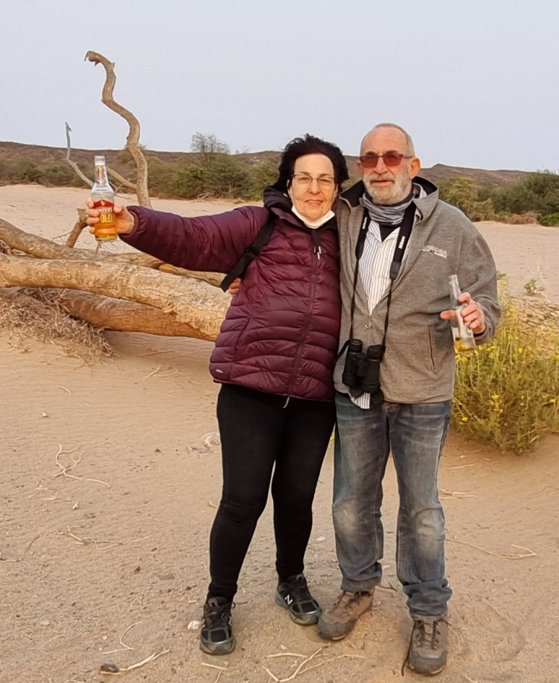

**"Small Tips for Big Emotions"**

**By Gaya Sankar**

**Shaking as a Cure**

Have you ever seen how a baby antelope trembles after a lion passes by? Or how a dog shivers during a thunderstorm?

As living beings, in the presence of a looming threat, stress hormones, primarily cortisol and adrenaline, are released in our bodies. These hormones give our bodies and muscles the power to react efficiently and protect us. At this time, when it seems like we are in a state of crisis 24/7, our bodies store more and more tension, creating a vicious circle of stress. The stress and anxiety increase hormone production, and the hormones intensify stress and anxiety in response.

Trembling of the muscles, as animals do in nature, signals to our nervous system, "I am not in life-threatening danger right now." Tension can be released, hormones can calm down, and the body's recovery system can take over, bringing more calmness to both our body and our mind.

What can you do?

The simplest thing possible: Stand still and start shaking your body. You can put on some music or do it in silence; it doesn't matter. Shake, tap, and let your hands be free to move around your body. Feel how the tension all parts of your body is being released , including your chest and pelvis.

Here's how:

1. Shake like this for a few minutes. You can do it several times a day.
2. What matters is the act of shaking, not necessarily how intense or vigorous the shaking is; it releases the tension just the same.
3. You can also do it while sitting if standing isn't possible. Shake every part of your body that can move.

**Give it a try and feel the calming effects it can have on your body and mind.**



**New English Library Books**

The Wise Woman's Tale/Phillipa Bowers

Saving Mozart/Rafael Jerusalmy

Lean Fall Stand/Jon McGregor

Vladimir/Julia May Jonas

Blood on Snow/Jo Nesbo

War Doctor/David Nott

Take My Hand/Dolen Perkins-Valdez

One to Watch/Kate Stayman-London

Q&A/Vikas Swarap

**The Music School**

**"Secrets of the Magic of Music – Part 4"**

By Prof. Roni Granot, Lecturer and Researcher in the Department of Musicology at the Hebrew University

**The Power of Recording**

There are many reasons for listening to music, which became apparent as music began to detach itself from daily life. The development of recording technology has played a significant role in this, allowing almost anyone to listen to any music repeatedly, anytime, anywhere.

When we listen to recorded music, it is easy to make it a background for other activities, such as doing homework, exercising, driving, cooking, and even working. Most of us can also easily switch our attention to and from recorded music, making it a versatile tool for both background and active listening. Active listening can involve spontaneous singing or even significantly change the nature of the experience.

Moreover, in a world filled with music, it is reasonable to assume that we accumulate many personal memories, both good and bad, each with its own musical soundtrack. In such cases, listening to that music will revive those memories and the associated emotional experiences. One of the most common emotions linked to music is nostalgia, making it one of the main pathways from music to emotion.

**Enjoyment, Distraction, and Emotion**

People listen to music for various reasons, falling into three main categories:

1. **Social and Emotional Needs:** This includes spending time with friends, alleviating loneliness, reliving adolescence, and shaping one's identity, especially during adolescence and throughout life.
2. **Utilitarian Uses:** This involves using music to alleviate boredom during daily activities like driving, washing dishes, improving sports performance, or enhancing concentration during studying.
3. **Emotional Needs:** Music can serve as a powerful tool for experiencing or altering emotions. This can be either for emotional catharsis, allowing us to release negative emotions or as part of a self-healing process, where the strong emotions awakened by the music help us overcome negative feelings. This process is similar to catharsis, a concept the ancient Greeks used in the context of tragic theatre.

The second category, utilitarian uses, is particularly interesting because it demonstrates the ability of music to change emotions in various situations. Music can be a means to balance our emotions and, rather than intensifying a negative mood, direct it towards a more positive one. Often, the shift results from the positive messages or imagery found in the lyrics or even from the simple enjoyment of listening to music we love.

Returning to the idea of eating, people use music to regulate their appetite, making it easier to eat or avoid overeating. The experience of eating can be significantly improved or worsened through the right choice of music. Thus, music serves as an auxiliary to the gastronomic experience.

The unique case is purely instrumental music, which lacks lyrics or visual imagery. Despite this, it can elicit powerful emotional experiences. Music has a language of its own, speaking to our inner world through sounds and patterns. This kind of music can convey delicate, profound, or even tempestuous feelings, often associated with love. Paradoxically, the lack of explicit meaning in instrumental music allows it to access our emotional world directly, bypassing conscious language and diving into the deeper realms of the psyche.

The process of music detaching from its daily roots enabled it to develop increasing complexity, diversification, and versatility. It has become a tool that allows us to nourish ourselves at many levels – physical, emotional, and aesthetic, without requiring continuous and focused listening. This versatility, in turn, allowed music to become a therapeutic tool. It is within this framework that it can assist in the process of therapy through music.

In conclusion, the study of how music influences our emotions and the profound role it plays in our lives is a rich field of research. Music can significantly impact our emotions, and its influence is complex, far-reaching, and multifaceted. Music has the power to heal, inspire, and transform our lives. It is a truly magical art form.



**שבלולים + חברים מרימים לעורף**

**Shablulim and Friends - Uplifting the Homefront**

**Friday 3.11.23**

**Lobby Entrance**

**20:30**

**Back to the Orange Season**

**Israeli Rock Classics**

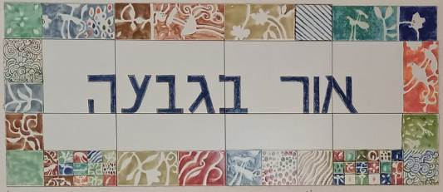 

**Daily 08:30 – 12:00 – coffee, cake, chats, board games**

**Sunday 5/11**

10:00 – 12:00 Around the World – (on Zoom)

10:00 Ceramics room open with instruction from Ziv Ben Bassat

16:30 Or B’Givah open for coffee, cake and friendly chats

**Monday 6/11**

08:00 Pedicure with Limor Mualem (by appointment only)

09:00 Lecture – Rochele Matalon

16:30 “Love is the Whole Story” – a meeting and singsong with kibbutz veterans and our guests – in the kibbutz Moadon.

**Tuesday 7/11**

10:30 Beit Lochamei Hagetaot will join us for a meeting with the veterans and our guests – in the kibbutz Moadon.

14:00 Ceramics room open with instruction from Ziv Ben Bassat

16:30 Or B’Givah open for coffee, cake and friendly chats

**Wednesday 8/11**

09:30 Nature is Blooming with Hammutal Assaf

16:30 Or B’Givah open for coffee, cake and friendly chats **OR**

17:00 Tai-chi (advanced) with Einan Grosser

**Thursday 9/11**

07:00 Pedicure with Na’ama Baum (by appointment only)

10:00 Movie screening “Power Corrupts” with Galia Shemi

17:15 Exercises on chairs with Michal Sha’anan

**English is Fun - with Rahel**

**DISORDER IN THE COURT**

Great Fractured Moments in Courtroom History

(Contributions from the National Association of Criminal Defense Lawyers)

CLOSING ARGUMENT

DA: Ladies and gentlemen, the defendant in this case can be analogized to a duck because there is an old saying that if it walks like a duck, quacks like a duck, and looks like a duck, it must be a duck, and the same argument can be made as it would relate to drunks and that’s what the defendant in this case is.

COUNSEL: Ladies and gentlemen, I deeply resent the characterization that the prosecutor had made of my client. My client is neither a duck nor a drunk. What the prosecutor has done in this case is create a hybrid bird that is a cross between a pheasant and a duck. I cannot pronounce the name of the new species but it is spelled P-H-U-C-K, and that is exactly what the prosecutor is trying to give my client in this case.

THE TRUTH STOPS HERE

COUNSEL: Well, our objection, Your Honour, and I want to make this very clear, is that there is a time that truth has to stop, and that time -

THE COURT: Why does it have to stop?

COUNSEL: Because the trial has started.

CROSS EXAMINATION  
THE COURT: Please begin.

COUNSEL: Thank you.

Q. (to witness) Miss, while you have, if you do have – you still - oh, you don’t….

THE COURT: That was a great start, Counsel.

TOUCHE

A: You mumbled on the first part of that, and I couldn’t understand what you were saying. Could you repeat the question?

Q: I mumbled, did I? Well, we’ll just ask the court reporter to read back what I said. She didn’t indicate any problem understanding what I said, so obviously she understood every word. We’ll just have her read my question back and find out if there is any mumbling going on. Madam reporter, would you be so kind?

COURT REPORTER: Mumble, mumble, mumble, mumble.

ANSWER TO THE QUESTION

THE COURT: Are all three of the defendants black?

COUNSEL #1: My client is white.

COUNSEL #2: My client is described in the police report as a mulatto.

THE COURT: How do you describe her?

COUNSEL #2: Pregnant.

FORGET SOMETHING?

COUNSEL: Your Honour, the defense would argue the People haven’t proved the prior conviction.

DA: Oh shit!

COUNSEL: That is a legal term?

THE COURT: One used quite often in law school.

MEANING OF THE CONSTITUTION

Q: In the course of your years practicing as an attorney, did you have problems with alcohol from time to time?

A: Yes.

DA: Objection. Move to strike.

THE COURT: On what grounds?

DA: It’s irrelevant. And I might define for the Court, since I think there are going to be a substantial number of these objections, that it is the State’s position that an attorney who has an IQ of 41, who has barely passed the Bar, and who has fouled up every case he has ever tried, is still perfectly capable of giving adequate legal services within the meaning of the Constitution.

………….more next week

**Credits:** Translated and edited by: Eddie Solow

Proofread by: Biff Markham-Oren

Printed by: Irit Cohen and Hedva Sharabani