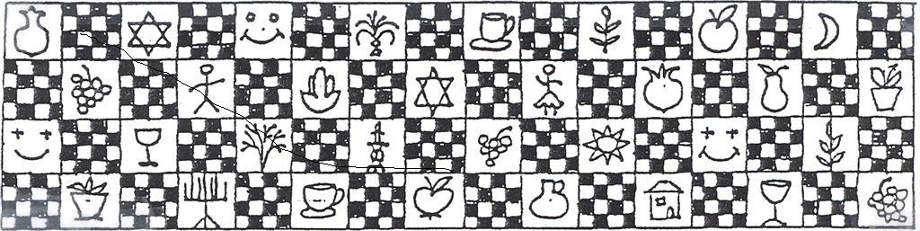**The Yizraelite**

**- No 2102 Date:14.4.23**

**Kibbutz Yizrael**

Translated and edited by Eddie Solow

**Edi-torial.** The seder in the dining room was extra- special this year. Well done to all those who put in so much work. It is so special to have such fine musicians to accompany us all evening. I think we all “klub Nachus” even if the musicians are someone else’s children.

Yifat Asaf made a very powerful speech at the Seder Dinner. She made it clear that even in this generation, we need to guard our rights and the rights of all minorities, otherwise they may disappear before we know it.

**Thank You All**

With the end of the "Shiva" for the death of my father, Moshe, I would like to thank everyone who helped and supported us during the months of my father's illness, at the time of his death and during the Shiva.

To our doctor, Yifat Assaf, to Rahma, and to Margalit Levy - and especially to Liran Pen, who, in addition to being a nurse, was an attentive and supportive shoulder to lean on

To Kobi Levy, the health director - who supported us

Yitzhak Peleg - who was by our side in the difficult moments and helped us with the complicated bureaucracy

To Anan Grosser and the members of the mourning committee - who acted efficiently and sensitively

To all the volunteers who helped at the club room and on shifts at home

To Michal Sha’anan, our private angel, who has been with the parents throughout the last months – we are very lucky to have you there

To my good friends - Hadva Shaharabani and Noga Harpaz - I wish everyone friends like you

To everyone who came to the funeral, offered condolences, or said a kind word - many, many thanks

Rochala Matalon, on behalf of my mother Shoshana, my siblings Sarit and Eyal and the whole family

**The kibbutz movement:** sends good wishes and a happy holiday to all of us on the celebration of our  freedom from bondage. We wish health, peace, security, joy and a healthy democracy to all the communities of the kibbutz movement

**The Sports Union:** In spreading the Passover spirit - we bless the harvest and the home, the light and the freedom, harvest and gathering - and we add: let us cross the sea of descent, leave the crises far behind us, and embark on a  path of peace and brotherhood, equality and love. From Dudu and the management of the sports union

**Yad Tebenkin:** We wish that freedom, equality and mutual respect will be an inseparable part of our lives! May we succeed in crossing the 'Red Sea' that has opened up in Israeli society, for the benefit of a fair and sustainable future for all residents of the State of Israel

**Holocaust and Heroism Remembrance Day**

80th anniversary of the Warsaw Ghetto Uprising April 2023 bulletin

  David Mittelberg, from his father's book

Before World War II, Polish Jewry numbered 3.3 million souls and at the end of the war only 380,000 people survived. There were 380,000 Jews in the city of Warsaw in 1939, the second largest Jewish settlement in the world after New York. In July 1942, the deportation of Warsaw Jews to the extermination camps Treblinka and Majdanek began, and continued until the last “action” in January 1943. From then until April 1943, the ghetto residents moved to live in bunkers, until the Warsaw Ghetto uprising on Seder Eve. After that, the Warsaw Ghetto was completely destroyed.

On the occasion of the 80th anniversary of the Warsaw Ghetto uprising, I am sharing with you, from the testimony of my father, the late Yisrael Yaakov Mittelberg, as written in the book "The Testimony and Testament":

 "On Passover Eve of the year 1943, around noon today, we were given Matzot, sugar and honey. “We still believed that we would celebrate the "seder", although we knew from experience that on every Jewish holiday the Germans invented some reason for their own "celebration". At four o'clock in the morning we heard the cars. The commando searched the ghetto and at seven in the morning everything started - units of soldiers arrived and stopped in the small garden next to the Judenrat headquarters. A few minutes later we heard shots. One of the Jewish policemen brought us several pistols and several hundred bullets.

We decided to oppose the Germans. Szymkiewicz brought some ammunition from the Poles on April 19 (the first day of Passover). We were in contact with the underground in the ghetto. A friend of mine, Igleberg, a mechanic and locksmith in the Jewish police, suggested that we move to the bunker at 18 Ganeshia Street. We - my wife and child, my sister, Stock's wife and their child, Igleberg with his wife and child - made our way up the partly burned stairs of the building on Ganeshia Street. Igleberg knocked on the door and said he was alone. When they opened the door, we all squeezed in. The bunker belonged to Rabbi Meir, the janitor of the building. After a few hours we began to examine our shared fate. Our concern was for Igleberg's baby, who was three months old. Others worried that there was not enough oxygen in the bunker for the number of people crammed into it. We got weaker and weaker because the supplies were running out, especially for those who moved from bunker to bunker. Owners of groceries did not show any desire to share them, and this caused petty quarrels. I felt that the adults would last somehow, but we had to find food for the children. I asked Rabbi Meir for some food for our child. He refused but agreed to swap for some brandy and cigarettes.

Every whisper, every rustle, endangered those hiding, since the Germans continued to search for surviving Jews. The bunker's residents feared that the cries of my friend Igleberg's three-month-old baby would betray them. Some thought that the lives of many should not be endangered because of one baby. But how can a mother be demanded to end the life of her newly born baby? One hundred and sixty people faced this difficult question, for which the greatest thinkers could not find a solution. We were going crazy. Some suggested poisoning or suffocating the baby. The mother wanted to die with the baby."

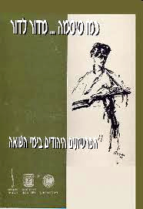David adds: On May 12, 1943, my father, his wife and son were deported from the Umschlagfelz in Warsaw to Treblinka, from there, after a cruel and heartbreaking separation from his family, my father spent two years of torment in Majdanek and in forced labor camps in Poland and Germany until his release from Matthausen by the Americans on May 5, 1945.

**Short excerpts from a book Michael Shani wrote about his family's history in the Holocaust**

Until 1941 my life was comfortable and pleasant for me. I had friends, I had a family, I was spoiled from all directions.... [...]

One morning I woke up early, it was dark outside. Father entered the house and mother asked him: Eliezer, are we going

"Yes, we're going." Father answered, "Only young people go"

And so it was. They woke us up. I was the eldest, eight and a few months old, my brother Haim, seven years old, and my brother David, who was two and a half years old. They dressed each of us in shorts and a short shirt, mother took half a loaf of bread in her hand and we started walking... [..]

The Jews who we encountered, shouted at us: "Where are you going? The Germans are a civilized people, the Russians are rude people, we don't like the Russians. The war will last about a month in total. Everything will be over, everything will be fine, is that why you are running away

The feeling was that the people standing on the street were trying to pull us back, but mom didn't give up and we kept walking

(At the end of the war) I remember well…It’s a strange story that happened to me... I got hold of a bicycle. And with it I rode through  the village and saw how the Germans were being transported away. Suddenly a boy and a girl walk in front of me. The boy asks me: "Tell me, do you want to immigrate to Israel

I tell him: Yes

He tells me: Then come with me

I went to return the bike and met my brother, Haim

I asked him: "Haim, Tell me, do you want to immigrate to Israel

He tells me:Yes

I told him: "Come with me ... (p. 24

Editor's note: Michael's family was saved when they fled the city of Kostopol, because the Germans murdered all the Jews who remained in the city... Later the father was drafted into the Russian army, and their mother, with great wisdom and resourcefulness, while going through difficult events in their wanderings, managed to save her three sons... Everything is told in the book...

After they came to Israel on the ship  'Pen York' ship (from Michael's book, Galia Shemi learned2**²** that she was on the same boat...) the family, including their brother David, moved to Gan Shmuel. Michael and Ilana moved to Jezreel after living in Kibbutz Ein Hasofet

The excerpts from Michael Shani's book: "On the Path of Life" family histories

Thanks to Ilana Shani, who shared with us the family history of Michael, who survived the Holocaust with his family

**Roger Baruch - Liora Kamlian's father - tells**

I was born in Tunisia in 1942, in the city of Tunis. My mother died when I was a baby. She got sick and died when I was three months old. When I was orphaned , they wanted to move me and my older brother to Algiers, to a Jewish orphanage. Luckily, my aunt, my mother's  sister, adopted me. My brother was taken by my father's mother (the grandmother). At the age of six I asked my aunt why our names were different. Then she told me about my mother and took me to her grave. It was the first time I went up to my mother's grave

From Wikipedia on the Jews of Tunisia: "Tunisia was the only country among the Islamic countries that was directly controlled by the Germans. Because of this, Tunisian Jews were the only ones among all North African Jews who had to face a direct German occupation. The damage to the Tunisian Jewish community was severe

Over 20 labor camps were established in Tunisia where young Jews were held prisoner. Very heavy fines were imposed on the Jews. The Jewish community organized itself to deal with the German demands on the one hand and to respond to the needs of the Jewish population on the other hand It was a difficult period, perhaps the most difficult in the history of the Jews of Tunisia in modern times

My mother, when she was pregnant with me, sewed buttons on the suits of the Nazis...

At the age of 13 I decided to immigrate to Israel with the help of "Habonim". I immigrated to Israel with a group of 21 children, boys and girls, and we were initially sent to a religious institution... none of us were religious, so of course, we had 'difficulties' with the residents. We asked to move to another place, after arguments they moved us to Kibbutz Givat Brenner. I was there until I joined the army. I was an officer in the tanks. After the army, I married Rachel (Cooper) and we had 3 children. We lived in Karmiel for about 50 years, I worked in the municipality. We came to  Yizrael to be with the grandchildren and great-grandchildren...

**Shimon Tshuva - Gil Hillel's grandfather**

I was born in May 1930 in the city of Benghazi in Libya. My earliest memories begin in a small town of Safar, on the Libyan-Egyptian border, "Porto Bardia", where my family settled. My father migrated far from his hometown of Benghazi and settled in this town of Safar, where he expanded and established his business and his ties with the Italian authorities and with the small Jewish community, of which he was a spokesperson and leader

One evening (1939) two people knocked on the door of our house. They were accompanied by the shamash of the local synagogue. They did not know the language of the place, and only said at the door of our house "Shema Israel..." These were refugees from Europe whose only desire was to reach the Land of Israel. My father took care of the necessary arrangements, and since then I could not stop thinking about the Land of Israel

At the age of 9 I was expelled from the Italian school where I studied. I was late for class. The teacher took advantage of the racial laws adopted by the Italians to expel me in shame. We had to abandon Porto Bardia, leaving all our possessions behind, because of the fear of the Italian authorities that the Jews would spy for the British who ruled Egypt and Palestine in 1918

We returned to Benghazi. In the eyes of the Italian authorities, we were Jewish Libyan citizens, while in the eyes of the local Arabs we were considered inferior, stateless and did not belong there. In the eyes of the extremists, the fanatics, we were infidels who should be destroyed if we did not agree to convert to Islam, and they were ready to conduct a pogrom against the Jews. We were at the mercy of the volatile war situation, the city passed from hand to hand, from Italian-German rule to British and back. The racial laws greatly reduced the possibilities of the Jews of Benghazi. We lived in constant fear

During one of the nights of disturbances that preceded the deportation, the Italian rioters managed to break down the door of our house with gunshots and broke into our home. They found us, the children, clinging frightened to our mother, who was trying to protect us. We watched with streaming eyes and gaping mouths, how the three rioters insulted our father who came out to meet them, and beat him brutally with clubs. They would not leave him alone and they didn't rest until they humiliated him. Our father was thrown at their feet, protected by his hands on his head. He was beaten and bruised. The day after the night of the riots, it became clear to the Jews that all their businesses had been broken into and looted and some of them had been set on fire

In April 1942, the local Jewish committee published a list of families (2,600 Jews) who were ordered to report to the synagogue with their belongings. We were put on huge Fiat trucks, detained for many hours next to the high wall of the prison, where three Jews from the city were imprisoned. The three were executed by firing squad. We all heard the shots. This was done in order to break our spirits on the way to the concentration camp… as if hinting at what awaits us in the camp. After traveling for a few days, we found ourselves in the desert, in the middle of nowhere, about two hundred and thirty kilometers from Tripoli, in an abandoned military camp - Jado camp - a concentration camp. The conditions were inhumane. The nights were very cold. The overcrowding was terrible. Each pavilion housed 300-400 people, and only a makeshift partition separated the families. There were no beds. We slept on the floor. The toilet buildings were primitive and public. There were no showers, not even medical services. The guards there were Italians and Arabs and they were allowed to shoot anyone who dared to approach the fence

I can't remember what we ate. Water was distributed only two hours a day for all needs, the families received meager food rations that included rice or macaroni, sugar, tomato paste and coffee or tea. Hunger, poor sanitation and overcrowding are breeding grounds for epidemics. The death of the prisoners in the concentration camp from starvation, from typhus and other diseases were a matter of daily routine. About a third of the Jews died, including my younger brother Yosef, who was about five years old, and my father who was forced to do hard labor and died of hunger, weakness and typhus. They were buried in an ancient Jewish cemetery located near the camp. So too, five other members of my family, uncles and cousins, and hundreds of others. I feel a wild and terrible grief and rage that overwhelms me at the death of my father, who was only forty-two years old. I myself fell ill with typhus and miraculously recovered. I remember that in the first days after the illness, I was unable to stand on my feet, and at the age of twelve I was crawling on all fours like a baby. The grief, and especially the rage that filled me then, will accompany me until my last da

One day, in February 1943, the Italian soldiers in charge of the camp gathered us all in the parade ground, and surrounded us with a belt of armed soldiers. They placed machine guns on the roofs of the buildings, and waited for an order from above to kill us all before withdrawing from the camp. Thus, we stood in formation for about four hours in the burning desert sun. The weak and exhausted fainted, and the  muffled cries of sick children could be heard from every corner, like the howling of hungry cats, until an order came to the soldiers to leave us to our own devices, saying: "Either way you will all die, it's a shame to waste ammunition on you." The same night the soldiers left the place. The British army entered the camp the next day, and freed us

We returned to Benghazi, to the house where we once lived before the deportation. We found only walls and empty rooms. All the contents were looted and had disappeared.  We had to start from the beginning – We were left with the childhood memories and the loss of school years. We were deprived of a normal family life

A little less than two years later, I arrived in Israel, mainly thanks to Jewish soldiers from Palestine, who were stationed in Benghazi - but that's another story

**My father, the late Moshe Rosenblum**

**Lukov 1933 – Israel 2023**

Moshe, my father, was born in Lokov in 1933 to his parents Yehiel and Rachel. Moshe was the youngest of four children

When the war broke out, Moshe was a six-year-old boy. At the beginning of the war, another baby was born in the family, but the mother, Rachel, died during childbirth. The baby survived only a few months and also died. Father Yehiel remained with four orphan children. The family remained living in their home even after the establishment of the ghetto. "Kanalova" street. The street where the family's house stood, was included in the ghetto

One day, German soldiers entered the Rosenblum family home, murdered the aunt, who was taking care of the children and wounded the father who was lying sick in bed. Later, in one of the actions, the children of the family hid in three hiding places that the father had constructed inside the house and thus they were all saved-

Yehiel, the father of the family, realized that the situation was getting dangerous and that it was necessary to take the children out and hide them. Thanks to his connections with the Poles in the area, he found a hiding place with a Polish acquaintance named Majic from the village of Krynicki. His home was a lonely house near the railway that led to Treblinka. For  sometime, the children and David (the father's brother) lived in hiding in Kryniki with them. Yehiel the father would come every few days to see the children and take care of the food supply

One night, shouts and shots were heard very close to the farmer's house. In the morning they saw two bodies of Jews they knew, Pervan and his wife. The suspicion arose that the farmer, who was also a hunter and knew the couple, was the one who murdered them after they asked to find a hiding place with him

The father was afraid to leave the children in a place that was probably dangerous. He returned them to Lokov and at the same time looked for another solution. He found a farmer named Khmelevsky from the nearby village of Zhimny-Veda who agreed to accept the family. The father, the farmer and his son dug a hole under the stable in the yard. The pit was small and low. It was impossible to stand upright in it. One could only sit or lie down. The conditions were difficult, the pit was cold, the humidity was high, the food was scarce. In the summer, the father would bring some fruit and it was basically the only source of vitamins. For a year and eight months, the family hid in a pit, while being especially quiet, because a relative who was known to be anti-Semitic, lived in the Polish farmer's houseIn August 1944 Lokov was liberated. Because of the long time the family members were in hiding, it took several days of adjustment before they could stand on their feet and walk again. A few days after the liberation, the father decided to return to the city and see the condition of the house that was used for the entire war as the headquarters of the Germans. The children and the uncle remained in the village, waiting to hear the news that the father would bring. They waited and waited but the father did not return. They prayed for his safety but unfortunately, they learned after a long wait that the worst had happened. The Germans left behind mines everywhere. There were buried mines around the Rosenblum family home. The father stepped on a mine and was kille

Four orphans remained. In unusual ways and after being separated from each other, all four managed to reach Israel. Moshe was transferred to a Polish orphanage and then taken and transferred by Hashomer HaTzair guides to an orphanage in Germany until immigrating to Israel at the end of the War of Independence

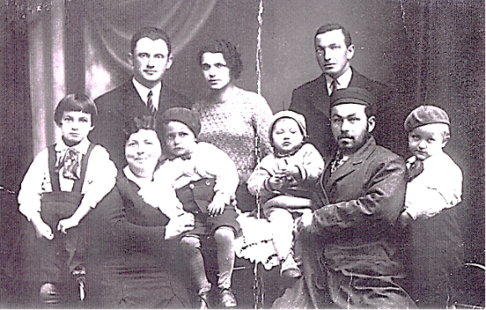Rochala concludes:To this day, My family members maintain regular contact with the farmer's family who hid them. The righteous family received the Rosenblum family home as a gift of gratitude. Here the farmer's daughter-in-law lives to this very day. We visited them several times over the years

Rochala Matalon

**Human Resources**

**The Changing of the Guard**

We say goodbye to Wasim Shibli after 18 years of working as a guard at the kibbutz gate

The completion of Wassim's work here on the kibbutz took place after a lengthy, respectful and sensitive process and out of responsibility for the security of the kibbutz and its residents

Wasim was replaced by a security company, which provides security services, named: G1. Through them we will receive regular, stable and professional security

We thank Wasim from the bottom of our hearts for all the years he worked with us, and wish him great success in the future

Erez Peleg and Kinneret Govrin

**Group photo in honor of the 75th holiday**

In honor of the kibbutz's 75th anniversary, we will produce a large kibbutz picture, which will hang on a central wall in the kibbutz

The photo will consist of family and personal photos, and the photography will be done by a local and professional photography team

The photo will show all those living on the kibbutz at this point in time, as well as children up to the age of 30, even if they do not live in a kibbutz.

**What do we do**

Make sure the whole family is on one of the following Saturdays: Saturday 5/6/23, or Saturday 5/13/23

Sign up for a photo shoot time that is convenient for you on a form that will be published soon on Kehilant

At the appointed time - dress nicely,  and come to the photo shoot with a big smile

Everything else is on us

For questions and clarifications, contact Tamar Sankar orYifat Assaf

Good luck to us in creating a beautiful kibbutz souvenir which will be with us for many years to come

**The 75th Celebration Team**





**The Eighth Yizrael March – Over and Out**

On Saturday, 1.4.23, the traditional march took place. The last march was held as part of the celebrations for the 70th anniversary of Kibbutz

Five years have passed and the team gathered again to organize the march... but this time, reinforced by young forces, with extremely impressive technological and pedagogical abilities

By all accounts, the march was a great success, thanks to the hardworking team and many people who were recruited for various specific tasks

I dare not mention names. There are too many of you and any effort to remember you all is doomed to failure

**I will content myself with a big thank you** to nearly a hundred people who were  mobilized to contribute to the success of this wonderful day. I didn't count, against the evil eye

Thanks to the writers of the archaeological, historical and agricultural content

Thanks to the photographers, printers and proofreaders, graphic designers. To the film crew and actors. To the technical geniuses who put the brochure online, and to those who prepared the bar-codes

Thanks to the team of quiz writers, porters and drivers, first aiders, ushers and route markers, those who manned the refreshment stations , the duplicating and laminating people, the writers of the notices for the bulletin boards and kehilanet. Thanks to the  catering managers who ensured we did not starve

Thanks to the bosses of agriculture and community branches, who agreed to entrust us with their expensive work vehicles

Thanks to the office bearers and the 75th holiday team - who understood the importance of the matter and cooperated with all the requests

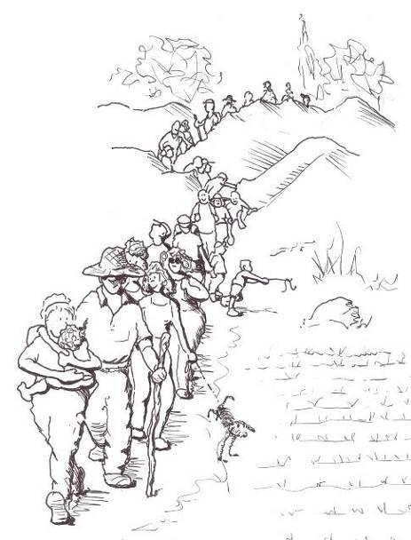 Thanks to the station takers down and marker box collectors

Thank you to  the Youth group and the

Group doing their year’s social service on the kibbutz

And to you, the marchers, thank you for getting up early to walk  through the bush. Some with a baby on their backs, others dragging a leg or a child... - you left a clean path without a piece of paper, chewing gum, or cigarette butt. There was no need to clean up after you at all - thank you for that the team will meet and draw conclusions for next time... and there will be a next time! We promise

Three Cheers to the marchers

The committee

Ruth Mor, Adi Ilan, Ella Cohen, Yotam Assaf, Navot Assaf, Barry Feldman, Vicky Hollander, Paul Zelas, Eyal Cohen, Benny Segal, Jeremy Perling, Ron Grannot, Shani Baor, Tal Darom (honorary team member) Eddie Solow

 .

**English is Fun   -   with Rahel**

Getting old….

* Looking 50 is great if you’re 60.

* Age is a high price to pay for maturity.
* No man is ever old enough to know better.
* Time may be a great healer but it’s a lousy beautician.
* When I was a boy, the Dead Sea was only sick.
* A man is not old until regrets take the place of dreams.
* You’re only young once but can stay immature indefinitely.
* Old age isn’t so bad when you consider the alternative.
* You know you’re getting old when you get that one candle on the cake.  It’s like, “See if you can blow *this* out.”
* Regular naps prevent old age, especially if you take them while driving.
* A stockbroker urged me to buy a stock that would triple its value every year.  I told him, “At my age, I don’t even buy green bananas.”
* He’s so old then when he orders a three-minute egg, they ask for the money upfront.
* By the time a man is wise enough to watch his step, he’s too old to go anywhere.
* True terror is to wake up one morning and discover that your high school class is running the country.
* There is no pleasure worth forgoing just for an extra three years in the geriatric ward.
* You can live up to be a hundred if you give up all the things that make you want to live to be a hundred.
* No, I don’t do alcohol any more.  I can get the same effect just standing up fast.
* Talk about getting old.  I was getting dressed and a peeping tom looked in the window, took a look and pulled down the shade.
* Birthdays are good for you.  Statistics show that the people who have the most live the longest.

……………..more next week.